

Nanette Wiser – Writer, AOL City's Best : The easiest way to find what's best/Tampa
Nanette is a freelance writer reporting on dining, travel and entertainment. Originally a syndicated writer and San Diego-based reporter and web producer, her articles have appeared in more than 500 papers and magazines, including Hemispheres, San Diego Magazine, California Magazine, SF Examiner, San Diego Union Tribune, NY Post and more. www.inquisitivetongue.com wisernan@aol.com www.aolcitysbest.com (San Diego & Tampa) (2011 stories)

Fried Chicken 4 Ways: Tampa's Best
May 9th 2011 3:00PM / by Nanette Wiser
Dipped and battered dozens of ways and served up on salads or in tacos, fried chicken will never go out of style. These restaurants offer a unique take on the comfort-food classic -- from Chinese Katsu to Southern drumsticks, these dishes transcend finger-licking good.
Cafe Dufrain: This romantic waterfront bistro boasts a stylish regional American menu, eclectic beer/wine list and seasonal dishes such as organic fried chicken and smoked bacon braised collards drizzled with Eden's Nectar spiced honey and served on a buttermilk waffle.
707 Harbor Post Dr., Tampa; 813-275-9701
Cracker Barrel Old Country Store: If you want boy-howdy cooking, order up the Colby cheese melted fried chicken BLT, buttermilk fried chicken and dumplings and Sunday chicken fried chicken blue plate special, a meal for two at this homespun favorite.
2151 54th Ave. N., St. Petersburg; 727-526-0031
4011 Ulmerton Rd., Clearwater; 727-572-8685
13833 W. Hillsborough Ave., Tampa; 813-855-4200
Lee Roy Selmon's: Fried is a religion here (sweet potatoes, green tomatoes), but you'll be a fanatic after biting into the Selmon family classic sandwich, cooked crispy and hot, topped with Swiss cheese and served with lettuce, tomato and garlic horseradish aioli sauce.
2424 Tyrone Blvd N., St Petersburg; 727-347-5774
Additional locations in Tampa, Brandon, Bradenton, Sarasota.
Pei Wei Asian Diner: Roy Yamaguchi's popular fast food healthy eatery will make you crave the fire not typically associated with granny's fried chicken. Take a bite of the honey-seared crispy chicken tossed with garlic sauce, chili oil, rice sticks, scallions and red bell peppers, and you''ll be hooked.
1402 66th St. N., St. Petersburg; 727-347-1729
12927 North Dale Mabry Hwy., Tampa; 813-960-2031

Just Roll With It: Tampa Bay's Best Sushi

May 5th 2011 11:00AM / by Nanette Wiser

Your inner Buddha will sigh with happiness when you order up fresh fish at Tampa's best sushi restaurants.
Hook's Sushi Bar & Thai Food: Hook's Thai, Japanese and Chinese dishes, baked mussels and spicy seaweed salad may tempt you, but the makimono rolls rule here. Feast your lips on the Beauty & the Beast (California roll with fish medley and eel on top), First Love (eel, cream cheese, avocado topped with salmon), Never Say Never (jalapeño, salmon, eel, yellowtail, cream cheese, asparagus, crab) and the spinachy Popeye rolls.

1210 9th St. N. St., St. Petersburg; 727-898-4665
Oishi Japanese Restaurant: In addition to the traditional and hibachi-cooked dishes, this Channelside Thai Thani sister features arty rolls such as the avocado-wrapped Dragon (shrimp tempura, cream cheese, avocado, rice, seaweed), Three Company (avocado, scallion, fish egg inside tuna, salmon and avocado outside) and Dirty Old Man (California roll on top with spicy tuna and dynamite).
615 Channelside Drive, 204-A, Tampa; 813-228-9202
SoHo Sushi: These trendy restaurants update traditional Japanese dishes including noodles, dumplings and extraordinary chef-inspired sushi such as Sabine's Screaming-O Rolls (steamed shrimp, cucumber, tempura chips and avo topped with salmon and spicy mayo, then backed and finished with eel and sriracha sauce) and Hosea's T-N-T (spicy tuna roll tempura fried and finished with ponzu sauce and scallion). Best of all, USF students get 10% off and everyone enjoys discounted sushi happy hour 5 p.m. - 7 p.m. daily.

3218 West Kennedy Blvd., Tampa; 813-873-7646
2826 East Bears Ave., Tampa; 813-977-8744
The Vue Sushi and Martini Bar: The newest Bank of America restaurant tenant will move to the 19th floor and a water view this month, but for right now, enjoy the red neon chic interior, faux alligator banquettes, clever sake-based mixed drinks and 24 specialty rolls, some named for sports teams (Rays' Special, Buccaneer), others famous for being abfab (Surf and Turf with jumbo lump crab and filet mignon).

200 Central Ave., downtown St. Pete; 727-821-4600

Middle Grounds Grill Jazzes Up Tampa
May 3rd 2011 4:00PM / by Nanette Wiser
10925 Gulf Boulevard, Treasure Island; 727-360-4253
Once upon a time, Robbie's Pancake House was flapjack heaven until they decided it was time for a face lift and emerged as Middle Grounds Grill, the angels' answer to "Where can we get gourmet food, exceptional wine and classy, casual decor in Tampa Bay?" Open daily for dinner and sporting an early-bird menu (4:30 p.m. - 5:30 p.m.) Thursday through Saturday, live music, organic prix fixe Monday and 1/2 price wine bottle Wednesday, this is as glamorous as the beach gets. So gussy up with your designer capris for supper. Reservations are a must on weekends.

If Only You Could Eat The Decor: The outside patio sports Gulf glimpses, elegant umbrellas and tables perfect for sipping your Grey Goose pear martini. The magical aquarium (one tropical fish, one wine cellar), sleek lighting, elegant furnishings and cuddly booths hum with excited banter and clinking wine glasses.
Sip Sliding Away: Loquacious, efficient bartenders excel in making you feel like everyone knows your name; I love to eat at the bar and chitchat while sipping fab wines by the glass (Guenoc petite syrah, ZD chardonnay, Cakebread sauvignon blanc) and making new friends. Continually updating the boutique wine menu and mixing up seasonal cocktails makes this Pinellas County's best upscale bar, other than Bonefish.
Starters: Seafood is the name of the game here, so you can't go wrong with the oniony smoked fish spread, tangy ginger calamari, lemon-infused blue crab cakes and garlicky Prince Edward mussels. Eat light with the savory tomato Key West chowder (shrimp, scallops, clams, fresh fish) and a warm walnut-crusted goat cheese and grilled portabello mushroom baby field green salad.
Surf & Turf: In addition to abundantly creative specials, dine on mango nut grouper in mango beurre blanc sauce, grilled honey ginger glazed salmon, Caribbean grilled tuna with berry inferno sauce or shrimp Sambuca (sliced crimini mushrooms, cream, marinara sauce). Meatlovers swear by the wet aged steaks, especially the bone-in cowboy ribeye topped with gun powder onion rings or the veal osso bucco with roasted root veggies. Save room for fresh sorbets or the key lime Dagwood tower and an espresso martini.

Sing Your Heart Out, Tampa: Best Karaoke Bars
May 2nd 2011 11:30AM / by Nanette Wiser
Sure, you all sing in the shower (some of us better than others). And maybe you're glued to your TV when it's time to watch "Glee," "American Idol" and "The Voice." But do you have what it takes to become a local queen (or king) of the mic? Whether you crave that kind of spotlight, or just want to belt out of few power ballads for fun, you can do it at these local Tampa karaoke bars. In addition to the adoration and fame, you may even pick up a cash prize at some spots.
Good Time Charlie's Pub: This fun, casual bar hosts karaoke seven nights a week, with a pub menu (spicy wings, cheese fries, Buffalo shrimp), heavy pours and outstanding amateurs who give Dolly Parton, Patsy Cline and Alan Jackson a run for their money.
4030 West Waters Ave.; 813-881-1735
Green Parrot Pub: Two-for-one drinks, sensational King-Kong-sized wings and "Cheers"-friendly bartenders makes the Parrot the perfect place to watch sports and catch weekend karaoke with some pals ... and make some new ones.
11759 N. Dale Mabry Highway; 813-962-2954
Mugs & Jugs: Large wings, larger jugs and even larger pipes make the nightly karaoke entertaining and worthwhile at Mugs. Sing up a storm and just might go home with some prizes! Need a little liquid courage? The discount shots of Patron and Grey Goose ($6) or the Captain ($3) should help you out.
14100 Highway 19 North, Clearwater; 727-535-5847
Stump's Supper Club & Howl At The Moon: Elvis velvet paintings and Southern cuisine (fried chicken salad) followed by dueling pianos and karaoke is old Florida fun at its best. At the bar in back, you and your redneck friends can howl a favorite '80s wannabe ditty, especially at "Rock Star Friday" karaoke.
615 Channelside Dr.; 813-226-2261
Yard Of Ale: Every Saturday, the $10 open bar (7-9pm) attracts beer and wine aficiandos who like to croon their heartstrings out for an evening of admirable karaoke, made more pleasant by the Abita-beer fueled crowd.
406 South Howard Ave.; 813-251-4433

Dine, Wine & Food Finds: Blueberries, Cinco de Mayo & More
Apr 29th 2011 12:00PM / by Nanette Wiser
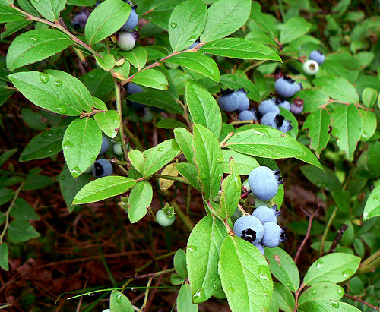With Mother's Day, Cinco de Mayo and the Kentucky Derby all right around the corner, there is plenty to eat, drink and do in the Tampa Bay area.
Blueberry Festival: Farmers will be winding down the markets as the June heat approaches, so now is the time to enjoy some local produce. Head to Keel & Curley's 4th annual berrylicious weekend event Saturday, April 30 (8am-6pm) and Sunday, May 1 (10am-6pm). You could event give Mom a basket of delicious pick-your-own blueberries as an early Mother's Day present. In addition, sample blueberry wine and enjoy crafts, foods from 40 local vendors, a kids' zone and, the best part of all, free admission!
5202 W. Thonotassa Road, Plant City; 813-752-9100
Green Thumb Festival: Learn how to grow your own food and get a plant check-up at the Arbor Day celebration this Saturday and Sunday (9am-4pm). There will also be children's crafts, a flower show, tool sharpening clinics, free mulch, $3 trees, yummy noshes and live entertainment.
Walter Fuller Park, 7891 26th Ave. North, St. Petersburg; 727-893-7441
Gulfport Cinco de Mayo: Those loco O'Maddy's owners double their south of the border fun with a fiesta at Bo-Tiki, their chic beach boutique with a keg on tap. The "Sex and the City" crowd gathers Thursday, May 5 (5-8pm) for margaritas, door and raffle prizes and discounted designer jewelry, boho clothes and Floribbean decor.
3015 S. Beach Blvd., Gulfport; 727-498-8757
There Goes Sea Biscuit: Start your day at Derby Lane or Tampa Bay Downs, then celebrate the Kentucky Derby on Saturday, May 7 (4-8pm) at this Yuengling Brewery fundraiser (Aging Solutions Office of the Public Guardian). Tour the brewery, don your funky hat for the contest and turkey trot to the Nunes at Night while nibbling hors' d'oeuvres and suds.
Yuengling Brewing Co., 11111 30th St., Tampa; 813-949-1888

Resto Review: Villa Gallace Italian Restaurant
Apr 25th 2011 1:03PM / by Nanette Wiser

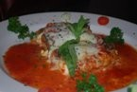Pasta equals love. Sharing spaghetti a la Lady and the Tramp, making baby pasta (with butter and parmesan) for the nieces, ziti well done is a day's just desserts. No where in Tampa Bay does it get better than when Pompeii, Alice and Luigi Gallace greet you at the door, kiss both cheeks and show you to your booth overlooking the Intracoastal, your very own Italian Riviera evening where the sign always promises fresh gnocchi.
The Vibe: As the good Chianti arrives, you notice you're rubbing elbows with TV anchors, baseball stars and local captains of industry who recognize the regional Italian dishes. Andrea Bocelli croons, crisp white linen sleek decor dazzles and crystal glasses tinkle in a heartfelt Ciao. Sample unique Italian vineyards and sexy wines such as the Gavi Y Gavi white or voluptuous Barolos.
Small Plates: Known for their spicy sauced jumbo shrimp and the gorgonzola gnocchi, it's the calamari fra diavolo and Caesar salad for two that I poignantly yearning for in between visits as well as the egg drop soup with spinach and tantalizing pasta fagioli, swimming with fresh veggies. Crusty warm Italian bread with parmesan herb infused olive oil sops up the sauces you can't leave behind.
Intermezzo: Like a good opera, the excitement builds as Chef Caravello debuts homemade pastas (spinach ravioli with cream sauce, eggplant rollatini, spaghetti carbonara) with a side of sauteed white wine mushrooms. Chicken and veal dishes shine in every incarnation (Marsala, parmigiana, cacciatore, piccata and lemony Francaise style) and the brandy peppercorn cream filet is a carnivore's dream as is the grouper Florentine.
Finishing Flourishes: Refresh the palate with a lemon or orange sorbet or opt for the sinfully dense chocolate torte paired with a vintage port or dessert wine.
109 Gulf Blvd., Indian Rocks Beach; 727-596-0200

Best Early Bird Dinner Savings
Apr 21st 2011 12:00PM / by Nanette Wiser
Before Groupon, Open Table and the Daily Deal, your grandparents' counted on the early bird suppers to save money and sample new restaurants beyond their budget. With restaurants begging you to friend them, more upscale eateries now purvey early bird gourmet specials including Rumba's, Salt Rock Grill, Madfish, Middlegrounds, Island Way Grill, Grillsmith, The Wine Cellar, and more. Foodies rejoice, and double your pleasure on Wednesday when many restaurants offer 1/2 price wine bottle discounts.
Bernini's: Explore innovative Italian cuisine (1/2 price daily 4-7 pm) and impeccable service as well as $2 Finlandia martinis Mon.-Fri. 11 am-7 pm Veal carbonara, shrimp orecchiette, clam linguini, crispy duck, pork osso bucco and chicken madeira range between $9.50-$14.
1702 East Seventh Ave., Ybor City; 813-248-0099
Cafe Alma: In addition to Monday's all you can eat crab legs or prime ribs and Tuesday's half-price wine/tapas menu, you can enjoy Alma's early bird prix fixe (salad, entree, dessert and soda/ice tea) Mon.-Fri. 4:30-6 p.m. After the Alma house salad with figs and feta or Caesar, go wild with the petite sirloin with roasted garlic demi-glace and veggie medley, linguini (shrimp pesto or ground sirloin meatlballs/chorizo) or blackened catch of the day with saffron rice.
260 1st Ave. South, downtown St. Pete;727-502-5002
The Palm Restaurant:From 5-7 pm (and 9 pm to close), you can order dinner from the Palm's Prime Time Bar Bites menu for only $4.50/dish featuring Nova Scotia lobster BLT sliders, crispy blue corn fried oysters, mini crab cakes with chipotle tartar sauce or the charcuterie plate. Oysters on the half shell are only $1.50 and a jumbo shrimp cocktail $2.50. Mangia!
205 Westshore Plaza, Tampa; 813-849-7256
Red Mesa: The $14/person sunset TexMex menu includes choice of sangria, margarita, draft beer or soft drink (4 -5:45 pm, order by 6 pm). Exceptionally spicy entrees reign from seafood (Chimayo chile grilled salmon with black bean sauce; grilled mahi with avocado tomato salad) to carne (pork carnitas with morita chile sauce, carne asada). And if you're going to Push Ultra Lounge, enjoy Red Mesa Cantina downtown.
4912 Fourth St. N,, St. Petersburg; 727-527-8728

Alfresco Allure: Best Places to Dine Outdoors
Apr 18th 2011 11:00AM / by Nanette Wiser
Breezy April weather encourages dining outdoors, but with so many patios to choose from (Pia's Trattoria, Parkshore Grille, Cassis, Bernini, Gaspar's Grotto), aficiandos opt for alfresco with a waterview. Some places, such as The Wharf, Pub and Salt Rock, allow you to arrive in style from your yacht (or Sea Ray). Whatever the transport, the meal tastes better consumed with fresh air.
Fresco's: Lively crowd and Floribbean cuisine vitalizes any day, especially if you order Fresco's smoked sausage and chicken gumbo, portabello salad tower, siracha marinated amberjack, blackened swordfish etoufee, citrus marinated conch or the haddock po'boy served with Cajun curly fries.
300 Second Ave. NE, downtown St. Pete; 727-894-4429
The Pub: Same owner as Parkshore, Hanger and 400 Beach guarantees quality dishes at affordable prices on the Pub's three outdoor decks. Featuring a weekend breakfast buffet, indoor piano bar and great service, you can't go wrong with the baked oysters Rocks, crab-stuffed mushrooms, smoked fish spread, black and bleu sirloin salad and sunset specials served from 11-6 daily (stuffed flounder, onion-crusted salmon, tomato basil mahi).
20025 Gulf Blvd., Indian Shores; 727-595-3172
Jackson's Bistro: Perfect for brunch, sushi, lunch or dinner, this chic eatery, lush lounge and island bar enhances any rendezvous, romantic or gourmand. Start with the polenta-crusted calamari, salmon carpaccio or crab lobster bisque, then order the wild mushroom marsala, caramelized diver scallops and red snapper or pistachio-crusted rack of lamb (truffled mash potatos).
601 S. Harbour Island Blvd., Tampa;813-277-0112
Salt Rock Grill: Chef Tom Pritchard's seafood dishes, Asian-inspired apps, wine list and stories qualify Salt Rock for Tampa's hall of culinary fame. Often overlooked, the nautical bar, patio and boat docks behind the restaurant serve up all your favorites, even better if its in time for the two for $25 early bird (4-5:30) featuring filet mignon bordelaise, jumbo lump crab cake, coconut crusted shrimp, mussels provencale or salmon croquette oscar, served with salad, dippy bread and dessert.
19325 Gulf Blvd., Indian Shores; 727-593-7625
Sea Critters: Jimmy Buffet decor and ambiance, this laid-back bar/restaurant knocks you out with their rum punch and Bahama Mamas. Surf tender lobster roll or pasta, crab cakes, salmon, kingfish or mahi or chow down on a burger for some island time comfort food.
2007 Pass-A-Grille Way, St. Pete Beach; 727-360-3706

Best Bets for Easter in Tampa Bay

Apr 19th 2011 11:00AM / by Nanette Wiser

If Peeps and pastel candy corn make you smile, then this weekend's Easter festivities will delight your family and friends. Gather your minions and make reservations now for Tampa Bay's best brunches at Tradewinds, Sirata, Marchand's, Hyatt Sand Key, Fleming's, Ceviche, 400 Beach, Don Cesar or jelly belly up to these events.

Eggs-travaganzas: At the Florida Aquarium April 23-24 (10 a.m.-2 p.m.), get a picture with the Easter Bunny (small fee) and and ogle the Easter Bunny dive (11 a.m., 2 p.m.) in the Coral Reef exhibit. On April 22 (11 a.m.), the Orangutan family hunts for eggs at the Zoo's popular annual event. MOSI celebrates April 23 (9 a.m.-6 p.m.) with an egg scavenger hunt, egg toss, egg catapult and scientific discussions about animals that hatch from eggs.

Florida Aquarium, 701 Channelside Dr.;813-273-4056

Lowry Park Zoological Garden, 1101 West Sligh Ave.;813-935-8552

MOSI, 4801 East Fowler Ave; 813-987-6000

Cotton Tail Express: All aboard the Museum's diesel-powered train April 23 (9 a.m., noon, 3 p.m.) ato the Easter Egg Patch where Mr. Bunny greets the kids and the annual egg hunt and other festivities make this a beloved family tradition ($18/adult; $14/kids 3-11).

Florida Railroad Museum, 12210 83rd St. E, Parrish; 941-776-0906

Coachman Park Easter Party: Grab the family and their bonnets (noon-2 p.m.) for this waterview extravaganza complete with petting zoo, wandering Easter bunnies, pony rides, bouncy house, giant blow up slide, face painting, live entertainment, food and the Easter Egg hunt (12:30). Bring your basket to collect all the goodies.

Coachman Park, 301 Drew St., Clearwater; 727.442.2099

Easter Brunch Tampa Bay: Cruise the brunch buffet aboard Yacht StarShip for Easter and snap your picture with Peter Cottontail while nibbling applewood smoked bacon, scrambled eggs, balsamic grilled chicken, roasted salmon, leg of lamb, ham, fresh salads (grilled eggplant and artichoke), shrimp cocktail and heavenly desserts. Reserve now; seating is limited.

Yacht StarShip; 813-223-7999

Alfresco Allure: Best Places to Dine Outdoors
Apr 18th 2011 11:00AM / by Nanette Wiser
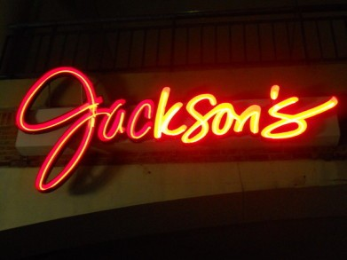Breezy April weather encourages dining outdoors, but with so many patios to choose from (Pia's Trattoria, Parkshore Grille, Cassis, Bernini, Gaspar's Grotto), aficiandos opt for alfresco with a waterview. Some places, such as The Wharf, Pub and Salt Rock, allow you to arrive in style from your yacht (or Sea Ray). Whatever the transport, the meal tastes better consumed with fresh air.
Fresco's: Lively crowd and Floribbean cuisine vitalizes any day, especially if you order Fresco's smoked sausage and chicken gumbo, portabello salad tower, siracha marinated amberjack, blackened swordfish etoufee, citrus marinated conch or the haddock po'boy served with Cajun curly fries.
300 Second Ave. NE, downtown St. Pete; 727-894-4429
The Pub: Same owner as Parkshore, Hanger and 400 Beach guarantees quality dishes at affordable prices on the Pub's three outdoor decks. Featuring a weekend breakfast buffet, indoor piano bar and great service, you can't go wrong with the baked oysters Rocks, crab-stuffed mushrooms, smoked fish spread, black and bleu sirloin salad and sunset specials served from 11-6 daily (stuffed flounder, onion-crusted salmon, tomato basil mahi).
20025 Gulf Blvd., Indian Shores; 727-595-3172
Jackson's Bistro: Perfect for brunch, sushi, lunch or dinner, this chic eatery, lush lounge and island bar enhances any rendezvous, romantic or gourmand. Start with the polenta-crusted calamari, salmon carpaccio or crab lobster bisque, then order the wild mushroom marsala, caramelized diver scallops and red snapper or pistachio-crusted rack of lamb (truffled mash potatos).
601 S. Harbour Island Blvd., Tampa;813-277-0112
Salt Rock Grill: Chef Tom Pritchard's seafood dishes, Asian-inspired apps, wine list and stories qualify Salt Rock for Tampa's hall of culinary fame. Often overlooked, the nautical bar, patio and boat docks behind the restaurant serve up all your favorites, even better if its in time for the two for $25 early bird (4-5:30) featuring filet mignon bordelaise, jumbo lump crab cake, coconut crusted shrimp, mussels provencale or salmon croquette oscar, served with salad, dippy bread and dessert.
19325 Gulf Blvd., Indian Shores; 727-593-7625
Sea Critters: Jimmy Buffet decor and ambiance, this laid-back bar/restaurant knocks you out with their rum punch and Bahama Mamas. Surf tender lobster roll or pasta, crab cakes, salmon, kingfish or mahi or chow down on a burger for some island time comfort food.
2007 Pass-A-Grille Way, St. Pete Beach; 727-360-3706

Dine, Wine & Food Finds in Tampa
Apr 15th 2011 10:38AM / by Nanette Wiser
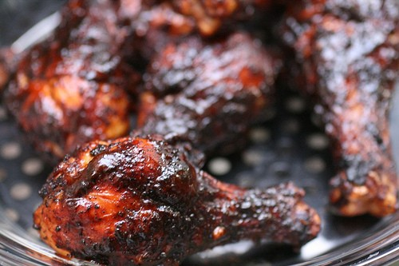In addition to Festa Italiania and Taste of South Tampa this weekend, spring festivals, wine and beer tastings bloom all over town. Sample the grape every Friday at Pic Pac Fine Wines & Liquors, Sunken Gardens, American Spirits Fine Wine & Liquor, Total Wine & More and Uncorked.
Barbecue Bedlam: Sample yet another barbecue cook-off, take a tractor hayride and play some family games at Pinellas Pioneer Settlement Saturday (April 16) from 10am-4pm. Free parking/admission, $5/tasting wristband.
2900 31st St. South, St. Petersburg; 727-893-7326
Gulfport Spring Fest: Two live music stages, kids games and face painting, Easter bonnet parade, butterfly exhibit and endless food booths beckon at this annual celebration Saturday (April 16) from 10am-8 pm Enjoy specials at the neighborhood restaurants, from O'Maddy's to Neptune's Grille.
Beach Boulevard, Gulfport; 727-344-3711
Get Raw: Sweetwater Organic Farm is ground zero in Tampa Bay for everything organic and on Saturday (April 16) from noon-5 pm, you can sample raw food, get recipes, meet vendors and buy organic fruits and veggies, a perfect way to support Mother Nature. Wear a sunhat, bring a basket and find new Sunday supper ideas.
6942 W. Comanche Ave.; 813-887-4066
Two Wheeled Tastings: RSVP by April 21 for this mobile feast Saturday (April 23) from 3-6 pm. Mount your steed at the Trek Bicycle Store, and put the pedal to the metal to free samples purveyed at Tour de Pizza, 400 Beach Seafood and Tap House, the new Taco Bus, Grand Central Perc, the Hanger and Harvey's 4th St. Grill.
3169 Fourth St. N, St. Petersburg; 727-498-8655
Let's Eat: Apron Cooking classes perk up your culinary IQ at Publix with this Saturday's Fruity Desserts, Sassy Souffles (April 19), French Riviera Cuisine for Couples (April 22) and Veggie Spring Rolls (April 23). Follow up with progressive dinner parties (appetizer one house, entree another house and dessert at the third), all the rage among foodie twenty-somethings.
7835 Gunn Hwy.; 813-926-4465

Spring Salad Selections in Tampa
Apr 12th 2011 12:00PM / by Nanette Wiser
If you like Sweet Tomatoes salad bar, you'll love these audacious salads, brimming with farm to fork bounty. Boasting ethnic influences, unique dressings, artisanal cheeses and toasted nuts, these sensational entrees turn even the most dedicated carnivore into a salad fan.
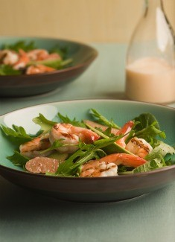
Cafe Ponte: Chef Chris Ponte's inspired dishes at this trendy cafe is a Zagat's favorite, from the sleek modern decor to the extensive wine list. Best of show is the Mediterranean parmesan-pine nut crusted chicken salad (roasted peppers, feta, pesto pasta, artichokes) served with kalamata tapenade crostini and drizzled in a balsamic sun-dried tomato vinaigrette. Equally delicious is Ponte's shrimp BLT, Asian chicken salad, chopped Tuscan and Bosc pear candied pecan cafe concoctions.
13505 Icot Blvd #214, Clearwater; 727-538-5768
California Pizza Kitchen: Skip the Thai chickie pie. Enjoy CPK's international healthy salads big enough for two such as the warm roasted veggie (artichoke hearts, asparagus, Japanese eggplant, yellow peppers in Dijon balsamic vinaigrette), BBQ chicken chopped or the Moroccan chicken salad (roasted butternut squash, Medjool dates, avo, beets, chopped egg, dried cranberries, etc.).
International Plaza, 2223 N. Westshore Blvd., #189; 813-353-8155
Westfield Brandon, 827 Brandon Town Center; 813-684-2375
Mitchell's Fish Market: If you crave seafood, the Fish Market salads are for you. You won't be disappointed by this sensational trio: seared tuna (sliced egg, green beans, olives, fingerling potatos), chilled shrimp salad with lemon-poppyseed vinaigrette and blackened salmon and spinach salad (Granny Smith apples, goat cheese, maple bacon vinaigrette).
204 WestShore Blvd.; 813-289-3663
NoHo Cafe: Using Urban Oasis farm greens as a palette, NoHo's culinary elves toss butter-roasted flat iron steak on the anchovy-garlicky Caesar or toast walnuts and layer seasonal fruits and gorgonzola crumbles on the signature salad.
1714 N. Armenia Ave.; 813-514-0691
Photo Courtesy of MCT

Dine, Wine & Food Finds in Tampa
Apr 8th 2011 2:00AM / by Nanette Wiser
In addition to this weekend's Tampa Bay Blues Fest at the Vinoy, stop by downtown St. Pete's Artwalk Saturday starting at 5:30pm where you can meet artists and enjoy neighborhood eats. Head up to Dunedin for the monthly second Friday celebration serving up 40 merchants, art, wine tasting and live entertainment including Showboat tunes. Still hungry? Pinkberry celebrity frozen yogurt is now open in Westshore Plaza and wouldn't Paris Hilton be thrilled.
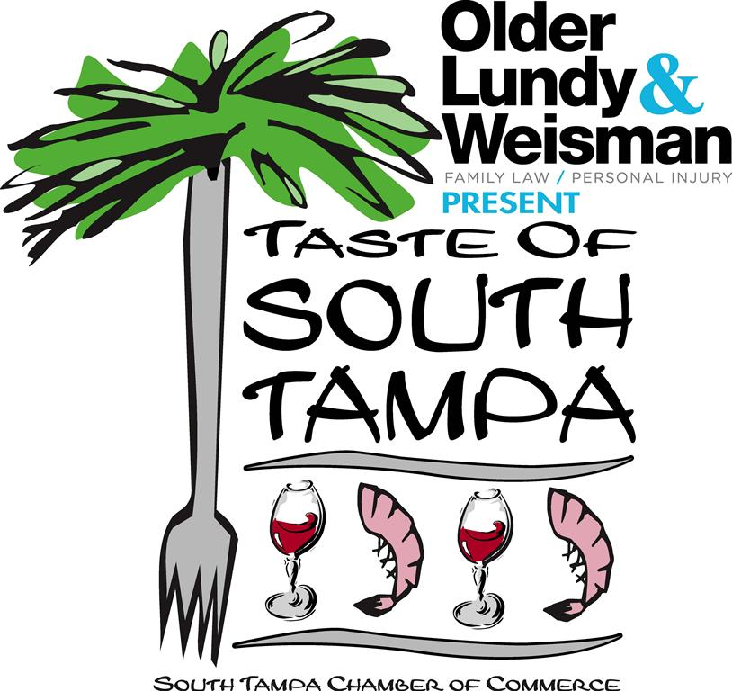Japan Fundraiser: Help the Red Cross support tsunami and earthquake victims by donating money and helping Garage Bar & Grill donate a portion of food sales (Fri. April 8, 5-8pm) while enjoying sushi and drink specials ($2 Bud Light drafts, $5 martini, 25% sushi discount).
1120 E. Kennedy Blvd.; 813-679-0515
Ybor Tapas Trail: Starting at 4pm (Sat., April 9), nibble on the best of Ybor's dishes (Bernini, Columbia, New World Brewery) and enjoy an After Party/Smoker at the Italian Club. Continue the celebration on Sunday with Columbia's jazz brunch, silent auction and tapas cooking challenge. Cost: $35/person Sat., $45 Sun.; both days $70.
8th Ave., Ybor City; 813-241-8338
Mama Mia Eno Pino: Kick off the Festa Italia weekend with the wines of Italy (Thurs., April 14) courtesy of Maggiano's $50/person advance, $60/person at the door. Continue on with Friday's amore film festival, Saturday's homemade vino and bocce ball competitions and Sunday's repast provided by thirty top Italian restaurants. Save room for the cannoli.
Wine: The Italian Club of Tampa, 1731 E. 7th Ave., Ybor City
Event: Centennial Park, between 18th and 19th Street along 8th Avenue, Ybor City
Taste of South Tampa: Don't miss the 6th annual Hyde Park Village celebration (Sun., April 17) with food and beverage from forty restaurant, beer (Dos Equis), wine (Barefoot Wine) and live music. Great opportunity to inexpensively sample delights from Eats American Grill, Five Guys Burgers, The Cupcake Spot, NoHo Bistro, Timpano's Chop House and more. You can even get a chair massage. With advance purchase, regular admission tickets are $35/adult; $20 (ages 11 to 20); kids 10 and under get in free. On the day of the event, ticket prices increase $5, pending availability.
Hyde Park Village; 813-786-7480. info@TasteofSouthTampa.com.
Photo Courtesy of Taste of South Tampa

Asian Fusion Reigns at P.F. Chang's
Apr 7th 2011 1:23AM / by Nanette Wiser
When you've shopped till you drop at Sak's and Old Navy, satiate your inner foodie at P.F. Chang's Chinese Bistro, a culinary crossroads where healthy dining, stylish fare and modern decor meet. With 200 locations and a devoted hipster following, the tony after-work crowd sips creamy chardonnays, often creating wine flights for tasting (three 2.5 ounce pours only $10).
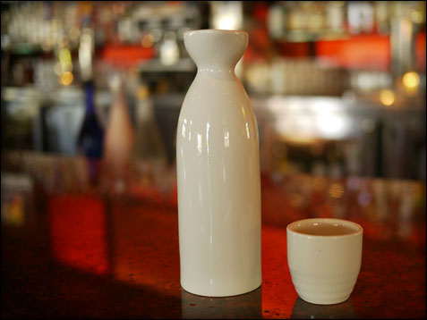The Chinese Connection: Owner Philip Chiang was born in Shanghai and grew up in Tokyo, before relocating to San Francisco. In the early 1960s, his mother opened The Mandarin, one of the first Chinese restaurants in the United States to serve Chinese food from regions other than Canton. The Mandarin became widely known for its high-end cuisine and eventually led to a second location in Beverly Hills. After graduating with a B.F.A. at the Art Center College of Design in Los Angeles, Chiang became involved in the family business. After opening numerous restaurants, Chiang agreed to consult on a Chinese restaurant in Scottsdale, Ariz., for the legendary Fleming restaurant empire.
The Bar: Fantastic-ly flavored sake cocktails (Moonstone Raspberry, Snow Maiden), unique martinis, Asian beers (Tsingtao, Sapporo, Harbin, Chang) and extraordinary tea menu (white tangerine, dragon eye oolong) complete the exotic experiment.
Small Plates: Truly my favorite way to dine here is to order four small plates (crisp smoky dynamite shrimp, five-spice spare ribs, Sichuan marinated chicken and scallion flatbread, salt and pepper calamari), then move on to the Asian grilled shrimp and watermelon salad tossed in citrus dressing and a side of green tea noodles or garlicky snap peas.
The Main Event: Noodle dishes, vegetables and tangy sauces distinguish the dishes, especially the Hunan pork, wok-seared lamb (scallions, sesame, cilantro), oolong marinated sea bass (sweet ginger soy, spinach), candied walnut shrimp (tossed in honeydew melon sauce), spicy Dali chicken (sliced potatos, leeks) and V.I.P. sweet soy plum sauce duck.
Dinner for Two: An inspired date idea promises a four-course meal for only $39.95, which includes soup, one starter (crispy green beans, pork dumplings), two entrees for sharing (orange peel chicken and Cantonese shrimp), and two mini desserts, best paired with Chinese 88 martini (Plymouth dry gin shaken with fresh lemon juice topped with sparkling wine).
Healthy Menu: All dishes can be prepared gluten-free, and a special menu features chicken lettuce wraps, Singapore Street noodles, egg drop soup, fried rice, spinach stir-fried garlic and Buddha's Feast. In addition, dozens of vegetarian dishes catch the eye, especially the Sichuan crispy tofu in vegetarian sauce with steamed broccoli, chili-pepper stirfried eggplant, and coconut curry vegetables.
219 Westshore Place; 813-289-8400
Photo Courtesy of P.F. Chang's

Cheesesteaks Bring Philly Taste to Tampa Bay
Apr 6th 2011 12:00PM / by Nanette Wiser
Foodies debate endlessly about a common hoagie roll filled with gooey cheese, sauteed onions, and frizzled rib eye or top round. No longer the pride of just Philly, cheesesteaks show up dozens of ways: slathered in Cheez Whiz®, provolone or artisan cheese; topped with grilled green peppers and mushrooms; or topped with pizza sauce, mayo or steak sauce, and all are lip-smacking delicious.
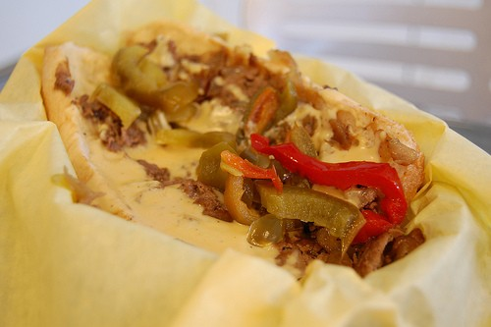The Ale & The Witch: Open till midnight, this delightful bistro serves up 30 intoxicating brews (Lagunitas IPA, Napa Smith Lost Dog), jazz and indie music. Sip a cold one and munch on your killer vegetarian Philly cheese steak sandwich picked up from Jim's Lettuce Eat Healthy vending cart when he sets up outside the Witch Friday and Saturday nights.
111 2nd Ave. N.E., St Petersburg; 727-821-2533
Big Jim's Famous Cheesesteaks: Amoroso rolls and thin juicy marinated rib eye illuminate this flavorful cheesesteak at Big Jim's, which is best eaten with a side of savory potato salad or crispy onion straws, and washed down with Birch Beer. The Cuban and meatloaf sandwiches give the cheesesteaks a run for their Hollywood star.
9218 Ulmerton Road, Largo; 727-518-6201
Philly Phlava: Relocating this month from the Hillsborough Avenue Town & Country location to one on Sheldon, this Philadelphia eatery pays homage to the city's best creations (Tastycakes, Herr's Chips, Center City's pretzels, Hank's soda, Birch Beer, Wawa coffee and more). Eagles fans swear by the steak and chicken cheesesteaks, from the original to the pizza sauce and barbecue versions.
5537 Sheldon Road; 813-249-7181
13149 N. Dale Mabry Hwy.; 813-4514-1230
Charann's: Featuring a 4pm to 7pm weekday happy hour, this friendly sports bar grills up outstanding thinly sliced grilled steak with white American cheese, grilled onions, tomatoes, and choice of peppers (sweet, banana, mild, medium, the devil), as well as chicken and turkey cheesesteaks.
6821 W. Hillsborough Ave.; 813-886-1199
stu_spivack, Flickr

Tampa Bay's Stylish and Surprising Comfort Foods
Apr 4th 2011 1:28PM / by Nanette Wiser
Ozzie and Harriet cuisine never tasted this good, from creamed spinach with bacon to SOS. Fifties and '60s favorites sport seasonal ingredients and ethnic influences from spicy and savory.
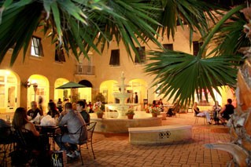Back Fin Blue Cafe: Charming bungalow and garden patio set the stage for Back Fin's famous prime rib, gorgonzola meatloaf and Maryland-style jumbo lump crab cake lovers best washed down with a Delirium Tremons Belgian beer or crisp Sauvignon Blanc. Closed Tuesday.
2913 Beach Blvd. S., Gulfport; 727-343-2583
Bailey's Restaurant & Catering: The delicious meatloaf with broccoli cauliflower mashed tators, grits, crab cakes and mac & cheese will make you swoon at mom-style dishes and upscale decor Bailey's excels on Davis Island. Sweet and sour meatballs go Asian, made with brown sugar soy wasabi sauce. Don't miss the open-faced rib eye Philly cheesesteak or fresh corn fritters.
815 S. Rome Ave.; 813-254-8018
Pinky's Diner: Enjoy friendly service and heaping portions of Texas hash, stuffed French toast, classic egg benedicts, and grilled cheese updated with prosciutto and basil that makes this the must-visit weekday breakfast hangout.
3203 W. Bay to Bay Blvd.; 813-777-4000
The Refinery: The award-winning bungalow serves up stylish comfort food and boutique beers at dinner and Sunday brunch (homemade biscuits smothered in country sausage gravy, fried grit cake topped with poached eggs and tomato gravy). Owners Greg and Michelle Baker feature a happy hour menu in the bar (5pm - 7pm) and late night menu (11pm - 1am, Friday - Saturday, Tuesday - Thursday, 10pm - midnight). Where else can you get organic chocolate milk sippy box, lots of fab wines and beers, maple pudding, Carolina mustard barbecue flat iron steak, and pickled okra with shook and baked pork chop. Ask them about the jackalope in the dining room.
5137 N. Florida Ave.; 813-237-2000
The Royal Brownie Co.: If you love fried Twinkies and cupcakes, you'll flock to Chef Alexis Winning's sweets shop featuring brownies for every taste (s'mores, red velvet, maple bacon blondies) and devilish chocolate treats.
4 Sixth St. N., downtown St. Pete; 727-238-7226
Photo Courtesy of Bailey's Restaurant & Catering

The Taste and Charm of Dunedin
Apr 4th 2011 11:15AM / by Nanette Wiser
Dunedin's charm won this north Pinellas village kudos for most liveable small town. It's coastal pristine beaches at Honeymoon Island and Caladesi made Dr. Beach's best seashore lists. Downtown Dunedin sports chocolate, clothing boutiques, kitschy antiques, fine art, and a gaggle of fab restaurants and bars.
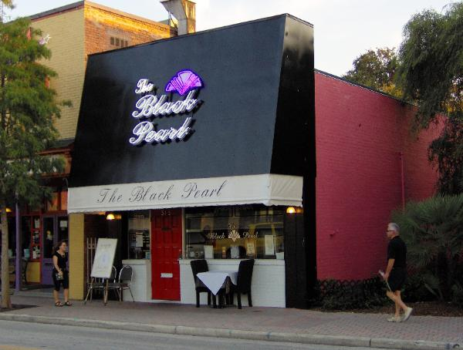Come for the weekend and stay at the Marina Best Western, where you can fish on the dock or rent a bike and ride the Pinellas Trail. Check out the spring events such as the Friday night films in the park, Highland Games on Saturday, April 9, Island Earth Days, and Shark Bite Challenge Canoe/Kayak Race on April 16-17.
The Black Pearl: One of the finest restaurants on both sides of the bay, The Black Pearl is known for its romantic decor and delicate entrees (shrimp and roasted red pepper scampi, New Zealand rack of lamb, veal paillard with vanilla bean sauce). Save room for black licorice ice cream drizzled with raspberry coulis and meringue, flaming hot chocolate cake, or the lemon pavlova with fresh berries.
315 Main St., Dunedin; 727-734-3463
Casa Tina Mexican & Vegetarian Cuisine: Linger for lunch, dinner or brunch at this festive restaurant and sister cafe (Pan Y Vino brick oven pizza and wine bar), where owners hope the "Chili of Cheerfulness forever Chubby your Cheeks." Go with upscale starters such as nachos, ceviche, queso fundido and quesadillas, or begin with the posole and black bean roasted jalapeno soups. Garlicky grilled fish, crabmeat and spinach chalupas, New Mexican-style enchiladas, and chicken mole star here.
369 Main St., Dunedin; 727-734-9226
Dunedin Brewery & Snug Pub: Take the tour, then quaff handcrafted beers (Highland porter debuts in April), rock 'n' roll and pub fare (sliders, crazy quesadilla fillings, real beer-battered onion rings, blackened mahi wrap).
937 Douglas Ave., Dunedin; 727-736-0606
Kelly's For Just about ... Anything: Crazy fun, from the Chic-A-Boom music and martinis to the food, this party palace serves breakfast, lunch, dinner, eclectic entertainment and events (Halloween mash). With rib eyes, Cajun fries, soy-glazed salmon, or smoked chicken salads, chimichurri pork tenderloin or Cornish game hen, this unique menu delivers on taste and style.
319 Main St., Dunedin; 727-736-5284
Living Room On Main: Elegant, eclectic decor and dishes at Living Room on Main include starters/sides such as mango brie quesadilla, grape leave wrapped goat cheese, artichokes broiled in rosemary butter topped with parmesan herb crust and mozzarella cheese, or fingerling potatoes with a smoked gouda gratin. Entrees are equally amazing, especially the braised hoisin pork shanks and fennel chicken tajine.
487 Main St., Dunedin; 727-736-5202
Photo Courtesy of The Black Pearl

Dine, Wine & Foodie Finds
Apr 1st 2011 12:00PM / by Nanette Wiser
Did you take any of last week's cooking classes and upgrade your spring culinary I.Q.? If not, don your toque and visit Rolling Pin Kitchen, Apron's Cooking classes, or Foodies for zucchini, sauce, Mexican, pie, fruity desserts, and Asian dish tuneups. Explore Seminole Heights restaurants by bike, see bartenders compete or drink wine, wine and more wine in Sarasota.
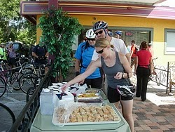HubGrub Bicycle Ride: Explore Seminole Heights restaurants and sights Saturday, April 2, on two wheels. Amble past Lake Roberta, Ella's Americana, Viitals Bakery, New Way Cafe, Ella's Americana, and other neighborhood jewels 2:30pm to 7pm. For information, email alansnel@yahoo.com.
5119 N. Nebraska Ave.
Perfect Pour Competition: Ogle the bikinis poolside while 40 Tampa Bay bartenders compete on who can pour the most perfect Guinness, shamrock on top and more Sunday, April 3, 2pm to 5pm, then tempt lady luck at blackjack at the Seminole Hard Rock Casino Tampa.
5223 N. Orient Road; 1-866-502-PLAY (7529)
Chillounge Night: Brazilian samba parade, tango, flamenco, fashion food and Stella Artois flow at this hip transformation of Curtis Hixon Park into an outdoor nightclub, complete with couches Saturday, April 16, benefiting Friends of Tampa Recreation. The ongoing mobile party is the coolest event in town. $20 in advance, $25 in event.
Curtis Hixon Park, 600 N. Ashley Drive
Enophile Extravaganza: Run, don't walk for your tickets ($15-$200) to the annual 2011 Florida Winefest & Auction benefit in multiple locations around Sarasota. Enjoy new wines from 30 boutique wineries, food and wine seminars, winemaker dinner, beach festival, brunch and charity auction and al fresco wine and food tasting. Foodies, start your purring.
941-952-1109
Photo Courtesy of 2nd Annual HubGrub Ride

Best Eats For Tampa Bay Rays Fans
Mar 31st 2011 12:10PM / by Nanette Wiser
When the Rays whoop the Orioles opening night (Friday, April 1), will you be munching a hot dog slathered in sauerkraut or Dippin' Dots? Expanded dining delights, craft beers, gluten-free dishes and traditional barbecue now grace Tropicana's eateries, should you be tempted in between visiting the Pro Shop, looking at the Ted Williams Museum, and ogling the live rays touch tank.
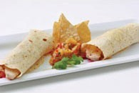What's Cooking: Tampa Bay classic Cuban sandwich, fresh mahi-mahi fish tacos with tropical pineapple salsa, authentic New Orleans Po' Boy or grouper sandwiches, cheesesteaks, burritos, chili cheese fries, fish and chips, garlic fries, corn dogs, grilled Italian sausage, nachos and more.
Healthy Eating: Chicken Caesar salad, grilled panini sandwiches, hummus cups, garden burgers, turkey burgers and pasta.
Returning Foodie Faves: Outback, Checkers, Papa John's, Carvel, and, of course, peanuts, Cracker Jacks, and hot dogs.
Cuesta Rey Cigar Bar: The only cigar bar at a Major League ballpark where you smoke a fine stogie and relax in leather chairs and sofas and watch the game on TV.
The Whitney Bank Club: Watch the game live from the first base line or from any of the dozens of flat-screen televisions. Premium benefits for Whitney Bank Club Season Ticket Holders include an exclusive, all-inclusive buffet, unlimited bar service (beer, wine and soda are complimentary), private restrooms, complimentary parking, and a premium priority number for relocations. Group discounts are available in the Whitney Bank Club for 10 or more people. Call 888-FAN-RAYS for information.
What's New?
The Brewhouse: Sports theme pub menu and handcrafted beers.
Burger Up: Fresh ground burgers (Cuban, mushroom Swiss, bacon blue and old-fashioned).
Everglades BBQ: Formerly the Batter's Eye, the on-site smokers yield mountains of fresh barbecued pork and beef ribs with dozens of sauces to choose from. Now home to the Rays Radio pre- and post-game shows.
GF: Gluten-free ballpark favorites such as hot dogs, pretzels and beer.
Wings Around The World: Cluck about the multi-flavored boneless delights.
Raymond's Little Leaguers: A new kids concession stand in Right Field Street, offers smaller portions at lower prices and several unique items.
Photo Courtesy of the Tampa Bay Rays

Shrimp-ly Delicious Dishes In Tampa
Mar 29th 2011 3:31PM / by Nanette Wiser
If you're working on your bikini bod, shrimp for lunch or dinner saves the day, especially when tossed in a salad, dancing with a filet or topping a mini-portion of spinach fettucine after being sauteed with tomatoes, capers, garlic and onions. Buy wild Gulf or jumbo prawns and put a shrimp kebab on the barbie tonight.
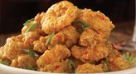Bonefish Grill: Simply the best appetizer ever created and imitated frequently, this bistro's crunchy Bang Bang shrimp (pictured at right) ($5 discount Wednesday) is muy caliente and now available in a Cajun style taco with mango salsa. Coconut crusted shrimp and a lime garlic shrimp concoction with Kalamata olives and feta satisfy the more conservative tastebuds.
Multiple locations in Tampa, Tyrone Mall, Belleair, Clearwater, Palm Harbor and Sarasota
Mid-Peninsula Seafood: This family owned market/restaurant sells wild caught and sustainable farm-raised seafood, as well as homemade soups, salads and other dishes including spicy seafood gumbo (fish, shrimp and shellfish), cooked to order popcorn or jumbo shrimp, oyster/shrimp combo platters and a mouthwatering shrimp scampi. Thursday through Saturday, grab a dozen large fried shrimp and half pound fried sea bass fingers for just $11.99.
400 49th St. S., St. Petersburg; 727-327-8309
Shrimp & Co. Restaurant: Stuff yourself silly with prawns of every style, from the Tarpon Springs to Key West south. Dine on filet stuffed with shrimp scampi, Louisiana steam pot (shrimp, andouille, etc.), shrimp ceviche or shrimp stuffed Mofongo (garlic, mashed green plantain stuffed with Caribbean mojo shrimp washed down by homemade sangria.
2202 E. 7th Ave., Ybor City; 813-374-0192
Z-Grille: Kamikaze cuisine, rock 'n 'roll vibe and tattoo art enhance the taste of unique seafood dishes, especially the spicy jumbo shrimp lettuce wraps with jicama/garlic slaw, shrimp burritos and jasmine rice topped with grilled shrimp and sea scallops, hoisin butter beans, and a lemongrass coconut shiitake sauce.
104 2nd St. S., downtown St. Pete; 727-822-9600
Photo Courtesy of Bonefish Grill

Jade Bistro's Chic Vietnamese Fare
Mar 29th 2011 10:44AM / by Nanette Wiser
Navigating strip malls and snowbird traffic, you may almost miss Pinellas Park's Pan Asian jewel, nestled next to a Mexican money exchange and perfume boutique. Jade Bistro's modern Vietnamese fare blends traditional flavors, unusual dishes and farm fresh vegetables for extraordinary fare with flair. The soothing setting features impeccable service, contemporary modern decor, ethnic lithos hung on warm butterscotch walls, linen tablecloths topped with white paper and ivory pots filled with dozens of savory, spicy sauces. The restaurant is closed on Mondays.
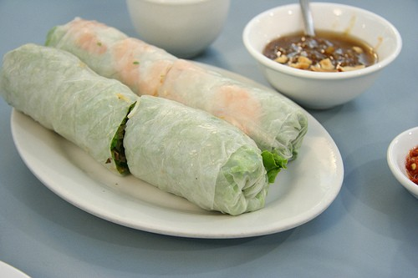Lunch Specials: For $7.95 cash, you can choose from 20 entrees, accompanied by scallion-topped broth swimming with veggie bits and choice of eggroll or fried beef wonton. Try the stir-fried beef or chicken with lemongrass and rice noodles, pork lo mein, peanuty chicken pad thai or spicy fried pan noodles with chicken.
Starters: Dip crisp spring rolls filled with clear vermicelli and vegetables in chili sauce or the shrimp lettuce wraps (mint, basil, carrots) in spicy lime sauce for a flavor explosion. The spicy oyster (garlic, butter, onion) cooked at your table and served with French bread or bacon-wrapped shrimp canapes compete for your attention along with the roasted quail served with fresh lime juice and shrimp and sweet potato tempura.
Soup, Sandwiches & Salads: Traditional pho (rice noodles and beef toppings served in hot beef broth garnished with onions, cilantro) is served with basil, bean sprouts, jalapeno pepper and lime, and is the best soup I've had anywhere, but you do want to try the hot and spicy shrimp mushroom or crabmeat asparagus delight. Share a noodle soup, salads (tamarind beef, grill beef spicy) and bahn mi baguettes (shredded pork, curry chicken).
The Big Event: Skip the appetizers and order family style dishes such as the crunchy pan fried rice noodles with mixed veggies and pork in house sauce; Maine lobster chunks in ginger scallion sauce; the Thang Long-style sizzling fish flavored with baby dill, red onion, roast shallot and peanuts; and the sizzling ginger duck. Chicken, lamb, tofu and seafood round out the menu, each dish a masterpiece of flavor and presentation. Wash it down with a glass of wine or beer or a condensed milk and sweet tea concoction.
Jade Bistro, 6139 Park Blvd., Pinellas Park; 727-544-6186
gpeters, Flickr

Indian Food in Tampa
Mar 28th 2011 1:30PM / by Nanette Wiser
If you are a Bollywood fan, curry some favor with friends and celebrate deliciously pungent Indian cuisine. Explore warm garlic naan bread baked in a tandoori oven, radiant chutneys, spicy chicken vindaloo tamed with raita (cool yogurt) and unforgettable vegetarian dishes.
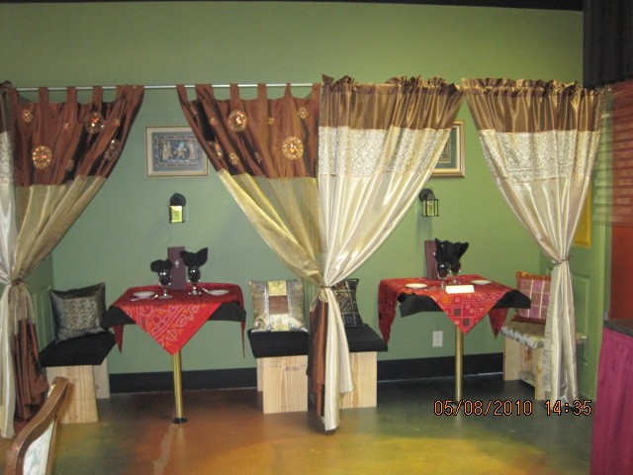Angithi Indian Cuisine: Explore inexpensively with the daily lunch buffet or Tuesday dinner buffet. Best bets are the chicken korma, butter chicken and chicken korma.
2047 Fowler Ave.; 813-979-4889
Bombay Masala Restaurant: Heat up your palate with the garlic naan, chicken vindaloo, tandoori mix platter or vegetable makhanwala accompanied by onion chutney at this no-frills pleasant spot hidden in an unassuming strip mall.
4023 W. Waters Ave.; 813-880-7511
Green Chili Indian Bistro: Simple chic bistro, attentive service and spectacular Indian dishes make for a great date at Green Chili. Start with potatoes and fresh spinach cooked in a tomato broth and cheesy naan, then opt for oniony chicken masala or curry (lamb, beef, shrimp) with a side of fragrant jasmine rice studded with raisins and nuts. Sip mango lassi, a lightly sweetened mango drink to cut the burn.
310 Central Ave., downtown St. Pete; 727-894-3663
Taste of Punjab: Charming restaurant, succulent lunch buffet and outstanding biryani (shrimp, chicken, lamb, goat or beef), savory lentil soup and dozens of naan and vegan dishes. Best of show are the curries, tandoori chicken or fish tikka, lamb korma and shrimp vindaloo. Condiments accent the flavors, especially the papad, tamarind, mango, mint and onion chutneys.
6540 Park Blvd., Pinellas Park; 727-545-4103
Taj Indian Cusine: A 20-year favorite, Taj serves traditional lamb vindaloo, spicy chicken tika, tandoori and curry dishes as well as goat and keema matar (ground beef cooked with spring peas, onion and chopped spinach). A convenient buffet caters to the lunch crowd.
2734 E. Fowler Ave.; 813-971-8483
Photo courtesy of Green Chili Indian Bistro

Italian Cuisine at Rigatoni's Tuscan Oven
Mar 25th 2011 1:07PM / by Nanette Wiser
Downtown Tampa's taste of Tuscany begins at Rigatoni's Tuscan Oven where generous portions and casual style go hand in hand. Serving lunch and dinner daily, owners Sonia and Rick Barcena's comforting family recipes range from traditional spaghetti to hearty meatball subs as well as classic Tuscan sandwiches (whole roasted garlic, turkey and ham) served with cold pasta salad. The restaurant features an outstanding wine list, sangria and Italian beers (Peroni) as well as dessert flights.
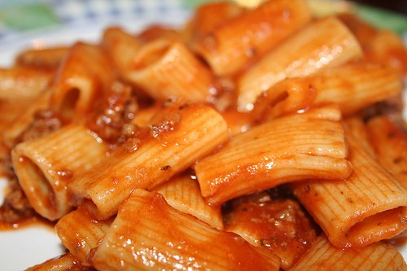Starters: Kick it off with Tuscan grilled oysters or lightly breaded soft shell crab, accompanied by the garlic knots or bruschetta. Greenies love the sautéed chicken, sun-dried tomato and mozzarella cheese spring mix salad or the robust Caesar.
The Main Event: Tuscan sea bass sautéed in lemon butter, lobster ravioli, Tuscan seafood casserole, shrimp and lobster cannelloni, calamari diabolo or Tuscan seafood paella will please fish aficionados. Ravioli, baked ziti, lasagna and other pasta dishes shine, especially the penne with fresh tomatos, capers, olives, sausage, garlic and fresh basil are stand-outs. Veal and chicken can be ordered piccata, marsala or parmesan and come with pasta and herbed garlic knots, irresistible. Save room for the flan or mini-cream puffs.
Healthy Choices: In addition to gluten-free dishes, munch on the low-crab pizzas , especially the gourmet tomato and feta or spinach and feta pies.
Special Savings: During the week, Rigatoni's offers specials such as All U Can Eat Snow Crab Legs (Sunday, Wednesday), 2-for-1 drinks daily and music (Jose Mariscal Sunday and Friday, 6pm to 9pm; live karaoke Saturday night).
Party Hearty: And, if you've got a special occasion such as a rehearsal dinner, weddings, office function or birthday party, you can book one of the two beautiful banquet rooms -- The Castle or The Verandah. Rigatoni's offers catering menus for its banquet rooms or off-premise events, with an outstanding catering service department that handles all your needs.
Rigatoni's Tuscan Oven, 3437 W. Kennedy Blvd.; 813-879-700

Dine, Wine & Foodie Finds in Tampa
Mar 25th 2011 11:07AM / by Nanette Wiser
In addition to this weekend's Honda Grand Prix, Cigar City Brewing's Criterium & Festival (food/beer garden, bike race/tricks) and Gasparilla Film Festival, you can nosh and sip for a good cause as well as shop the Pinellas Park farmers market Saturday since downtown St. Pete's is on hiatus because of the race.
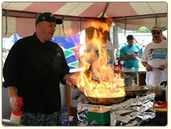Brewski Breakfast: Eggs-actly what you need at 9am on Saturday, March 26, beer and flapjacks, auction sponsored by Sun Coast Law Enforcement Charities to benefit families of fallen officers.
Mandarin Hide, 231 Central Ave., downtown St. Pete; 727-537-0208
Casks for a Cause: Support Whole Foods' Whole Planet Foundation Saturday (March 26) from 2pm to 6pm at Tampa Bay Brewing Company where craft beers, beer-inspired grilled dishes and live music supports micro-enterprise loan programs and training in 3rd world countries. $10/person
Whole Foods, 1548 N. Dale Mabry Hwy.; 813-874-9435
Tampa Bay Brewing Company, 1600 E. 8th Ave., Ybor City; 813-247-1422
Pet Grapes: Cru Cellars' blind wine tasting raises money for We Care for Paws Foundation Saturday, March 26, from 7pm to 9pm. Next Wednesday, March 30, Tower Club's ZOOshi benefits Lowry Park Zoo with complimentary cocktails and apps, plus door prizes and live entertainment from 5pm to 7pm at Kona Grill.
Cru Cellars, 2506 S. MacDill Ave.; 727-479-6345
Kona Grill, 4134 W. Boy Scout Blvd.; 813-877-5938
Taste of Pinellas: If you want to sample a new restaurant cheaply, the annual All Children's Hospital fundraiser is the place to be for just $10/day. Tickets go on sale at Ticketmaster for Chris Isaak and Josh Turner (May 20); Bonnie Raitt and Buddy Guy (May 21); and Third Eye Blind and Colbie Caillat (May 22). Golden Circle Seating tix include premium seating near the stage, $40 of food and beverage coupons, a speed pass to skip the lines at the great restaurants and a 2011 Taste of Pinellas T-shirt ($150/person).
Vinoy Park, downtown St. Pete
Tampa Bay Culinary Club: Reservations are required for this monthly foodie gathering on Saturday, April 2, at 3pm with Chef Tony Bruno's cooking demonstration.
$10/person
Dunedin Smokehouse, 680 Main St., Dunedin; 727-789-2605

Enjoy Spanish Tapas in Tampa Bay
Mar 23rd 2011 11:15AM / by Nanette Wiser
Bullfighting, manchego cheese, Rioja wines and flamenco are some of Spain's best imports. Tampa Bay boasts a diverse Spanish population, purveying Cuban food, South American empanadas and other south of the border sensations. If you love Columbia Restaurant's authentic Spanish cuisine, then these tapas will delight you.
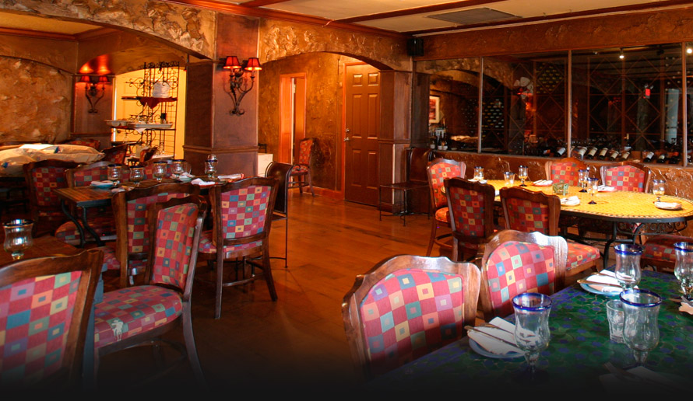Ceviche Tapas Bar & Restaurant: Popular hangout with additional locations in Sarasota and Orlando, the Barcelona decor and classy bar's Tapas Tuesday (30 tapas, sangria special $4 or less) overflows with beautiful people. Best bets are the vegetable tapas (sauteed spinach with fig, honey and garlic or portabello mushrooms stuffed with spinach or manchego cheese, meat tapas ( braised oxtail, pesto marinated chicken breast in a Spanish sherry cream sauce) and seafood (grilled sea scallops, sauteed little neck clams with chorizo and tomatoes). Paella, ceviche, salads and killer desserts (meringue cake with fresh cream and nutmeg) star as well.
2109 Bayshore Blvd.; 813-250-0134
10 Beach Drive, downtown St. Pete; 727-209-2299
22930 Gulf to Bay Blvd., Clearwater; 727-799-3082
La Teresita: Enjoy lunch or dinner and stop by the bakery for sweets and treats to take home. Dip into the Spanish beef stew, chicken and yellow rice, black beans, shrimp in garlic sauce, picadillo (ground beef in sauce and grilled skirt steak) but save room for the cream cheese flan.
3248 W. Columbus Drive; 813-879-9704
Tapas Garden Bistro & Wine Bar: Just like dining in a beautiful Spanish pensione, this jewel features a garden patio, exquisitely decorated intimate dining room and a friendly bar where tapas and Tattinger flow, especially during happy hour 3:30pm to 5:30pm daily. Start with the lobster escargot and Chef Randy's garlicky mussels or duck and chicken liver pate. You can share appetizers for an entree, such as the tenderloin salteado and small filet mignon with portabello mushrooms and Maytag blue butter or go for the saffron-infused paella Valenciana. Just nibbling? Order the homemade potato chips or artichokes with crispy Serrano ham.
321 Gulf Blvd., Indian Rocks Beach; 727-595-4321
Toma Bar: Graze on amazing tapas such as fried squid in red marinara sauce, pork, scallion and water chestnut rolls with sweet and sour sauce or pimentos stuffed with crab meat and shrimp but save room for the extraordinary paella.
513 Tampa St.; 813-223-2831
Photo Courtesy of Ceviche

Honda Grand Prix St. Petersburg Revs Up
Mar 22nd 2011 1:30PM / by Nanette Wiser
The world's fastest spring break party, the Honda Grand Prix, speeds into downtown St. Petersburg March 25-27 following the Festival of States Parade on March 24 (7pm). On Sunday, Honda Grand Prix Grand Marshall and Lightnings' legend Vinny Lecavalier will command the finalists, "Gentlemen, start your engines" while the world (and spectators) hold their breath. Mega-yachts, celebrities and racing enthusiasts flock to this world-class event rivaling Monte Carlos. Nightclubs such as Push Ultra Lounge and Jannus Live feature the pit row of partying.
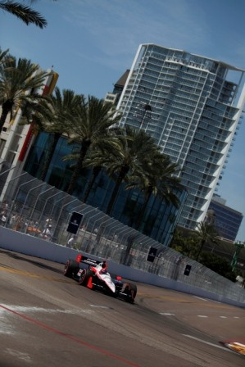Spectator FYI: Motorheads with moolah rent a spot for the RV or opt for an expensive V.I.P. tailgate tent spot. Gates open 8am to 6pm. Gate 1 is located at 1st Avenue S. and 1st Street S.; Gate 5 is located at 5th Avenue S. and 2nd Street N. Both offer on-site ticket sales. No food or drink may be brought in, so enjoy the beer garden and food kiosks dotting the racetrack. Comfortable shoes, ear plugs and sunscreen are must-haves. Click here for the schedule.
Family Fun: Visit the interactive displays and racing simulators at The Bright House Networks Speed Zone, which is located near turns 5 and 6 and the Firestone Bridge. Pit paddocks are open to all spectators (Firestone Indy Lights, Star Mazda, USF 2000, World Challenge). Enjoy live music, driver autograph sessions and a massive Ferris wheel.
Parking: Public parking is available nearby in metered spaces or city-owned garages. City parking garages will charge a $10 all-day event rate. Garages include South Core (enter from the north side of 1st Avenue S. between 2nd and 1st Streets) or the BayWalk Garage (enter from 2nd Street N. between 1st and 2nd avenues N.)
Photo Courtesy of Honda Grand Prix of St. Petersburg

Spring Break 2011 Hangouts
Mar 22nd 2011 11:23AM / by Nanette Wiser
They're baaaack! March madness translates to waves of spring breakers thronging the beaches and bars 24/7, from downtown (The Local 662, Jannus Landing, State Theater) to Clearwater (Shepherd's and Frenchy's). Catch thongs and shots at these hot spots. Need a ride? Jimmie's Free Local Rides runs the beach daily from 9pm - 2am, tips appreciated (727-217-6935).
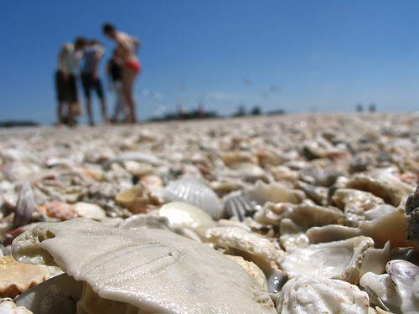Beach Bar: Revel in the heart of spring break magic on Clearwater Beach at this popular watering hole featuring 73 beers, a full liquor bar and menu, and drink specials.
454 Mandalay Bay, Clearwater Beach; 727-447-4100
Caddy's On The Beach: Big fun, huge crowds, massive foofoo frozen cocktails rule a Caddy's where the live music beats from 1pm to 10pm daily. Ogle the crowd from the rooftop bar, picnic on barbecue and burgers on the beach or rent a cabana. You can bring chairs, but no coolers.
9000 W. Gulf Blvd., Sunset Beach; 727-360-4993
Gators Cafe & Saloon: Drink deals, live music, games, Florida kitsch and oodles of decks overlook John's Pass, and you can wave at your pals across the bay at Hooter's and Bubba Gump's. With 25 beers on tap, happy hour runs 11am - 7pm daily ($1 domestic drafts, $3 Smirnoff vodka) and on Thursday, ladies drink for a buck. Build your own burger and hop on the Florida cuisine bandwagon with gator nuggets or frog legs.
12754 Kingfish Drive, Treasure Island; 727-367-8951
Jimmy B's Beach Bar: King of tikis, Jimmy B's music kicks off 3:30pm daily with midnight madness drink specials Sunday through Thursday from 11:30am to 3pm. Multi-decks overlook the Gulf, and its signature Wet Spot (pina colada, blueberry liqueur, rum, blue curacao) makes for a perfect sunset libation. Feed your party animal Caribbean jerk chicken wings, beer battered grouper fingers, panini or pizza, then dance the day/night away.
6200 Gulf Blvd., St. Pete Beach; 727-367-1902
Sloppy Pelican: With rum runners $5 all day, college night Thursday amps up with $1 drafts, $10 beer towers, beer pong tourneys and Blind's Pass waterviews at the Sloppy. Soak up the suds with boneless garlic parm chicken wings, coconut-crusted mahi fingers and ahi or roast beef wraps. Catch Billy Agans Wednesday nights.
677 75th Ave., St. Pete Beach; 727-360-7100
jonny.hunter, Flickr

Today's Happy Hour: Taps Wine & Beer Merchants
Mar 21st 2011 1:41PM / by Nanette Wiser
Happy hour and wine go together like a horse and carriage, and when it comes to wine by the glass and upscale small plates, Taps Wine & Beer Merchants should be your first choice. Beer drinkers get equal opportunity here, with dozens of brews on tap and dozens of boutique bottle beers to quaff.
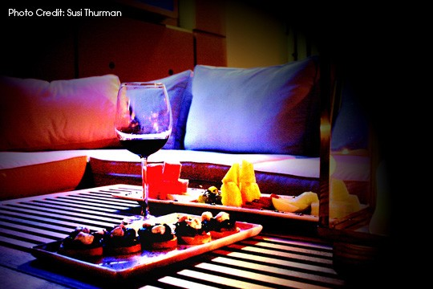The Skinny: Perched in the ground floor of downtown Tampa's Skypoint condo tower, this hip lounge complete with couches, settees and chic contemporary lighting is all the rage as is the al fresco seating. Belly up to the bar or perch on an oversized black and white cow patterned footstool and peruse the trendy menu.
Starters: Share the artisan cheese plate or the prosciutto, basil and buffalo mozzarella bruschetta. Spice lovers gravitate to the smoky adobo guacamole, black and white bean dip trio or the chipotle apricot barbecue chicken sandwich with roasted garlic mayo on grilled sliced ciabatta.
Lunch: Seafood fans can lightly dine on the Far East Coast sesame ahi tuna salad, lemon-roasted salmon salad, warm lump crab and artichoke dip, shrimp cocktail or Mediterranean tuna salad sandwich. Dinner ramps up the seaworthy plates, including the curried salmon tartare, ahi tuna summer roll and crab and ricotta tortelloni.
Best Bet: Enjoy the prosciutto-wrapped asparagus followed by the roast beef sliders au jus, topped off by the chocolate lava cake or skewered apple wedges with warm caramel and peanuts.
Beer Buffs: Order up a hot pretzel slathered in spicy mustard. That's easy, compared with deciding whether it will be a pilsner or IPA for round one. MY favorites on tap include Dogfish Head IPA, Spaten Octoberfest, Old Chub Scottish Ale, Ship Yard Pumpkin Ale, Sierra Nevada Pale Ale, Full Sail Amber Ale and that's just on draft. If you like a bottle beer, you can take a mixed case home.
Groovy Grapes: Super glass and bottle list. California's best vineyards strut their stuff here, especially Franciscan Magnificat, Seina Ferrari Carano, Cakebread, Silver Oak, Duckhorn, Merryvale, Mollydooker Scooter, Layer Cake and other robust reds and succulent whites.
Taps Wine & Beer Merchants, 777 N. Ashley Drive; 813-463-1968
Photo by Susi Thurman

Dine, Wine & Foodie Finds in Tampa
Mar 18th 2011 11:00AM / by Nanette Wiser
Spring ushers in adventures in cooking, including experimenting with new dishes and cuisines as well as oodles of yummy events celebrating the bounty of Tampa Bay.
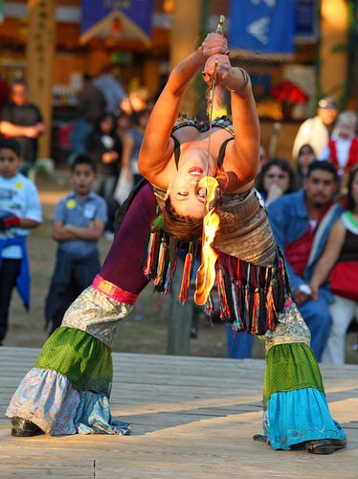
2011 Bay Area Renaissance Festival at MOSI: From now through April 17, this ongoing weekend extravaganza is the place to be. During March 18-20, the Chocolate, Wine & Romance Festival will feature free wine and chocolate tastings, free vow renewals, a grape stomp, glorious finger foot (turkey drumstick, mini corn dogs, fried mac n' cheese) and a couples pie-eating contest.
Festival Hotline: 813-983-0111
MOSI, 4801 E. Fowler Ave.; 813-987-6000
Chalktail Party: Life after St. Patrick's Day continues with this Hyde Park Village kick-off celebration today, Friday March 18 (4pm to 9pm) with a day full of sidewalk art-making followed by live music (Ben Bryan Band, Nunes at Night) as well as drink specials from Blue Moon Beer and Barefoot Wine & Bubbly. The fun continues all weekend long, with food vendors, crafts booth, children's activities, face-painting, Lowery Park zoo animals, an Elmo sighting and more.
Hyde Park Village; 813-221-2787
Nights in the Garden of Spain: Belleair Rotary raises money for charity with tapas, a wine tasting party and casino fun on March 24 (6pm to 9pm) at the Largo Cultural Center (Central Park Drive).
Belleair Rotary; 727-251-8277
Herbalious: If you spent Saturday shopping for herbs and Sunday planting them, you'll be ready to discover what wines mate best with herb-infused dishes and why at this fun cooking class Friday, March 25 (6:30pm).
Rolling Pin Kitchen Emporium, 2080 Badlands Drive, Brandon; 813-653-2418
Indian Delights: Feeling like curry? Whip up Fine Indian Cuisine favorites such as samosa and chicken tikka masala March 25-27, or sign up for Green Chili's Indian cooking class for Saturday, March 19 (noon to 2pm).
Fine Indian Cuisine, 4063 Daventry Lane, Palm Harbor; 727-667-8369
Green Chili Indian Bistro, 310 Central Ave., downtown St. Pete; 727-898-2783
Alaskan Dude, Flickr

Tampa Mobile Meals Can Bring Lunch, Dinner to You
Mar 17th 2011 1:44PM / by Nanette Wiser
Need lunch or dinner brought to you? Mobile Meals delivers delicious meals from restaurants in Tampa, Brandon, Lithia, North Tampa, South Tampa and downtown. Brandon residents Jennifer Mekdeci and Christopher Shelton founded Mobile Meals for those who crave more unique, less traditional fare from more upscale restaurants. Entrepreneurs run in the family; her grandfather owns Sabal Homes and her grandmother is the owner of the oldest real estate business in Brandon.
The Skinny: There's no food markup, just a $3.99 delivery charge per restaurant for most participating restaurants, but with some exception, such as Estela's Mexican ($1.99). This is especially useful for planning business luncheons or meetings, and a great morale booster for employees who are tired of Panera or pizza. It's a boost for busy families, working single parents and seniors who may not want to drive at night.
Restaurants To Go: Beef O'Brady's, Bonefish, California Pizza Kitchen, Cheesecake Factory, Hooters, Lee Roy Selmon's, Macaroni Grill, Maggiano's Little Italy, Olive Garden, Outback Steakhouse, P.F. Chang's, Red Lobster and Ruby Tuesday, Taste of India, Tokai Sushi, Louis Pappas, O'Toole's Irish Pub, Ploy Thai, BubbaQue's, Caribbean Crown West Indian, China City and China Palace, Acropolis, Café European.
Discounts: Best of all are the daily and weekly specials on food, free delivery and the addition of new restaurants to the mobile meal menu monthly.
Mobile Meals, Tampa; 813-907-MEAL
Photo Courtesy of Mobile Meals

Dine, Wine & Foodie Finds
Mar 15th 2011 1:11PM / by Nanette Wiser
Fill up on corned beef this week, and remember not to drive and drink green beer. In between, you can sample chili for a good cause and hobnob with arty types who like a drink deal.
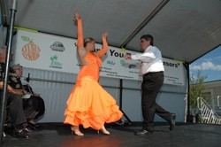Irish Toasts: On Thursday, March 17, Dunedin's St. Patrick's Festival kicks off 11am and goes to 11pm at Flanagan's Irish Pub and will feature the Irish Step Dancers, Dunedin Pipe Band, and traditional Irish fare. O'Houston's starts its bash at 11am with dancers, fiddlers, bagpipes, Jello shots, contests and more.
Flanagan's Irish Pub, 465 Main St., Dunedin; 727-736-4994
O'Houston's, 518 W. Bay Drive, Largo; 727-584-7772
Chilly? Eat Chili: Quaker Steak & Lube's bike night (Wednesday) and classic car show (Thursday) draw the motorheads, downing chicken wings and trading tips. On Saturday, March 19 (11am to 3pm), $5 gets you a tasting kit to sample the chili cookoff and enjoy smokin' blues music, all to benefit Tannehill Children's Education Fund.
10400 48th St. N., Clearwater; 727-572-9464
Country Charm: Saturday, March 19, from 10am to 10pm, this annual favorite boot-scooting outdoor festival features local and nationally known acts, arts, crafts, pony rides, car show and yummy gyros, ribs, burgers, ice cream and other goodies for sale. Free.
England Brothers Band Shell, Town Square Plaza Park, 5010 81st Ave. N, Pinellas Park; 727-541-0805
Culture & Cocktails: Every Friday night from 5pm to 7pm, the classy Tampa Museum of Art's Sono Cafe hosts happy hour on the terrace including free admission to the museum, two-for-one appetizers and creative drink deals. Young professionals and arts lovers mingle like rock stars.
Tampa Museum of Art, Curtis Hixon Park; 813-253-6473
Photo Courtesy of Palm Harbor Citrus Festival

Savannah's Cafe Serves Up Southern Comfort Food
Mar 15th 2011 10:37AM / by Nanette Wiser
If you love Southern cuisine, collards and sweet tea, this Grand Central District haven is your lunch and dinner mecca. Commence to eating, and when you've wiped up the gravy with your biscuit, explore the antique and art shops dotting this charming neighborhood.
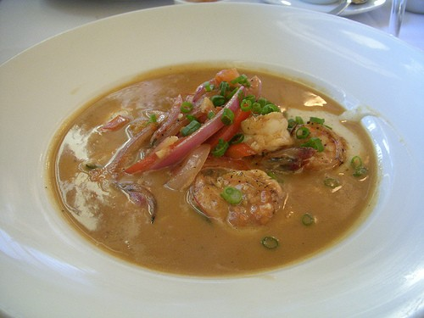The Skinny: This is comfort food, served with Southern hospitality at its best. Lowcountry favorites include jumbo crab cakes, shrimp and grits, Grandma's meatloaf, homemade corn bread and roast chickory coffee that even appears rubbed on the beef ribeye (along with Applewood smoked bacon and shallot compote). Enjoy Sunday brunch, a fab wine list (half-price wine Wednesday bottle), two outdoor patios, ample parking and down home decor.
Starters: Paula Deen fans willl love the seafood stuffed herb-marinated portobello mushroom drizzled in Creole sauce, Low Country eggrolls (Tasso ham, chicken and fresh collard greens stuffed) served with peach chutney sauce and fried green tomatoes finished with goat cheese in pecans. Get liquored up with the Kentucky bourbon pan steamed mussels savory with Andouille sausage and roasted garlic.
Sides & Salads: Make sure he orders the lump crab corn chowder and share tastes of your cucumber mint salad with baby arugula sprinkled with toasted sunflower seeds. Or share the fried pecan crusted chicken chopped salad with smokey barbecue vinaigrette and yes, more crisp bacon, a Southern staple.
Vegan Heaven: So many farm-fresh choices, best of show are the grilled vegetable casserole (zucchini, squash, tomato, parmesan cheese), the black bean portobello burger with cumin sour cream, sweet potato shoestring potatoes, magnificent collard greens, and fresh vegetable wrap.
True Grit: Traditional dishes done right include the corn and oyster fritters, Mississippi fried catfish with remoulade sauce, buttermilk fried chicken stuffed with herbed goat cheese, Carolina pulled pork Napoleon with a brandy wild mushoroom ragout and the po' boys (fried oysters, catfish, chicken or shrimp). Save room for the huge Southern desserts.
Savannah's Cafe, 1113 Central Ave., downtown St. Pete; 727-388-4371
Navin75, Flickr

True or False? Test Your Tampa History I.Q.
Mar 14th 2011 2:35PM / by Nanette Wiser
Tampa has a rich and strange history. Entertain your know-it-all friends and out-of-town visitors with our myth-busting quiz about local legends.
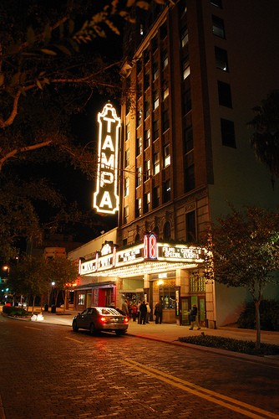Famed Jose Gaspar: This larger-than-life dude inspired the Gasparilla Festival. Supposedly from a wealthy family, he graduated from the Royal Naval Academy until he upset the Spanish government and sought out like-minded sailors and hoisted the Jolly Roger pirate flag. Gaspar and his crew terrorized Spanish vessels for 20 years and looted 400 ships. He vowed to never be taken captive. This vow drove him to tie an anchor chain around his neck and jump overboard while being pursued by a U.S. Navy frigate. (It's true!)
Tampa's Missing Link: An enormous skeleton of a fish head, sporting foot-long fangs washes up on the beach and a photograph surfaces on the Internet circa 2006. This thing looks like a cross between a dragon and a triceratops. (It's as fake as Jurassic Park.)
Haunted Hops: The old Tampa Brewery is still home to a patron who died after an argument about a beer and now haunts a law firm in the building. Employees say the ghost is jolly enough, laughing and muttering late at night, sometimes chattering with a Spanish accent. (Ghostbusters requested for arbitration, with or without a pint for the inebriated spirit.)
Movie Buffs Never Die: The famous Tampa Theatre is still haunted by Foster Fink, their one-time projectionist. Fink manned his post in the projection booth from 1930 to 1965, when he suffered a heart attack and died in the booth. Apparently, he thinks the theater still needs his help. Fink opens doors, moves items and shuts off the power. (A 1984 seance confirmed the presence of a spirit.)
Love Bugs: Natural occurrence, outer space visitors, or over-sexed biological experiment gone terribly wrong? (Nope, a 1920 guest from South America to New Orleans, then Florida visitor since 1947, not a Florida State science mistake.)
gordontarpley, Flickr

Greek Cuisine in Tampa Bay
Mar 14th 2011 11:00AM / by Nanette Wiser
Health experts boast Mediterranean cuisine translates to long life, slim waistlines. From Tarpon Springs' Greek community evolves dozens of gracious Greek restaurants, some with belly dancing and nightclub, others with artful platters of lamb chops, lemony Greek potatoes, pita, feta, olives and tzatziki. With Greek Independence Day right around the corner (Friday, March 25), now is the time to celebrate with taramosalata and horiatiki salad. Opa!
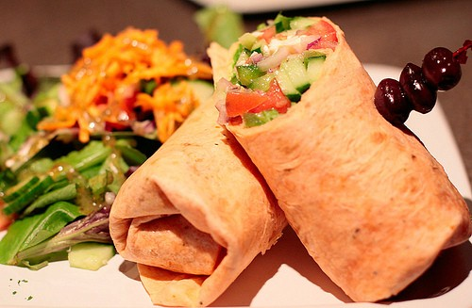Acropolis Greek Taverna: Immerse yourself in the outstanding cuisine, Lolonis wine, sophisticated decor, and high-energy Greek experience (belly dancing, plate breaking, napkin throwing, Zorba dancing) and Athens-like nightclub. Traditional dishes feature moussaka, pastitsio, spanakopita, gyros and chicken souvlaki, but it's the drunken wine sauced chargrilled quail and shrimp sauteed in lemon wine sauce that steal Zeus's thunder. Enjoy two for one margaritas and sangria all day long.
515 Central Ave., downtown St Pete; 727-823-1010
1833 E. Seventh Ave.; 813-242-4545
14947 Bruce B Downs Blvd.; 813-971-1787
6108 Winthrop Town Center, Riverview; 813-654-2255
Athenian Gardens: From the starters (chargrilled octopus, spinach tiropitas) to the desserts (baklava, cinnamony rice pudding), every dish here smells and tastes like manna for the gods. You won't be able to finish the exotic gyro platter, grilled grouper, charbroiled lamb chops and souvlaki (chicken or beef). The ample booths, horseshoe-shaped bar and attentive service add to the charm.
12670 Starkey Road, Largo; 727-518-888
Gogos Greek Grill: Fresh and healthy is the catch of the day at this Olympus haven. Enjoy a salad (low-carb or regular) or sandwich (pita or wrap), then select your stuffing (savory chicken, steak, pork, gyro, Greek or Mediterranean veggies) and top with lettuce, tomato, cukes, onion, black olives or sliced pepperocini and splash it with Greek vinaigrette, spicy tzatziki or other dresses. Best sides are the potato salad, Greek lemon potatoes, hummus and feta.
4616 W. Kennedy Blvd.; 813-289-4646
2716 E. Fowler Ave.; 813-868-4646
Mythos Greek Taverna: Waterfront dining, belly dancing and live music Saturday night serves your Bacchanalian spirit, especially the free happy hour buffet from 5pm to 7pm and live music.
13575 58th St. N., Clearwater; 727-538-4273
waferboard, Flickr

Start the Weekend with Dinner and Dancing
Mar 11th 2011 1:18PM / by Nanette Wiser
Night owls, rejoice. In addition to the premiere Hard Rock Cafe and Blue Martini Lounge, Tampa Bay serves up dinner and dancing from disco to two-stepping. In the mood for a romantic supper and sashay, sail Starlite Cruises. Check out these hotspots where you can shake your booty after fueling up.
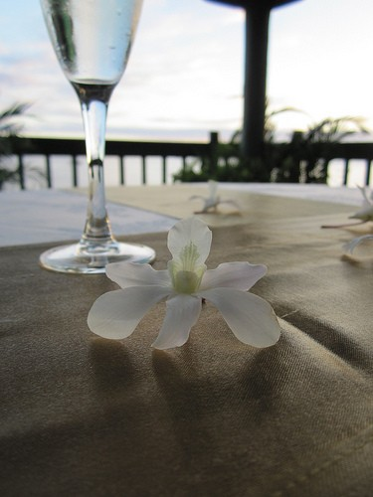Dallas Bull: Whether it's a hot country band or top country stars (Bellamy Brothers), the purtiest bartenders and servers on the planet make sure you have a rootin' tootin' time at Dallas Bull. Free line dancing Wednesday through Saturday 7:30pm to 9:30pm, then the real deal two-steps in. Even Kenny Chesney stops in! Enjoy $3 Southern Comfort and $2.50 Bud and Bud Lights, free mechanical bull rides and karaoke in Jack Daniels Lounge. Next door, you can grab a burger or hotdog before meeting the cowboy of your dreams.
3322 N. U.S. 301; 813-987-2855
Jackson's Bistro: Upscale Jackson's Bistro is the place to dance the night away on Friday and Saturday night. Fantasy Fridays serves up a mélange of tunes, from house music to the best of the 80s and 90s. Book a V.I.P. or cabana spot, and ogle the beautiful people. Saturday sexes it up with South Beach Latin swank style.
601 S. Harbour Blvd.; 813-277-0112
Skipper's Smokehouse: This remote Tampa hideaway is legendary for its Floribbean flavor, communal benches and beachy fare as well as for its blues, world beat, reggae and rock groups/concerts as well as the eververscent Grateful Dead tribute band. Munch crab-stuffed mushrooms, gator tail, smoked fish dip, fried okra and Cajun popcorn, or go full hog with the barbecue ribs or crab cakes and hush puppies.
910 Skipper Road; 813-971-0666
The Venue: Chef Robert Uzzillia's two restaurants thrill the palate, and this nightclub's elegant hipness smells of Vegas, baby. Linger at Viaggio (steak, seafood and tapas with Mediterranean and Asian influence) and Takara (sushi), then dance the night away at 10pm enjoying SIN night Monday, Latin night Thursday, Absolut Ladies night (no cover) Friday and Ketel Saturday. Revelers discover multitiers of experience, best reserved in advance, including bottle service and skyboxes overlooking the martini atrium.
2675 Ulmerton Road, Clearwater; 727-571-2222

Tonight's Dinner: Steaks at Spoto's Grill 131
Mar 10th 2011 5:05PM / by Nanette Wiser
When legendary Spoto's on Park Street closed, you could hear the meat lovers moan, then cheer at the opening of Spoto's 161 in Seminole, rated Tampa's best steakhouse by the St. Pete Times in 2009.
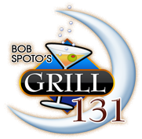The elegant lounge hosts live pop music Wednesday, Thursday and Friday, illuminated by arty lighting and flickering candles. Casual modern classic decor reverberates through the restaurant, sleekly designed and staffed by attentive servers.
Wine specials and a robust 4pm to 6:30pm happy hour entices locals, especially the Rubbino Libaio unoaked Chardonnay and berrylicious Joel Gott Cabernet Sauvignon. Monster martinis, dirty or fruity, match well with the appetizers, especially the Maryland crab cakes, baked brie en croute, beef carpaccio and roasted garlic sauteed Prince Island mussels.
Early bird dinners from 4pm to 6pm give you an affordable taste of the menu, especially the braised lamb shank, shrimp and pasta pomodoro, golden pork shnitzel and pan-roasted sherry butter sauced tilapia, ranging from $12 to $15.
Seafood, prime rib and steaks star here. Start with the trio of bluefin tuna sashimi and a Caesar salad with Parmesan crisp. Neptune aficionados appreciate the pan-roased Chilean sea bass with orange-ginger beurre blanc or sweet chili glazed red snapper. Add a broiled lobster tail to the filet of beef tenderloin with Bernaise sauce for the perfect surf and turf.
Entrees come with soup or salad and crusty bread and sweet farm butter. Prime rib, porterhouse, New York strip and rib eye compete for your main choice with tangerine-cilantro glazed duck, bacon-wrapped pork filet mignon with Dijon rosemary cream and home-style meatloaf that melts in your mouth. Save room for the flaming desserts (cherry jubilee, banana foster, apple crepe Suzette) or chocolate Kahlua pecan pie.
13079 Park Blvd N., Seminole; 727-393-1703
Photo Courtesy of Spoto's Grill 131

Spring Break: Tampa Bay Road Trips
Mar 10th 2011 1:15PM / by Nanette Wiser
The weather is beautiful and your sunroof needs opening. Explore Gulf Coast Florida lifestyle. Load up the car with a cooler (water, ice tea), great tunes and overnight bag. Point the car north, or south with only one goal: where to lunch, sip and supper. After that, any cheap motel will do and many resorts offer Florida resident specials, even Walt Disney World. One tank of gas, one great adventure.
St. Pete Beach: Great beaches, tons of tikis. Head over to Jimmy's B's for outdoor dancing and banana pina coladas, then rock the Sirata' hammocks and party at Harry's. At night, grab a cab downtown and check out downtown's new urban chic from Jannus Live and Detroit Liquors to Ruby's Elixir and Push Ultra Lounge.
Caliente: Just north of Tampa and technically, a nudist resort but clothing is optional and the music/party scene is amazing on weekends, and open to the bikini beautiful public. Great food, cheap drinks. Skinny dipping Sunday is all the rage, replacing Shephards in Clearwater Beach as the place to be scened!
Crystal River & Homosassa: Old Florida at its best, complete with manatee watching, fishing, river airboat explorations, golfing, kayaking, and during August snorkeling and scalloping season is not to be missed. Brunch at Plantation Inn and Golf Resort, then tour dozens of tiki bars along Crystal River.
Caladesi Island, Florida: An unspoiled sanctuary and America's No. 1 Beach 2008 after Ft. De Soto lost its tiara to this sugar sand star near Dunedin. Nature trails and family oriented nature center and not much else other than picnics on the beach or in shelters. Caladesi Island Ferry (727-734-1501) departs from Honeymoon Island State Park to Caladesi, where you can surf fish, shell, kayak, dock your boat at the marina and cruise the snack and gift shop.
Anna Marie Island, Florida: North of Bradenton and Sarasota, locals know to head over to the talcum powder sands outside the SandBar. By noon, yachts are moored, boat drinks are hoisted, and mahi and burgers are served on the patio. Stay at Anna Marie Cottages just steps from Anna Maria's beaches, and grab dinner nearby at Waterfront or Rotten Ralphs, or down Longboat Key to top Zagat's pick, Euphemia Haye.
Photo Courtesy of Anna Marie Chamber of Commerce

Revel and Dine on St. Patrick's Day 2011
Mar 9th 2011 1:00PM / by Nanette Wiser
Everyone's Irish on St. Patrick's Day and corned beef becomes foie gras to emerald-sprouting party animals. A new St. Pete Beach Irish bar opens just in time to celebrate green beer, Paddy O'Sullivan's. From O'Keefe's to Kelly's, every bar worth its margarita salt will serve food and Irish drink specials. Get lucky at these great Irish spots.
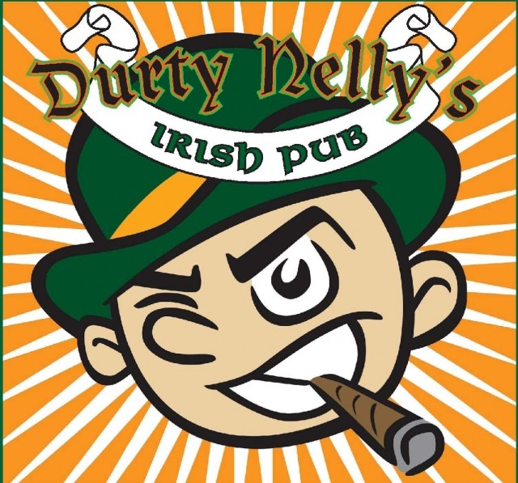Courigan's Irish Pub: Courigan's boisterous no-cover block party (March 17) features live entertainment outside, cash bar, $7 Car Bombs, $5 Irish beers and Irish pub fare such as corned beef and cabbage, shepherd's pie and Irish potato stew.
1 Beach Drive S.E., St. Petersburg; 727-551-9019
Dubliner Irish Pub: The North Tampa favorite celebrates St. Puppy's Day (Saturday, March 12) with an Irish brunch, costume doggie parade and Irish dancers. Both pubs feature authentic dishes and beer-infused delights, such as the Guinness stout wings, Ploughman's Platter (cheese, meats), beer-battered fish and chips, and extraordinary corned beef-cabbage and shepherd's pie.
2307 W. Azeele St., South Tampa; 813-258-2257
12836 Henderson Road, North Tampa; 813-300-2076
Durty Nelly's Irish Pub: Sip Tullamore Dew Irish whiskey at this popular indie music bar showcasing Not Tonight Josephine, Eye Empire, Renegade Strand, Boats-N-Hoes, and other bands from 11am to 7 pm. (Thursday, March 17). Irish brunch features corned beef hash, green eggs and ham, shephard's pie, and, of course, corned beef and cabbage washed down with Harp's.
149 1st Ave. S., St. Petersburg; 727-823-3878
Four Green Fields: An authentic pub named after a famous 1947 Irish ballad, this is ground zero for St. Patrick's Day, with music and tasty Smithwick's and Kilkenny Irish brews on tap. Munch on Dublin fish and chips, Irish stew with Guinness-braised beef, shepherd's pie, Irish potato leek soup, and Irish soda bread.
205 W. Platt St.; 813-254-4444
Photo Courtesy of Durty Nelly's

Delights Finicky Gourmets
Mar 8th 2011 1:00PM / by Nanette Wiser
Zagat loves them, even Manhattan visitors rave about Bern's oysters, caviar medleys (Orange Great Lakes salmon caviar), organic vegetables and innovative pairings of foods and wines.
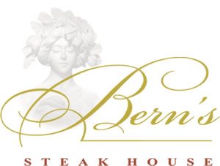The Vibe: Old World Bacchanalian decor, private dining room(if requested), impeccable service and statues deliver class, and guests should dress accordingly. There's no going cheap here. Book now for the legendary Bern's Winefest from April 8-11.
Starters: Sample the classics, especially the onion soup au gratin, Maine lobster bisque with smoke bacon and chervil oil, an amazing Cobb salad, black truffle tenderloin steak tartare with house potato chips. Go upscale with the foie gras or chateaubriand carpaccio with mushroom marmalade, parsley salad, and cracked pepper aioli.
Viva Meat: Steak lovers can't go wrong with the Delmonico, filet mignon or T-bone, but selecting from the sauce menu will be hard-Bernaise, choron, creamy horseradish, gorgonzola fondue, green peppercorn, pinot noir reduction, shiitake sauce Diane or soy armagnac to wow your taste buds. Other excellent choices are the famous Chicken Bern dusted in flour and sesame seeds, lightly sautéed and served with crispy mushrooms Brian or the crisp-roasted duckling in guava orange macadamia sauce.
Seaworthy Fare: You can't go wrong with the charcoal grilled salmon with lobster vinaigrette, Maine lobster, or the fresh catch (lobster, shrimp, lump crab, day boat scallops) en papillote. Bern's also offers Floribbean-inspired dishes such as the shrimp scampi done with a macadamia fricassee and curry mango butter, or its original smoked fish pate served with Melba toast, Key lime mustard sauce, and sweet pickled cucumbers.
Drinks & Desserts: A wine selection that would make Bacchus proud features 250 wines by the glass and another 80 in Bern's Harry Waugh Dessert Room, perfect for food-wine pairing during the meal's leisurely flow of tantalizing dishes. And the dessert room is a perfect topping for the evening, boasting specially roasted coffee beans, the best cappuccino with a float of vanilla cream and after-dinner specialty drinks, such as the Mad Monkey, a chocolaty pina colada and more. Cheesecake, dense flourless chocolate lush cake and Mississippi mud pie add a sultry finish to the evening's repast.
Photo Courtesy of Bern's

Tampa's Cheap Happy Hours
Mar 4th 2011 1:30PM / by Nanette Wiser
Everyone loves a bargain, especially $1 beers and $2 shots. Happy hour celebrates the art of frugal dining and drinking, and some barkeeps still provide apps for the minions (though the days of sweet and sour meatballs and endless cheese cubes is gone). Get a taste of fancy shmancy spots on the cheap, or just go for the discounts. And don't forget the half-priced Wednesday wine bottle nights at Middlegrounds, Savannah's and the Venue.
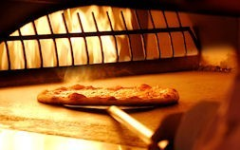Bella Brava: The chic new location is the best deal on Beach Drive, boasting happy hour daily till 7pm. Draft Bud Light ($1.99), well drinks ($2.99), and succulent sangria and house wine ($4.79) give you the right to ogle the pretty people. Food specials beckon, and the wood-fired pizza oven churns gourmet pies bubbling in cheese melange and gourmet toppings.
204 Beach Drive, downtown St. Pete; 727-895-5515
Lit Premium Cigar Lounge: Beer, scotch and wine marry well with puffing lazily on an elegant stogie, and for the ladies, vanilla and flavored cigars signal sex appeal. Open Monday through Friday at 4pm, and at noon on Saturday and Sunday, the cool dark lounge and bar, flat-screen plasma TVs, Wi-Fi access, comfortable furniture, and excellent ventilation system are the icing on the cake. Weekly specials include Monday half price for hospitality workers; Tuesday $5 Bacardi, Jack, Finlandia and Cazadorer, and $3 Presidente brews; 2-for-1 wine Wednesday; ladies drink free 9pm to 11pm on Thursday; 2-for-1 happy hour, 5pm to 8pm Friday; Bottles and Models Saturday with shots and bottle specials and Sangria Sunday just $4 and $2 domestic beers.
615 Channelside Drive; 813-221-5548
MacDinton's: A favorite watering hole for college students and military, MacDinton's legendary happy hours double as a frat party and hookup. MacWednesday features $10 open bar from 9pm to 11pm, including all draft beers, house wines, Jack, Finlandia vodka and SoCo cocktails, $2 Yuengling, $5 Patron and 50-cent wings. Mondays boasts cheap Harp, Tuesday $2 shots and on Thursdays, $1 Miller drafts fuel the boozy karaoke. Fun.
405 S. Howard Ave.; 813-251-8999

Celebrate Mardi Gras with Cajun Cuisine, Parties
Mar 4th 2011 12:00PM / by Nanette Wiser
Giving up chocolate for Lent? From Saturday through Fat Tuesday, laissez le bontemps rouler with Mardi Gras' carnival celebrations where debauchery, sweets, rum drinks, po' boys and collecting beads mark festivities all around Tampa Bay. Celebrate at these Mardi Gras celebrations or Cajun restaurants with a taste of crayfish and a whole lotta fun.
Cajun Cafe on the Bayou: Eat up, drink beer, dance all night at this Pinellas Park fixture on gator-infested Lake Seminole. Dine on Shrimp Creole, Dixie voodoo, gumbo, jambalaya, crayfish, and whiskey bread pudding. Hot fun all night long despite the no-frills decor. March 5, $15 admission includes crawfish corn bread, roast pork, red beans and rice plus J.B.'s Zydeco Zoo band.
8101 Park Blvd., Pinellas Park; 727-546-6732
Ybor City Mardi Gras: From 7pm to 11pm Saturday, March 5, don your masks, boa and feathers, and strut your stuff at the historic Don Vincente Inn for an extravaganza filled with music, dancing, costumes, freaky fun, and Louisiana delights to nibble and imbibe.
1915 Republica de Cuba, Ybor City; 813-241-4545
Kiwanis' Big Easy Charity Ball: On Monday, March 7, shake off the winter blues from 7pm to 11pm at this spirited party, where the ticket ($25) buys you spicy Bayou Catering Cajun fare, door prizes, dancing and live music. There will be a silent auction presided over by the Mardi Gras King and Queen, Tampa Bay Ray's communication chief Rick Vaughn and wife, Sue. Dress up in costume and raise money for a good cause.
Gulfport Casino Ballroom, 5500 Shore Blvd. S., Gulfport; 727-398-1360
Dunedin's Downtown Merchants' Association's Mardi Gras: More than 25,000 people will frolic from 5pm to 11pm on March 8, enjoying Zydeco music (Swamp Logic, Curley Taylor and Zydeco Trouble), a parade with flamboyant floats, kid-friendly activities, and Creole dishes provided by local restaurants. Free trolley from parking to event is provided.
Main Street, downtown Dunedin; 727-733-3197

Meet Meat at Tampa's New Texas de Brazil
Mar 2nd 2011 4:00PM / by Nanette Wiser
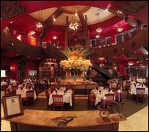Run, don't walk, to Texas de Brazil Churruscaria, the new Brazilian steakhouse and bring your appetite.
The generous portions of 15 traditionally grilled meats carved tableside by servers costumed as Gauchos flow like a river; just turn your card to green and the delicately seasoned meats appear, cooked just the way the cowboys seasoned and grilled their meats over the open pampas campfires.
Start by filling your plate from the seasonal buffet of soups, salads (Caprese, spinach), appetizers and gourmet cheeses and charcuterie. Save room for the sides, especially the garlic mashed potatoes, Brazilian cheese bread, and sweet-fried bananas served family style with the parading pork loin, Brazilian spicy sausage, garlic picanha, leg of lamb and filet mignon skewers, delectable and tender.
In addition to a gut-busting dinner fit for a king, the kicky Brazilian cocktails (mojitos, Caipirinha) and South American wines (Argentinian reds, Chilean pinot grigio) are a spirit and wine connoisseur's delight. For dessert, the flan and decadent rich chocolate cakes challenge your better judgment on overindulging.
Valet parking add to the joie de vivre of this upscale chain's entry into the Tampa special occasion restaurant market. Join the e-club for discounts and rewards.
4112 Boy Scout Blvd.; 813-871-1400
Photo Courtesy of Texas de Brazil

Grille 54 Blends Casual Class with Delicious Meals
Mar 1st 2011 1:07PM / by Nanette Wiser
Open seven days a week for lunch and dinner, Grille 54 mixes casual class with delicious dining. Best of all, the bar is open for late night fun and features 16 draft beers, cocktail specials, and 100 global boutique wines for the serious enophile, from Duckhorn to Caymus. So good, they just opened a second location in Citrus Park.
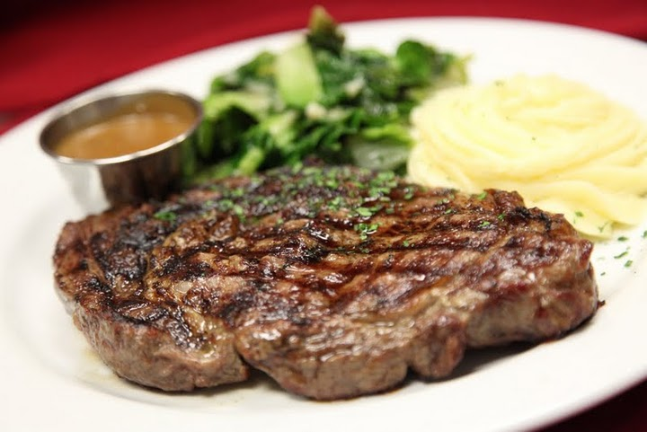The Bar: Chat with the convivial staff or enjoy sports on one of the six 50-inch plasma TVs in the full service bar. Happy hour is seven days a week from opening till 6pm, showcasing two-for-one premium wells, $1 off draft beers, and $3 house wines. The specialty drinks show off the mixologists' talents, from the Caipirinha to the Long Island mini skirt made with Stoli Strasberi vodka, Bacardi Big Apple rum, Patron Citronge, Tanquery Rangpur Gin, Patron Silver Tequila, sour and a splash of cranberry.
The Food: It's the Italian grill, steak and sushi that are the Academy Award winners at Grille 54. Start off with garlicky spinach parmesan bread, grilled bacon-wrapped scallops, beef carpaccio or Maryland style crabcakes, followed by a Caprese salad or heavenly crab bisque.
The flavor of the wood grill infuses the salmon, mahi and sea bass, Kobe burger, filet mignon and NY strip steak, and even though all the entrees come with vegetables and one side, you might want to consider adding the premium side of risotto, lobster mac and cheese or gorgonzola au gratin potatoes. All your favorite Italian dishes are on the menu (chicken parmesan or marsala, lasagna, shrimp scampi) but you can't find lobster risotto or saltimbocca di pollo this good anywhere else.
And the sashimi and sushi? Specialty rolls rock, especially the Hard Rock (fried scallop, cream cheese, tempura onion, cucumber roll topped with avocado, spicy mayo and eell sauce), General Tsao Chicken roll, and the Good Karma (tuna, salmon, shrimp, cucumber, avocado and smelt roe). Unusual apps include the ginger salad, lobster Rangoon and Peking duck wings served with wasabi aioli and chili sauce.
Kid's Menu: Even ankle biters get a gourmet menu, featuring the traditional bambino spaghetti and meatballs, and ravioli, as well as burger sliders, chicken parmesan and fettuccini alfredo.
11935 Sheldon Road; 813-920-0054
10900 State Road 54, New Port Richey; 727-376-0254

Twists on the Martini Stir Up Delicious Flavors
Feb 25th 2011 1:10PM / by Nanette Wiser
Warring martini lovers used to argue gin versus vodka. Today, it's all about the vodka, whether to mix with Van Gogh, Grey Goose or Absolut. In addition to ever-popular "Sex In the City" Cosmos or appletinis, trendy barkeeps mix up herb infusions (sage, cilantro), vegan flavors (cucumber) and fresh squeezed tropical juice alchemy.
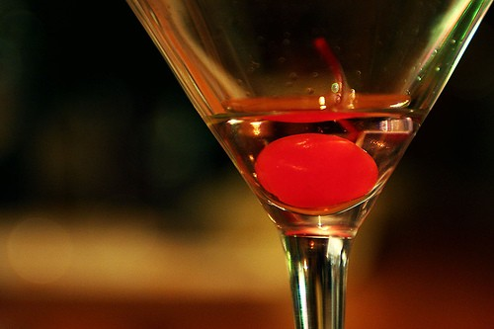Bella Brava: Blown away by the balsamic strawberry martinis (orange liqueur, fresh berries, sweet balsamic syrup, fresh lime juice) at Bella Brava? Sample the cucumber cilantro Plymouth gin or Zen green tea liqueur and lemon basil martini at this trendy Italian bistro.
204 Beach Drive N.E., downtown St. Pete; 727-895-5515
Blue Martini: Classics shine here, especially the Down & Dirty (Belvedere vodka, olive juice) or the Grey Goose perfect pear, a personal favorite. Top off the night with the signature Van Gogh blue martini (Citronge, blue Curacao, sour mix, orange juice and glow stick) or Almond Joy (vanilla vodka, Bacardi COCO rum, chocolate liqueur served with coconut shavings and chocolate sugar rim).
2223 N. West Shore Blvd.; 813-873-2583
Bonefish Grill: At Bonefish Grill, seasonal martinis, magically delicious, vanish too quickly, especially the Winter White Cosmo (Stoli cranberry vodka, Cointreau, fresh lime juice, white cranberry juice with a float of bobbing cranberries) and the lemony honey Bee's Knees martini. The skinny rita-tini made with Hornitos tequila, agave nectar and fresh lime is a refreshing change up from the ordinary.
Check the website for locations.
Roy's: With Hawaiian finest fusion cuisine and serious people-watching at the bar, the hand-shaken martinis at Roy's simply are the best, especially when Maui pineapples are drenched in SKYY Vodka, Stoli Vanil Vodka, and Malibu Coconut Rum. Don't miss the elderflower, sake-tini or Belvedere Vodka and sweet mandarin oranges with spicy Thai chilies and mint.
4342 W. Boy Scout Blvd.; 813-873-7697

Dine, Wine & Foodie Finds
Feb 24th 2011 9:00AM / by Nanette Wiser
Spring is in the air, and it's time to embrace the new. Nurture new dishes and try out family favorite recipes, even plant some tomatoes. William Sonoma, Publix's Apron Cooking School and Foodies offer popular classes. Enophiles can freshen up their wine and beer shopping list and raise money for a good cause at these upcoming events.
Memories of Things Past: Joanne Caras, author of The Holocaust Survivor Cookbook, speaks this evening, Thursday, Feb. 24, about her touching collection of recipes and resilience. It's an event not to be missed. Keep the spirit alive by baking Rose's Apple Cake or Reisie's Hungarian Cabbage Rolls.
Chabad of St. Petersburg, 4010 Park St., St. Petersburg; 727-344-4900
Up In Smoke: This annual gig celebrates cigars, boutique brews (stout) and the blues, three of our favorite things, on Saturday, Feb. 26. Use the event as an excuse to visit downtown Dunedin's hot spots, especially Kelly's Chic-A-Boom Room.
Dunedin Brewery, 937 Douglas Ave., Dunedin; 727-736-0606
Hot Stuff: Largo teams compete in the chili cook-off Saturday, Feb. 26, and the hilarious themes, cute firefighters and spicy stews attract a crowd. The event benefits Children's Burn Foundation of Florida.
Largo Fire Rescue Station 41, 180 Fourth St. S.W., Largo; 727-587-6737
Einstein Food & Wine: Science buffs, celebrate at this annual fundraiser Saturday, Feb. 26, a playground of food tastings, wine sampling and entertainment, a bargain at $80 per person.
Museum of Science & Industry, 4801 Fowler Ave.; 813-987-6000
Wine-apolooza: The 22nd annual Abilities wine tasting and silent auction on Saturday, March 19, features gourmet restaurant dishes, 100-plus wines, silent auction. The best bet is to buy your ticket now for the Grand Tasting ($100 for the event, $50 for the VIP add-on) -- it's always a sell-out.
Tropicana Field, downtown St. Pete; 727-538-7370, Ext. 345

Your Guide to Spring Training Eats
Feb 23rd 2011 3:20PM / by Nanette Wiser
Spring training brings fans and players to the Gulf Coast of Florida for sunshine, hot dogs and autograph signings. Celebrity sightings abound, from Yankee players at Indian Rocks' Villa Gallaci to rock stars and baseball luminaries (even Yogi) at Tampa's Capital Grille, Ruth's Chris Steakhouse and Fleming's.
Campagna's Dugout: The champion Phillies play ball at Bright House Field nearby, and Yankee and other team photos (including jumping Joe DiMaggio) grace the walls of this Italian sports bar and pizza joint, known for its ale house shrimp pasta made with garlicky dark beer, hearty calzone and ziti topped with tasty feta.
1653 Gulf-to-Bay Blvd., Clearwater; 727-441-4791
Donatello Restaurant: If you're not in a luxury suite at George M. Steinbrenner Field nibbling on dogs or Dipping Dots, and hobnobbing with baseball's hoi polloi, dine old-school New York Italian style after the game at Donatello. Northern fine dining cuisine, tuxedo-clad old world service, elegant decor and exquisite dishes (osso bucco Milanese, savory seafoods) take the bite out of a Yankee loss.
232 N. Dale Mabry Hwy.; 813-875-6660
Frenchy's Tiki Pavilion: Skip the Hooters down the street and party till the egrets fly home at Bright House Field at this popular 50-foot left field tiered tiki bar. Before or after the game, it's the place to be, especially when live music and Jager shots are flowing. Check out the World of Beers stand for a brewski or six at third base, if you can't get in.
601 N. Old Coachman Road, Clearwater; 727-712-4300
River City Grill: Port Charlotte boasts Tampa Bay Rays spring training, and even Evan Longoria and Manager Joe Maddon catch a meal at this all American eatery that serves burgers, salads, soups, pasta, serious steaks and seafood. Small wine list, good price on beers rounds out the fare.
131 W. Marion Ave., Punta Gorda; 941-639-9080
Ken Lund, Flickr

These Mexican Meals Can Spice Up Your Life
Feb 22nd 2011 11:00AM / by Nanette Wiser
California transplants yearn for real Mexican food, the late night taco stands for sopping up too much cerveza. Mexican taquerias dot Clearwater's neighborhoods, some decent, but we've got a long way to go before rolled tacos with guacamole becomes the catch of the day. Carmelita's is a good alternative, but these jewels will fill your South of the Border cravings.
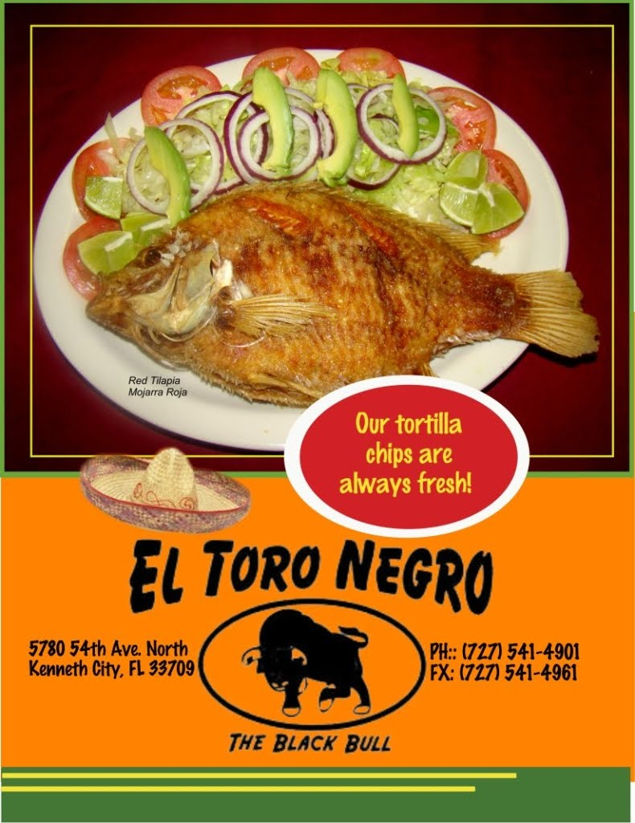Burrito Boarder: Skateboard art motif, projected x-treme wall videos, minimal decor and radical burritos, Negro Modelo, sangria and Mexican sodas make this eco-friendly hangout real. Start with black bean or tortilla soup, then order up tacos filled with adobo chicken or carnitas, topped with fresh pico or mango tango salsas, cilantro, sour cream, queso fresco and add some guac to make it green. Deliciously healthy, and another location in Tampa is coming soon.
17 3rd St. N., downtown St. Pete; 727-202-0202
El Toro Negro: Mexican market and tortilleria, the scent of fresh masa is a perfume for those devoted to the eatery's burritos, quesadillas, enchiladas, tortas and authentic Mexican (not Tex-Mex) dishes. The salsa and chips bar and a horchata while you wait for your red tilapia whole fish entree satiates your inner beast.
5780 54th Ave. N., Kenneth City; 727-541-4901
Los Mexicanos: Carnitas rancheras, fajita burrito, chicken enchiladas in mole sauce, and chile poblano clamor for your attention as mariachi music and gold margaritas entertain you at this beautifully decorated cantina. Combo plates, even huevos rancheros for lunch, and a light flan sweeten the allure.
301 Gulf Blvd., Indian Rocks Beach; 727-596-5253
38954 U.S. 19, Tarpon Springs; 727-945-0777
7081 Gulf Blvd., St. Pete Beach; 727-360-8200
Rojo Taco: Make your own burritos, tacos and taco salad from the array of grilled antibiotic-free
meats and chicken mixed up with organic veggies. There's limited indoor and patio seating, so plan on taking your healthy fun Mex treat back to the office or over to the park.
309 Twigg St.; 813-307-9000
Taco Bus: Sample multiple Mexican regional styles (Monterey, Yucatan, Mexico City, Sinaloa, Puebla and more) served up with rice and refried beans. Don't miss the fish or shrimp tacos, vegetarian specials (butternut squash tostada, tofu fajitas, roasted poblano peppers topped with Mexican cheese) or the burritos and quesadillas. Finish with flan and wash it all down with Mexican sodas, or fresh fruit agua frescas.
913 E. Hillsborough Ave.; 813-232-5889
2324 Central Ave., downtown St. Pete.
Photo Courtesy of El Toro Negro

Channelside Jewel: Zelda's Café's Home Cooking
Feb 21st 2011 11:30AM / by Nanette Wiser
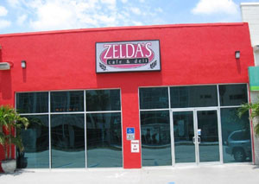Want comfort food? Zelda's Café and Deli delivers for breakfast, lunch and dinner in a casual oasis across from the Port Authority in Channelside, nestled next to a BP gas station. Fine wines and unique beers beckon from the cooler, and in addition to the menu, there are spectacular daily specials. You can check your Internet here and enjoy live entertainment in the evening. Courteous service and bistro fare in a no-frills setting make this unusual find worth the trip. Linger on the outdoor patio, then head out to Ybor for a night on the town.
Breakfast: For breakfast, corned beef hash or steak and eggs compete for your attention with veggie, meat lover and Western omelets, best with a side of cheese grits or biscuits. Pancake lovers can choose between banana or blueberry, or dine on the the sugar-dusted cinnamon French toast. Add a mimosa for a perfect day.
Lunch: Delectable selection includes oversized salads, such as chicken Caesar, macadamia and panko-crusted tilapia with orange vinaigrette, cobb, chef or Greek. There are wraps, mile-high deli sandwiches from roast beef to savory chicken or egg salad, and hot deli sandwiches, including killer Reuben, pressed Cuban, and steak and cheese. Take a slice of homemade cheesecake back to the office. The flavors change daily.
Dinner: Enjoy double lobster tail, crispy flat chicken or grilled flat iron steak with smashed potatos or a delectable grilled salmon with mango and papaya chutney served with vegetable couscous. 1239 E. Kennedy Blvd.; 813-226-0257
Photo Courtesy of Zelda's Cafe

Tasty Grub to Satisfy Your Late-Night Cravings
Feb 18th 2011 8:02AM / by Nanette Wiser
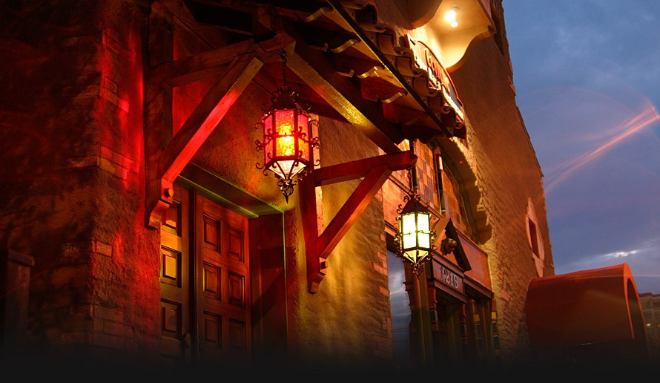You've been partying, and a Wendy's bacon cheeseburger, Village Inn pie, or a Grand Slam at Denny's isn't going to satiate your inner tiger. If you must be fed after 10pm, check out these grazing gardens for comfort food and tapas, and maybe a little last-minute flirt action.
Ceviche: At Ceviche, wash down your late night hot and cold tapas with white or red sangria pitchers. There's grilled shrimp, asparagus, olives, manchego cheese, garlic potatoes and so much more.
1502 S. Howard Ave.; 813-250-0203
10 Beach Drive, downtown St. Petersburg; 727-209-2302
2930 Gulf to Bay Blvd., Clearwater; 727-799-3082
The Deck Pizza and Pub: Open till 3am on Fridays and Saturdays, you can soak up the spirits with garlic-ey cheese bread, chicken Jack cheese quesadillas, Philly cheesesteak or meatball subs at The Deck Pizza and Pub. There's also calzones, stromboli, and some of the best pizza in Tampa Bay by the slice or pie, especially the white pizza or barbecue chicken.
2202 W. Platt St.; 813-250-1525
Walter's Press Box Sports Emporium: Walter's Press Box Sports Emporium offers five big screens (23 total TVs) and a great celebrity spotting local bar. This "real guys don't eat quiche" eatery serves appetizers, burgers, hoagies, sandwiches wraps and wings after 11pm, and steak and pizzas until then. Share the love, especially the starters (nachos supreme, homemade fried potato chips slathered in melted cheese, mozzarella cheese sticks, hearty chili, stuffed poppers, blackened shrimp).
222 S. Dale Mabry Hwy.; 813-3528
Samurai Blue: You can sup till midnight (Wednesday and Thursday) or 1am (Friday and Saturday) while sipping chilled sake martinis at Samurai Blue. Hot starters include blue crab Rangoon, hamachi-kama, deep fried calamari with ponzu, dim sum shumai, or grilled chicken yakitori. Cool your palate with cubed tuna sashimi, with spicy sesame and chiles, marinated squid salad or seafood ceviche. Or dive right into the entrees, a luscious mix of surf (steamed ginger salmon) and turf (samurai ribeye steak with a shiitake demi-glaze). The sushi, sashimi and rolls are among the best in town, especially the Love or Emperor rolls.
1600 E. 8th Ave., Ybor City; 813-242-6688

Dine, Wine & Foodie Finds
Feb 17th 2011 7:50AM / by Nanette Wiser
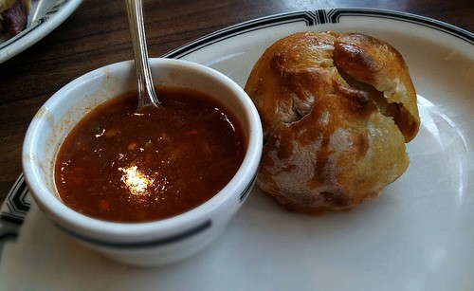You can drink wine on Friday and Saturday's wine tastings at Mazzaro's and learn to whip up a fab new entree for entertaining at home this week.
Brooklyn Knish: At 100,000 knishes later, the Farmer's Market favorite comfort food has a permanent home. This light flour pastry dough filled with 15 savory fillings (potato bacon, feta spinach) tastes just like the real deal, and Clearwater even boasts its version of the Brooklyn Bridge, albeit not for sale.
2551 Drew St., Clearwater; 727-408-5208
Drink for a Cure: American Spirits Fine Wine & Liquor's Friday tastings, from 7pm to 9pm, draw an eno-savvy crowd and every month, it raises money for a charity. At Friday, Feb. 18's tasting, your ticket benefits the Leukemia and Lymphoma Society.
Fri., Feb. 18, 7pm to 9pm; $10 in advance, $15 at the door
280 Third St. S., downtown St. Pete; 727-895-8700
Home Cooking 101: Take a cooking class with friends or your honey at Foodies, a culinary mecca. Learn to prepare Santacafe cuisine including spring rolls Saturday, Feb. 19.
2312 Fourth St. N., St. Petersburg; 727-209-1418
Healthy Living: Allergic to peanuts or gluten? Learn to cook without fear and discover alternatives at Rollin' Oats Market & Cafe on Monday, Feb. 21, then treat yourself to chai and homemade soup.
1021 N. MacDill Ave.; 813-596-6282

Coffeehouses Brew Unique Experience for Locals
Feb 16th 2011 8:00AM / by Nanette Wiser
Unique coffeehouses double as a sanctuary, especially when stocked with free Wi-Fi, fresh brewed java, and homemade desserts and savories. Make one of these your home away from home.
Cafe Bohemia: Dangling a coffee cup sign over Central Avenue, this luscious lounge and a garden patio will help awaken the artist within. Enjoy the earth mama vibe, from the craft brews and coffee drinks to the flatbread pizzas and warm brownies. The spoken word performances and live music make for a very Greenwich Village experience.
937 Central Ave., downtown St. Petersburg; 727-895-4495
Cafe Kili: African art, free wireless Internet access, live music (Monday, Thursday, Saturday) and a 15-person conference room make this USF hangout popular. Enjoy frozen frappes (white mocha), fruity smoothies, cafe con leche, homemade soups, breakfast sandwiches, and a superior focaccia topped with roast beef, bacon and provolone.
5731 E. Fowler Ave.; 813-988-2879
Kahwa Coffee Roasting: Organic cookies and muffins, salads, quiche, perfect pastries and robust fresh-roasted coffee blends and caramel lattes star at both eco-friendly hot spots, where you can relax in the sun with your pup and enjoy free Wi-Fi. Very San Francisco hip.
275 2nd St. N., downtown St. Pete; 727-823-4700
204 2nd Ave. S., Old Northeast; 727-821-1942
Indian Shores Coffee Company: With live music Saturday night, this adorable bungalow artfully adorned serves light snacks, killer cappuccino and sweets. It's the perfect meeting place before or after walking the beach.
19221 Gulf Blvd., Indian Rocks Beach; 727-593-1707
Sacred Grounds: This eclectic coffeehouse features role playing, game nights, live music and vegan delights (wraps, artichoke dip). Here, USF students and young professionals sip Yogi breath deep tea, herbal temptations (mango and apple fruit), smokey lapsang suchong, chai and smoothies (kiwi, melon, pineapple).
4819 E. Busch Blvd.; 813-983-0837

For Romance, Vive La French Cuisine
Feb 14th 2011 12:25PM / by Nanette Wiser
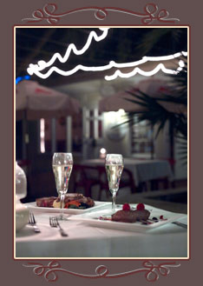French food starts with dining on seasonal cuisine, sipping Rhones, nibbling brioche and ends with gateau and fromage, no beret required. Attentive service, beautifully plated entrees and continental flair is just a kiss away at these delightful bistros. Book now for Valentine's Day and you'll see way food and l'amour go hand in hand.
Cafe Largo: Chef Dominique Christini's boulangerie and bistro charms, from the white tablecloths and sparkling candlelight to the Maine lobster and scallop flambe and blue crab soup finished with Absinthe. Provencal rack of lamb, chateaubriand and roasted duck with tarragon capture country French. For dessert, nothing satisfies more than the Grand Marnier souffle for two.
12551 Indian Rocks Road, Largo; 727-596-6282
Cassis American Brasserie: With its al fresco seating, mirrored bistro decor inside and a scent-sational bakery next door, Cassie American Brasserie is one of downtown's best hot spots serving brunch, lunch and dinner. Steamed mussels in lemon-garlic vermouth sauce, tuna niçoise salad, charcuterie or fromage plate, baked brie and the French onion soup sparkle. Happy hour, held from 4pm to 7pm Monday through Friday, offers free hors d'oeuvres and $4 red or white sangria.
170 Beach Drive N.E., St. Petersburg; 727-827-2927
Le Bouchon Bistro: At Le Bouchon, you will find affordable, delicious and authentic French cuisine, plus live music Friday and Saturday. From the crepes (portabello and duck, chicken and chive) to the brie fondue, pate, smoked salmon salad and Lorraine pizza (portabello, smoked bacon, brie), casual elegance reigns, especially in the entrees (coq au vin and seafood medley poached in a saffront chardonnay broth).
796 Indian Rocks Road N., Belleair Bluffs; 727-585-9777
Toasted Pheasant: In this casually elegant restaurant, start with garlicky escargot in puff pastry and a warm brie bistro salad. Then saddle up for red-wine braised beef bourguignon, toasted pheasant breast, grouper Niçoise, or rosemary-rubbed rack of lamb. You also can try the three-course crepe suppers (beef burgundy, seafood or chicken chardonnay). Save room for the strawberry filled dessert crepe covered in chocolate sauce. Cooking classes are held on Monday.
14445 N. Dale Mabry Hwy.; 813-265-6700

Hula Bay & Green Iguana Bring the Tropical Heat
Feb 8th 2011 1:01PM / by Nanette Wiser
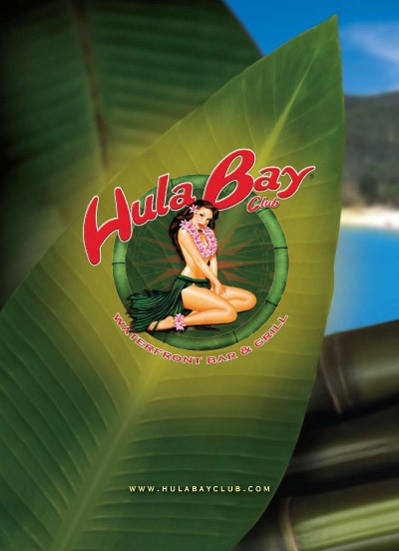A giant lizard guards the Green Iguana's doors, the ultimate Tampa Bay tiki bar where the party never stops, especially on Wednesday $1 drink night. Add to that Sunday football specials, Friday happy hours, unforgettable appetizers and entrees and nonstop entertainment, which could be live or a DJ-spun set, or at some locations, Latin salsa or reggae jams on Sundays.
With five locations in Tampa, one in Brandon and one in St. Pete, you're never too far from the fun. A sister restaurant, Hula Bay Club, boasts a Sunday wet pool party, sushi, sliders and all-you-can-eat crab or shrimp on Wednesdays, plus nightly music and more island bar libations, even sushi. I just became a member of Duke's Retired Surfer's club, as should every true blue hang-tenning, Laird-loving big waver.
Top shelf cocktails are high style at Hula Bay and Green Iguana, using Van Gogh flavored vodkas (McIntosh apple martini, chocolate martini), rummy magic (Iguana Mango Lemonade), Red Bull cherry and grape bombs, and my personal favorite, the smooth-talking Stoli Razz "Berry Your Iguana" with cranberry and pineapple juice. An excellent selection of domestic and imported beers on tap and in bottle round out the libations.
We like to share starters and graze our way through the menu, especially the loco coconut shrimp, conch fritters with avo mayo, smoking fish spread or crab Rangoon. Split a Sambal Salad with grilled shrimp and crisply fish, cool cukes and fresh greens, toasted peanuts and Thai chili vinaigrette or Harvest Salad with candied walnuts, sun-dried cranberries, bleu cheese and crisp apples tossed with raspberry vinaigrette. Very satisfying, especially when paired with a mojito or seven.
Burger lovers will thrill to the combinations. You can top it with bacon, cheddar, provolone and Thousand Island dressing or Caribbean barbecue sauce and tobacco onions, among other options. Seafood aficionados can fill up on yummy fish tacos, a crispy seafood basket, Key West grilled or blackened mahi with mango salsa and coconut rice, and so much more. Rounding out the menu are sandwiches, wraps, wings, pizzas and soups, as well as a mouthwatering New York strip steak smothered with caramelized onions, portabello mushroom and demi-glaze.
Each Green Iguana has its own vibe and crowd that eases from daytime's casual crowd and business folks meet ups to evening's stylemakers and singles on the prowl. When you're looking for nightclub and great food with drink specials, don't ignore Tampa's favorite lizard lounges. Specials abound, especially the $5 burgers, $1 Wednesday drinks and 2-for-1 well, wine and drafts Friday.
Click here for Green Iguana locations.
Hula Bay Club, 5210 W. Tyson Ave.; 813-837-4852
Photo Courtesy of Hula Bay Club

Your Guide to Top Food, Fun at the State Fair
Feb 11th 2011 8:15AM / by Nanette Wiser
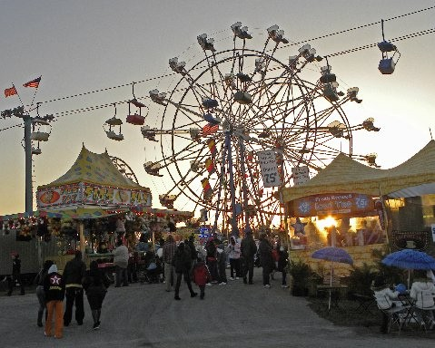Go whole hog at this year's lollapalooza. Ogle wacky Elvis competitions and pretty pigs, ride hair-raising roller coasters and win your gal a stuffed teddy. Best of show is WQYK's county showcase featuring Colt Nichols, Joe Ford and more today, Friday, Feb. 11. After you've cuddled in the picture booth for some memories, throw away your diet and enjoy these delicious delights from now through Monday, Feb. 21.
Best burgers: Rolled in French toast and Cap'n Crunch, served with bacon and a scoop of fried ice cream or stacked with French fries and cole slaw. For dessert, have a chocolate doughnut burger.
Best combo: The chicken eggo fried waffle-wrapped chick sandwich or fried mashed potato and gravy on a stick.
Best meal in a cup: Grilled meatloaf sundae (mashed potatos, gravy, shredded cheese) and hog-wild sundae (pulled pork, coleslaw, tortilla chips topped with chipotle barbecue sauce).
Best desserts: Maple-bacon cupcake, fried butter, red velvet funnel cakes.
Best movie snack: Forget kettle corn -- go for popcorn-flavored with dill pickle or Oreo Crunch.
Best Big Apple tasting: Mile-high deli sandwiches (pastrami, Reuben).
Best freebie: Bring a coupon from Sweetbay to the Florida Citrus Booth in the Ag Hall of Fame and get a free cookbook.
Best traditional: Corn dogs, fried Twinkies, cotton candy, tummy ache. Repeat.
Directions: Florida State Fairgrounds, 4800 US Hwy. 301 N., Tampa.

Mangroves Delights the Senses With Global Flavors
Feb 7th 2011 1:00PM / by Nanette Wiser
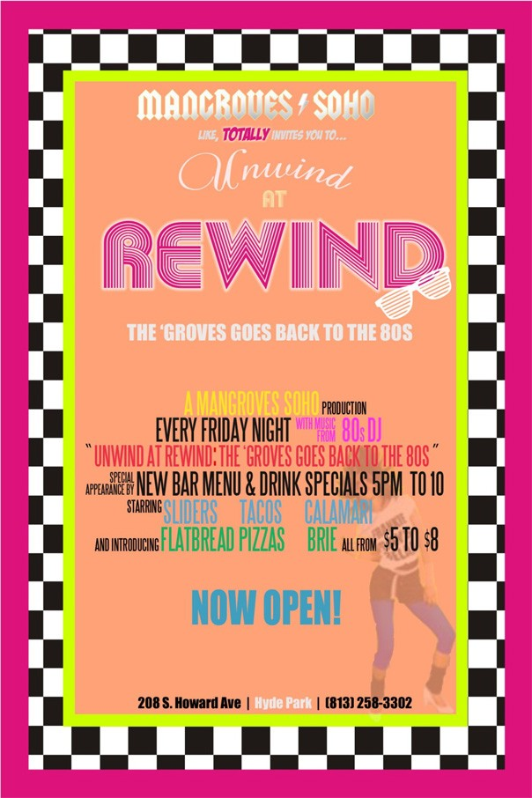SoHo teems with chic eateries, but Mangroves' New American cuisine and elegant wine list is one of the best in South Tampa. Infused with global flavors, these dishes indulge all of your senses and the attentive staff pampers you and your palate. This is the perfect place to dine before heading over to the Straz for theater or the St. Pete Times Forum for a concert.
Make reservations now for the Valentine's Day lovefest, complete with lobster-stuffed grouper, pan seared scallops or jumbo lump crab served with gorgonzola-crusted NY strip. Starters wow, especially the truffled beef tartar and escargot, and sweet endings include chocolate flourless torte with a white chocolate-covered strawberry.
Mangroves offers two indoor dining levels, an outdoor dining space, and a lounge featuring a stained glass-lit bar. Adorned with stylish Italian light fixtures, billowing sheer curtains, hanging glass cable cocktail tables, artistic furniture, private outdoor cabana and more, this elegant eatery can handle any occasion, including weddings and holiday parties.
Every Friday night, Mangroves SoHo Productions serves up Unwind at Rewind, where the Groove goes back to the '80s, a stylish bar menu and drink specials party from 5pm to 10pm. The menu features short rib sliders with truffled parmesan fries, tuna tartare, truffled mac and cheese, short rib tacos, Creole calamari, flatbread pizzas, baked cashew-coated brie and more for only $5 to $8.
It's good grazing after work, especially the $2 off all cocktails and wine, $1 off beers from 5pm to 8pm, as well as sangria pitchers $20, mojito pitchers $30 (classic, peach, raspberry), and margarita pitchers $35 ($45 for top shelf). On Friday and Saturday nights, the DJ spins the crowd from 11pm to close. LBD, please, this crowd is styling.
208 S. Howard Ave.; 813-258-3302

Dine, Wine & Foodie Finds, Feb. 4-13
Feb 4th 2011 2:15PM / by Nanette Wiser
Now is the time to start thinking about growing your own produce, whether it's starting an herb garden inside or tilling the soil for some tomatoes and lettuce. Publix offers tons of free veggie recipes in the produce section and Apron's cooking classes can spark new ideas for old favorites. Celebrate our favorite fruit, the grape, at these area tastings and don't forget your Cupid gift, best if consumable (chocoholics, unite)!
Super Bowl Cocktail Tasting: Total Wine will showcase specialty cocktail mixology this weekend, starting this evening. Sip tasty concoctions made with Captain Morgan Rum, Jose Cuervo gold Tequila and Crown Royal Whiskey.
Fri., Feb. 4, 5:30-8:30; 1720 N. Dale Mabry Hwy.; 813-350-9601
Sat., Feb. 5, 4:30pm - 7:30pm, 4880 Park St. N., St. Petersburg; 727-544-6018
Sun., Feb. 6, 1pm - 4pm, 2528 State Road 580, Clearwater; 727-431-1010
Victory Gardens: Learn how to grow fresh veggies and protect plants from pests at this free Florida Extension class Saturday (registration required 727-582-2100). Don't forget the weekly Saturday Harvest Market at the Florida Botanical Garden, also home to USF/County Extension.
Sat., Feb. 5; Registration required.
Weedon Island Preserve, 1800 Weedon Drive N.E., St. Petersburg; 727-453-6500
Valentine Vines: Preview 50 wines, all suitable for wooing your love. The $10 admission price per person includes a wine glass, coupon and hors' d'oeuvres.
Thu., Feb. 10, 6pm - 8pm; $10
ABC Fine Wines & Spirits, 3110 W. Gandy Blvd.; 813-839-7167
Florida State Fair: In addition to the fried Twinkies and other Fair fare, we'll preview next week the annual corn dog and country music-palooza (Feb. 10 - Feb. 21). The fair also will host a Youth International Cooking Challenge on Thursday, Feb. 17.
Photo Courtesy of Elysia L. Richardson

Kids' Valentine's Dance Adds to the Fun at Glazer
Feb 3rd 2011 12:00PM / by Nanette Wiser
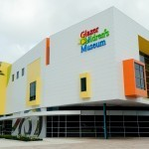Make believe is now officially open in downtown Tampa. The Glazer Children's Museum features 170 interactive exhibits in 12 themed areas that teach children how things work while having fun.
They can learn how the Port of Tampa works, diagnose stuffed animals as a wannabe vet, race a clock to assemble a tooth puzzle as a dentist, or suit up to fight invisible flames in the Fire House. In Art Smart, tykes can color with paint, create sculpture with pool noodles, and even make a kaleidoscope.
In addition to all the interactive fun, you can take refuge in the Tiny Bites Cafe and enjoy salads, sandwiches and wraps. You can have your tyke's birthday party here, and on Feb. 13, your little sweethearts can enjoy a Valentine's dance.
Climb up and down nets in the 35-foot Water's Journey, stage a newscast, dig for pirate treasure, shop Publix, dance or make paper airplanes or race animals in "Get Moving." Hands on, high tech is the catch of the day, and the kid-size exhibits are an amazing addition to downtown Tampa's must-see spots adjacent to the Curtis Hixon Waterfront Park. The museum spans 55,000 square feet and plans to host camps on site this summer. On the first Tuesday of every month from 4pm to 8pm, museum admission is free. Other museum highlights include:
Airplane Travel: A replica of a 1900s biplane that allows children to become pilots! Did you know Tampa Bay was the site of the first ever commercial passenger airplane flight? Made in 1914 by Tony Jannus, the flight took the Mayor of St. Petersburg to Tampa in just 23 minutes. Until this point, travel between the two cities took many hours. Airplane gives kids the experience of swooping over our own Tampa Bay much the way Tony Jannus did! Nearby aeronautical models and murals help highlight historic aviation.
Cruise Ship: This exhibit features a large make-believe cruise ship for children to become captains, sailors and explorers. Pick your destination and pilot the ship -- and all its passengers -- safely to your chosen destination. Peek underwater through a special periscope. Explore your own private island where young explorers can find mounds of buried treasure!
Outback Steakhouse Cafe: Kids can be a chef, a server or a customer in an Outback Steakhouse Cafe. Make a sandwich or a pizza, ring up the order, or just sit back and enjoy a meal with a great view! (Don't forget to tip the server!)
Hospital: Take a look inside the body in the hospital. Can you identify the sounds the body makes? Or put the teeth back in the right order? How does it all work together?
1110 W. Gasparilla Plaza, downtown; 813-443-3861

CinéBistro Offers an Unforgettable Movie Night
Feb 2nd 2011 1:00PM / by Nanette Wiser
Want to enjoy dinner and a movie? Clever cocktails named after your favorite flick, tres chic décor, and yummy desserts, appetizers and dishes all set the stage for a great night out at CinéBistro Hyde Park Village.
The Skinny: With two locations in Tampa (Wesley Chapel) as well as Miami, Vail, Colo., and other cities, this nouveau concept features Dolby sound, stadium seating, online ticket sales in advance and gourmet meals, but you must be 21 and older to watch a movie at CinéBistro. The dining room is open to everyone for lunch, dinner or appetizers. You can rent the theater for catered business events.
The Food: Corporate Executive Chef Isaac Stewart's Italian entrees are molto benne, from the fettuccine in roasted garlic cream sauce and tomato basil spaghetti pasta with broccolini to the barbecue pork rib stack. Other dishes offered are the brick chicken with wilted spinach, churrasco flat iron steak, topped with tomato chimichurri sauce, and the portabella mushroom lasagna.
Savvy diners share starters such as white bean hummus, sweet and spicy wings, popcorn chicken or rock shrimp, served with saffron dipping and charred tomato dipping sauces, or a ginger tuna and salmon spring roll. They can then move on to share the Caesar or Cobb salad for an entrée, or one of the sandwiches, which are accompanied by shoestring or sweet potato fries.
Desserts: In the mood for just dessert and coffee? Don't miss Dessert At The Movies, a medley of flourless chocolate torte, spiced caramel popcorn, chocolate film strip, cherry red carpet with Coca Cola cherry marmalade and starfruit or the tiramisu cupcake trio, washed down by a latte, mocha, espresso or herbal tea.
Imbibe: Spirits are just as wild, from the dozens of domestic and imported brews, and our favorite, the Magic Hat Not Quite Pale Ale to the "Sex and the City" Cosmotini, Ruby Red Slippers and Pink Panther Martini. Can an "Eat, Pray, Love" mojito be far behind? Add to this an exceptional wine by the glass list, served in six- or 10-ounce pours, with standouts such as Ferrari Carano Fume Blanc or Cabernet, Kim Crawford Sauvignon Blanc or Sonoma Cutrer Chardonnay.
The Experience: Best of all, you can bring your beverage into the theater, where you'll relax in oversized leather rockers, each equipped with its own table. The movie seating starts 30 minutes in advance, so you can enjoy your libation and comestible. The theater also is available for private rental, and CineBistro hosts public events, including Monday Night Football games and last spring, the "Sex In the City" release party and the "Lost" finale. You don't have to eat and drink to enjoy the movie, but the typical concession stand is replaced by Buncha Crunch, Raisonettes, Toblerone, Ghiradelli Caramel, and unlimited popcorn for only $5.75. No kidding. Sparkling waters and soda pop round out the movie fare. In addition to the theater, there is a bar and dining area for guests who just want to enjoy a gourmet meal with friends.
CinéBistro Hyde Park, 1609 W. Swann Ave., Hyde Park Village; 813-514-8300
CinéBistro @ Grove 16, 6333 Wesley Grove Blvd.; 813-948-5444

Chicken of the Sea: Fish Tacos
Feb 1st 2011 11:00AM / by Nanette Wiser
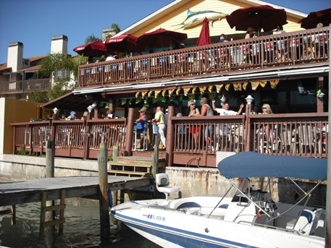Lobster and fish tacos are all the rage in San Diego where I hail from, best with secret sauce, fresh chopped salsa (pico de gallo), cilantro on warm, fresh corn tortillas. Other than Negro Modelo and a handful of hole-in-the-wall taquerias, you'll have to settle for the fish being just off the boat and the salsa homemade.
Bonefish Grill: Cajun-style fish tacos at Bonefish Grill are served with mango salsa, sour cream and lettuce, or even better, spicy Bang Bang crispy shrimp tacos. Both come with homemade chips. Chic cocktails, boutique wines, and unique brews on tap match up with super service.
Check website for locations in Tampa, Palm Harbor and St. Petersburg.
Crabby Bill's: New at Crabby Bill's this season is a tangy lobster roll and mahi tacos that are grilled, blackened or fried, and topped with cabbage, cilantro cream and mango salsa. They are served with creamy cole slaw and all the fixings.
Click here for locations Tampa, St. Petersburg, Clearwater.
Mema's Fish Tacos: Start your night in Ybor City off right at Mema's. A King Kong tortilla filled with sultry refried black beans and poached fish or shrimp, even salmon, is made more succulent by cooking the shell and meat together. It is then lathered with sour cream, lettuce, onion and cry-your-eyes out salsa. Even better, get the seafood nachos and praise Neptune.
1724 E. 8th Ave.; 813-242-8226
Sloppy Pelican: Black beans and yellow rice are so delicious at the Sloppy Pelican that you forget to munch on your mahi fish tacos, lightly blackened or grilled. Add to this Billy Agans live on Wednesday, beer pong college night, and pub crawls on Saturday, and you've got Party Central, and great food to fuel the frenzy. There's an awesome view of the Intercoastal rushing into the Gulf. If you're in the local crowd, get a seat on the deck if you can.
677 75th Ave., St. Pete Beach; 727-360-7100
Taco Bus: The most authentic Mexican food on both sides of the bay, the Guaymas beer-battered fish tacos with creamy sauce and chile de Arbol sauce on the side served with beans and rice at Taco Bus is the real deal. You also can get fish and shrimp tacos, as well as a shrimp burrito or quesadilla, muy caliente. Wash it down with a tamarindo agua fresca.
913 E. Hillsborough Ave.; 813-232-5889
2324 Central Ave., downtown St. Pete
Wildwood's BBQ: Think Gidget and Beach Blanket Babylon for this revamped beach hotel, tiki bar and restaurant known for its world famous skillet cornbread, natural pit barbecue, spicy chipotle barbecue wings, and yes, some of the best mahi mahi tacos served Baja style (lime, pico de gallo and guac), with New England-style salt and vinegar homemade chips.
Postcard Inn, 6300 Gulf Blvd., St. Pete Beach; 727-367-2711

Dine, Wine & Food Finds, Jan. 28 - Feb. 8
Jan 28th 2011 11:01AM / by Nanette Wiser
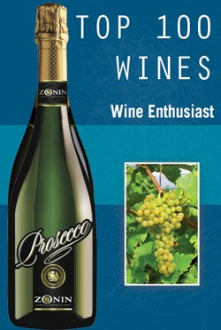Get your dog on a leash and spend an hour squeezing organic vegetables and fruits at area farmers' markets. In addition to those listed below, visit Gulfport (Tuesday), Largo (Thursday), and downtown Clearwater or Dunedin (Friday). Enophiles, enjoy dozens of fine vintages, many for a good cause.
Art & Eats: The Corey Avenue Sunday Market (10am to 2pm) boasts produce vendors, local arts and crafts, live music, foods and fun! On Saturday, Jan. 29, and Sunday, Jan. 30, the annual 17th Art & Craft Fair is in full swing from 10am to 5pm. When you're done strolling and nibbling, make a beeline for the Twisted Tarpon or the Swigwam for more food and drink.
Corey Avenue, just off Gulf Boulevard, St. Pete Beach; 727-498-8778.
Italian Dinner & Wines: Enjoy wines and prosecco and Shor American Seafood Grill's chef supper (osso bucco, beef carpaccio and zabaglione), as well as a wine auction to benefit Abilities Foundation job placement services for veterans with disabilities.
Tue., Feb. 1; $85 per person
Hyatt Regency, 301 S. Gulfview Blvd., Clearwater; 727-373-4780
Wing It: Live music, chicken wing eating contest, and dozens of restaurants showcase their flats for a saucy Saturday.
Sat., Feb. 5, 11am - 7pm; Free
Vinoy Park, 501 Fifth Ave., N.E., St. Petersburg; 404-456-4655
Toasty Tidbits: Sip Napa's Krupp Brother Wines and enjoy heavy hors d'oeuvres Tuesday, Feb. 8, at 6:30pm ($25), or raise money for LARC on Friday, Feb. 4, from 6:30pm to 8:30pm at the wine and appetizer tasting ($5).
Tosti's Spirits & Fine Wine, 5125 34th St. S., St. Petersburg; 727-867-7772
Friday Farmers Tampa Downtown Market: The market is one of the best around, delivering fresh fruits and vegetables, exotic cheeses, affordable food and gourmet products.
Fri., Jan. 28, 10am - 2pm
Lykes Gaslight Square -- Tampa Street and Kennedy Boulevard, downtown Tampa.
Saturday Farmers Winthrop Town Center Farmers Market: Browse crafts and cool clothes, fresh fruits, veggies, boiled peanuts, and good local eats.
Sat., Jan. 29, Opens at 8am
11109 Winthrop Market St., Riverview
Ybor Saturday Market: Get produce, gourmet foods, hot sauces, fresh breads, fresh eggs, prepared foods, orchids, herbs and plants, pet treats, honey, unique gifts, photography, artwork, jewelry, woodworking, bath and body products, candles and a lot of great people-watching.
Sat., Jan 29, 9am to 3pm
Centennial Park, Eighth Avenue and 19th Street
Land O' Lakes Market: Enjoy live music and good shopping, all for a good cause that benefits the Heritage Park Foundation and the Suncoast Harvest Food Bank.
Sat., Jan. 29, 9am to 2pm
Land O' Lakes Community Center, U.S. 41
St. Pete Saturday Morning Market: Come early before the crowds throng the market. Enjoy live bands (there's even seating), crepes, English meat pies, blintzes, sausage, gyros, and dozens of other yummies from the ethnic vendors. Take home mulled wine mixes, organic produce, beignets and breads, cunning desserts, flowers, crafts, jewelry, spices, herbs, Adirondack chairs and cool new recipes.
Sat., Jan. 29, 9am to 2pm
Al Lang Stadium parking lot, 1st Avenue South and 1st Street, downtown

Burger Places Think Outside the Bun
Jan 26th 2011 12:15PM / by Nanette Wiser
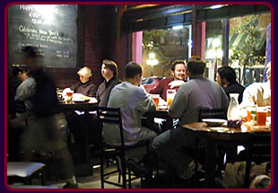Hankering for a hamburger? Search out the best, from local bars to chains you can count on (Applebee's, Five Guys, Chili's, Cody' Steakhouse, Outback Steakhouse). Meet some meat you won't forget, both gourmet and unique at these one-of-a-kind restaurants.
The Bungalow: The clever bar and grill is famous for its scrumptious Bungalow Burger, a half-pounder topped with lettuce, tomato, onion and your choice of cheese. Only insiders know about its Inside Out Burger. This creative twist on the burger scene puts the bacon and cheese inside the meat -- a real change of pace from the usual fare and some of the best fries in town.
2202 W. Kennedy Blvd.; 813-253-3636
The Capital Grille: This upscale restaurant boasts an elegant alternative, chopped sirloin served with Havarti cheese on a toasted onion roll, a change-up from Velveeta. Capital offers pricey, but worth it burgers. The bonus benefit is rubbing elbows with Tampa's hoi polloi.
222 N. West Shore Blvd., International Plaza; 813-830-9433
Square One Burgers: Burger aficionados, start your engines. Local foodies are discovering this restaurant and its unique approach to burgers. For all of you who want to avoid the bun bulge, you can order yours on a bed of fresh greens. One of Square One's best-sellers is a "Build a Burger." You choose everything from the roll, or greens, to the cheese. The eatery offers 11 sauces, including sun-dried tomato mayo and teriyaki ginger. Ten toppings and four sides to choose from round out this specialty of the house.
3701 Henderson Blvd.; 813-414-0101
Tampa Bay Brewing Company: The on-site brewery serves up nine to 12 tap beers, and the heavenly hops often end up in the entrees, such as Black & Tan onion rings or Jalapeno Beer Cheese Soup. Enjoy a healthy bison burger, tangy portabello mushroom topped with goat cheese, or brie and bacon concoction, best mopped up with Old Elephant Foot IPA, a traditional India Pale Ale with intense hoppiness or the Wild Warthog Weizen.
1600 E. 8th Ave., Ybor City; 813-247-1422
Wahoo's: This eatery offers four burners on a cast iron stove and a melt-in-your-mouth beach burger made from sirloin, best consumed with a Stella Artois and tater tots. Start off with seared ahi for a memorable surf and turf lunch.
17801 Gulf Blvd., Redington Beach; 727-393-5525

Money-Saver: 'Kids Eat Free' Specials
Jan 25th 2011 8:10AM / by Nanette Wiser
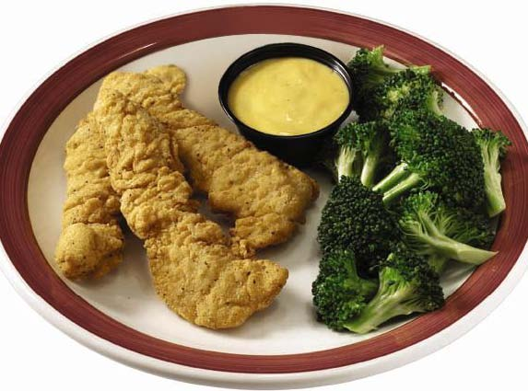Dining out with kids can be a chore, especially with picky eaters. Gather your ankle-biters and enjoy "kids eat free" specials at these family favorites, made even more entertaining by balloon-twisting servers and coin-guzzling games. In addition to these list below, some area Denny's allow kids to eat free 4pm to 10pm (one adult meal, two free kids meals) as do children age 12 and under at IHOP (4pm to 8pm, drink not included). Feeling flush? At Crispers, kids eat for only 99 cents. Check ahead for details, menu options and age limitations. In most cases, kids get a one children's meal per adult entree purchase.
Beef O'Brady's: On Tuesdays from 4pm to 8pm (and some locations 5pm to 9pm or close), kids eat free with the purchase of an adult meal, tasty mini corn dogs or burgers with fries, and grilled chicken wraps or salads. These are popular with Little Leaguers who are celebrating home runs all around Tampa Bay.
5006 East Bay Drive, Clearwater; 727-532-2333
210 S. Kings Ave., Brandon; 813-681-3428
10799 Park Blvd., Seminole; 727-393-2880
Click here for more locations in Tampa, Seminole, St. Petersburg, Clearwater
Carmelita's: Carmelita's offers free meal for kids age 10 and younger on Mondays. Kids love the chips and salsa, and in the wink of any eye, will devour a cheese enchilada or quesadilla, chicken and rice, bean and cheese burrito or beef taco with rice. There are no complaints about the Mexican veggies.
7705 Ulmerton Road, Largo; 727-533-8555
6218 66th St., Pinellas Park; 727-545-8226
5211 Park. St. N., St. Petersburg; 727-545-2956
Chick-Fil-A: One free four piece chicken nugget kids meal per combo meal purchased on Tuesday Family Fun Night (5pm or 5:30pm to 7:30pm or close depending on location) make this healthy choice popular with kids. On the second Friday in July, if you dress like a cow, you get a free combo meal. Mooove over, Halloween.
Click here for locations in Tampa and St. Petersburg.
Cody's Original Roadhouse: Kids eat free at Cody's Monday and Tuesday nights, and up to two kids can eat for free per adult entree purchased. Get all the peanuts you can crack, plus a choice of steak on a stick, chicken fingers, grilled cheese, corn dog, cheeseburger, Kraft mac and cheese or pepperoni pizza. The balloon guy at the new location on Park Street deserves a hip hip hooray.
Click here for locations in St. Petersburg, Tampa, Tarpon Springs.
Perkins Restaurant: Monday through Friday, one child under age 12 eats free with the purchase of an adult meal. You can print games and sign up for a birthday meal at the restaurant's website, and the servers are pleasantly patient. A free drink and crazy cookie accompany tasty entrees, such as chicken tenders, cheese pizza or quesadilla, cheeseburger, grilled cheese sandwich or mac n' cheese. It's the sides that make moms crow with pleasure: cup of chicken noodle soup, salad, broccoli, applesauce and other healthy choices.
Click here for locations in St. Petersburg, Tampa, Spring Hill, New Port Richey and Seminole.
Steak'n' Shake: Mom's all about the banana, dad likes peach, and everyone swears by the creamy chocolate shakes. Kids age 12 and under eat for free on Saturdays and Sundays, one free kid's plate (no drinks) for every $8 spent. Other treats: free chef hats, crayons and cruisers, plus delectable chicken fingers, steakburger, mini corn dogs, grilled cheese, hot dog with fries, mandarin oranges or applesauce.
Click here for locations in Tampa, Largo, Oldsmar, New Port Richey, Riverview, St. Petersburg.

Enjoy Culture and Cocktails at 3 Museum Cafes
Jan 24th 2011 8:15AM / by Nanette Wiser
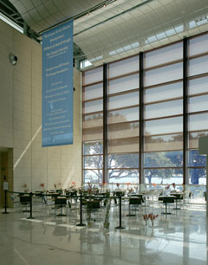Big city style is now showing here with the debut of another restaurant (Cafe Galat) that lets you celebrate art and dine on it. Got guests? Show off the city's growing cultural scene at these attractions. You can brunch at 400 Beach and visit the Chihuly exhibit (Morean Arts Center's fab downtown addition), enjoy a panini at Glazer's Children Museum in Tampa, and latte at the Ringling Museum in Sarasota.
Cafe Gala, Dalí Museum: Whether you have a museum ticket or just want to dine out, you can enjoy this fabulous indoor/outdoor bayview cafe, thanks to restaurateur Steve Westphal (The Pub, 400 Beach, The Hanger, Parkshore Grill) and PG's Chef Tyson Grant's sandwiches, wraps, salads, desserts inspired by Dalí's Spain. Traditional Spanish omelettes (potato and onion, smoked ham and artichoke), smoked ham and artichoke salad, roasted pork, garlic and piquillo pepper wrap and Spanish coffee cake will satiate all cravings. Beer and wine are available. The cafe is open for breakfast, lunch and dinner daily. Other Dalí fun includes the expanded gift shop, yoga Sundays, the Zodiac social group, and "Dillydally with Dali," which is free for kids on weekends.
1 Dali Blvd., St. Petersburg; 727-823-3767
MFA Cafe, Museum of Fine Arts: Lunch in the airy glass aerie or groove to jazz over dinner Friday from 6pm to 9pm. Casual bistro fare features yummy panini (roasted herb turkey with dried fruit jam/basil aioli, Croque madame, chargrilled chicken scalloppini) and seasonal salads, such as bistro steak with Spanish blue cheese and smoked duck with crisp apple and walnuts in a lemon champagne vinaigrette. Beer and wine are available.
255 Beach Drive N.E., St. Petersburg; 727-896-2667
Sono Café, (Tampa Museum of Art): Open daily at 11, this delightful café overlooks the river and serves wine and beer. Operated by Mise en Place, this slow food eatery is a garden of Eden in downtown Tampa that serves creative panini, such as grilled chicken with goat cheese and fresh basil, speck ham with gorgonzola, parma ham with sun-dried tomato, buffalo mozzarella, and arugula as well as salads, espresso, gelato and dolce.
2306 N. Howard Ave.; 813-274-8130

Wine, Dine and Foodie Finds
Jan 21st 2011 11:06AM / by Nanette Wiser
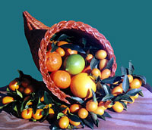Abundance is the name of the game this time of year. There are so many wine tastings and food festivals, including Plant City's upcoming Strawberry Bash and the fried marvels of the Florida State Fair. Here are some of January's crop.
Gulfport Tuesday Farmers Market: From 9am - 3pm every Tuesday along upper Beach Boulevard, this artsy village by the bay throws a garden party, complete with organic strawberries, artisan cheeses, smoked fish, piping hot New York bagels, boutique and crafts (Bo-Tiki is for hip chicks), Marie Gagne's unique hats and savory teas from the Vinoy's former chef, James Clark (sweet lavender, cherry and smokey green varietals). Worked up an appetite? Stop in Tangelo's or O'Maddy's and while away the afternoon.
O'Maddy's, 5405 Shore Blvd., Gulfport; 727-323-8643
Tangelo's, 3121 Beach Blvd., Gulfport; 727-894-1695
Wine Delights: Parkshore's good eats team up with American Spirits 3rd Friday wine tasting (Fri., Jan. 21, 7pm - 9pm) to raise money for Pet Pal Animal Shelter. Sip 20 global delights (Italian, Australian and South American). Want an early start? Check out the weekly Friday wine sampling at Mazzaro's Italian Market from 1pm - 5pm (11am to 2pm on Saturday) where you can discover Italian varietals and worldly new tastes, and take home homemade Italian dishes, handcrafted cheeses and meats, and so much more.
American Spirits Fine Wine & Liquor, 260 Third S., downtown St. Petersburg; 727-895-8700
Mazzaro's Italian Market, 2909 22nd Ave. N., St. Petersburg; 727-321-2400
Cocoa for a Cause: Chocolate lovers, heaven's gates open Sunday to raise money for Treats for Troops, March of Dimes, Abilities Foundation and Children's Cancer Center at Ruth Eckerd Hall. Sample candy, pastries, beverages, and other chocolate concoctions that compete for best of show. Don't dive into the chocolate sculpture; it's for show.
Sun., Jan. 23, noon to 6pm; $20 advance, $25 at the door
1111 McMullen-Booth Road, Clearwater; 727-791-7400
Taste of Spain: Be queen for a day with a five-course Spanish meal paired with Rioja wines and meet winemaker Jesus Madrazo at the legendary Columbia Restaurant in Ybor City.
Fri., Jan. 27, 7pm; $100 inclusive
2117 E. Seventh St.; 813-248-4961
Kumquat Festival: Relish the citrus family's little gold gem at Dade City's Kumquat Festival. Eat a kumquat just like a grape. This zesty little fruit tastes best if it is gently rolled between the fingers before being eaten, releasing sweet essential oils. Sample pies, cookies, ice cream, and other kumquat delights while enjoying crafts, a car show, farmers' market, 5K and 10K walks and live entertainment.
Sat., Jan., 29, 9am - 5pm; Free
Meridian Avenue at U.S. 301, Dade City; 727-567-3769

Grab Ethnic Eats for Lunch In Downtown Tampa
Jan 19th 2011 11:30AM / by Nanette Wiser
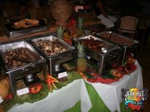Lunch in downtown Tampa is like a whirlwind world tour. Amazing ethnic cuisine means you don't have to settle for a sandwich or hot dog. Get some takeout for dinner and share the global love with your home team.
Bamboozle Café: This cafe offers hip Thai-Vietnamese cuisine that is healthy and tantalizing. We love the pork, beef and prawn rolls wrapped in rice paper with vermicelli noodles, green leaf lettuce, and your choice of veggies, Asian noodle salads, sandwiches and traditional pho, as well as the five-alarm chicken curry and five-spice barbecue pork sandwich.
516 N. Tampa St.; 813-223-7320
Fly Bar & Restaurant: If you love the one in San Francisco, run (don't walk) to Fly Bar & Restaurant! It offers global cuisine, an artsy atmosphere, and a chic crowd that trickles in when it opens at 4pm. Between the rooftop bar and nightly specials, after-work crowds like to gather here, especially for half-bottle wine Monday and $5 signature cocktail Tuesday. They also like to stay for the 10pm live music. Appetizers include shredded braised beef with green olives, panko-crusted goat cheese, authentic nachos, fish tacos, roasted garlic fries and Kobe beef sliders. Need we say more?
1202 N. Franklin St.; 813-275-5000
Jerk Hut: With one location downtown and another on East Fowler Avenue, the hottie Jamaican favorite been serving curry goat, chicken and shrimp for 20 years. Jerk Hut's zesty jerk sauce is mmm mmm good, and its secret ingredient (nutmeg? rum?) is much debated. Sample the pepper shrimp, beef and veggie patties, curried veggies with roti or savory oxtail stew. Enjoy live reggae on Fridays and Saturdays, and an all-you-can-eat Sunday brunch at Jerk Hut Jamaican Grille and Rhum Bar (Fowler).
207 E. Twiggs St.; 813-223-4473
Paninoteca Mediterranean Café: Savory homemade Greek dishes star at this cafe. Enjoy the hummus, roasted garlic and Greek feta spread, tzatziki served with homemade warm pita bread, Greek salad, tomato salad and a wide variety of panini, including salami, prosciutto, Calabrese, roasted lamb and more.
519 N. Franklin St., Tampa; 813-341-2525
Pizzaiolo Bavaro: Pizzaiolo Bavaro offers authentic regional cuisine, such as wood-fired sandwiches and pizzas, plus calzones. Don't miss the carne, uovo, arugula, cipolla or al crudo pizza dripped in fresh veggies and shaved aromatic Italian cheeses, or the penna alla vodka. Nap later, eat now.
514 N. Franklin St.; 813-868-4440
Rojo Taco: Make your own burritos, tacos and taco salad from the array of grilled antibiotic-free meats and chicken mixed up with organic veggies. There's limited indoor and patio seating at Rojo Taco, so plan on taking your healthy fun Mex treat back to the office or over to the park.
309 E. Twiggs St., Tampa; 813-307-9000

Eateries Dish Out Gourmet Pizzas Any Way You Like
Jan 18th 2011 8:00AM / by Nanette Wiser
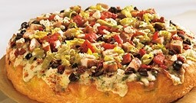
We eat $20 billion worth of pizza in the United States, from traditional to trendy. Thanks to California's innovative stylings, pizzas now come topped with goat cheese, lamb sausage, smoked salmon, barbecue chicken, even BLT. Sometimes, you just want an old-fashioned pie with garlicky crust, sizzling cheese and a meatball, mushroom or pepperoni. No designer veggie or Hawaiian. Definitely no caviar. Anchovies on the side, New York style -- maybe. Your diet? Forgeddaboutit. In addition to these favorites, check out Eddie & Sam's and Pizza Pazza in downtown Tampa, and Campanella's and Paesano's in St. Petersburg.
BJ's Restaurant & Brewhouse: BJ's offers stunning WPA-style wall murals, a wall of flat-screen TVs drilling down on NASCAR or football, and some of the best boutique beers, especially the IPA and ales. Deep dish, thin crust, order three and share, especially the spinach artichoke, tangy barbecue, Southwest blackened chipotle or spicy Buffalo chicken, sweet pig with ham and pineapple and a vegetarian as fresh as the farmers' market. The pizookie, warm chocolate chip cookie, is to die for.
3800 Park Blvd., Pinellas Park; 727-525-4640
California Pizza Kitchen: Shopping the International Mall? Save some change for lunch at CPK, especially the chopped salads and designer pies a la Wolfgang Puck. Munch pizzas topped with roasted artichoke spinach, caramelized sweet onion cheeseburger pizza, vegetarian with Japanese eggplant, Mexican carne asada, and a heavenly fontina cheese wild mushroom (portabello, crimini, shiitake and white). The original BBQ chicken started here, made special by the snoked gouda and fresh cilantro.
International Plaza, 2223 N. Westshore Blvd. #189; 813-353-8155
East Coast Pizza: You can order a personal pizza, thin or Sicilian crust with any combo of toppings, or just by the slice at East Coast Pizza. Cluck over the barbecue chicken and Buffalo chicken pizzas, or go wild with a meatlovers or Hawaiian pizza. Ravioli, lasagna, spaghetti and meatballs, baked ziti and manicotti round out the yummy Italian fare. You also can get all three parmigiana as entrees. Added touches include a tasty kids' menu, beer and wine list and for dessert, sugary zeppola.
13340 Lincoln Road, Riverview; 813-234-1700
10433 County Road 39 S., Lithia; 813-737-1919
Pizzaiolo Bavaro: Italian brews (Moretti, Peroni) and wines, from a berry good Amarone Classico to a nicely balanced Pinot Grigio, can spice up your Neapolitan pizza experience at Pizzaiolo Bavaro. The buffalo mozzarella and the lighter-than-a-feather pizza dough comes topped with the freshest of vegetables and meats. You'll want to come daily for a different succulent pie: The prosciutto with basil or the sopressata and Italian olive? The carne or the prosciutto and artichoke hearts with basil? Or maybe the cipolla (caramelized onion, provolone) or the zucchini, eggplant and mixed peppers vegetarian? Tempting and worth it.
514 N. Franklin St.; 813-868-4440
Rigatoni's Tuscan Oven: In addition to gluten-free pies, Rigatoni's offers low-carb pizzas for the health conscious. My favorite? The gourmet tomato and feta or spinach and feta concoctions, accompanied by fruity sangria or Peroni by the pitcher. Sweetening the experience is the the Tuscan flan and dessert flights for tasting and sharing. Kick it off with Tuscan grilled oysters or lightly breaded soft shell crab, accompanied by the garlic knots or bruschetta if you have four to feed.
3437 W. Kennedy Blvd.; 813-879-7000

Wake Up for These Sunny Side Up Breakfasts
Jan 17th 2011 8:00AM / by Nanette Wiser
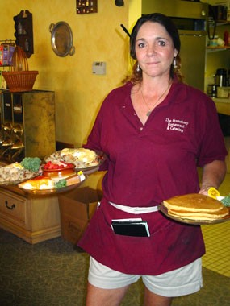
There are two kinds of morning people: the ones who go to Denny's at 3am for a Grand Slam, and the ones who get up with the chickens to eat their eggs. Whichever category you're in, start the day off right by heading over to these original hash-slinging spots for the real deal in comfort food that is carefully prepared and beautifully served. Other favorites include The Savory (Largo), Cafe Alma (downtown St. Pete for the Bloody Mary bar at Saturday brunch), Bob Evans, for the berry-stuffed cream cheese pancakes or pot roast hash, and Crabby Bill's for the Floribbean crab omelette with Bay Spice.
400 Beach Seafood & Tap House: Casual chic, overlooking Beach Drive and the Bay, you'll toast Sunday with Bloody Marys and mimosas, and stay all morning if you choose the brunch buffet ($23.95 Sunday, 10am - 3pm) and have a corner window table. You'll enjoy relaxed coastal cuisine, live aquariums on flat-screens, and after dining, the Chihuly exhibit next door (you'll see his Pepto-pink glass sculpture as you walk in). Enjoy the raw bar, applewood bacon, potato hash, roasted salmon, deviled eggs, caprese salad, carving (roast beef, spiral ham) omelette stations, and the ultimate dessert room (vanilla trifle, bread budding, and chocolate-dipped strawberries).
400 Beach Drive N.E., downtown St. Petersburg; 727-896-2400
Brunchery Restaurant: This MacDill favorite serves up Benedicts plain, or with crab or ham on croissant or traditional English, fluffy omelettes fit for Humpty Dumpty (ham, bacon, Spanish, Italian, Monte Cristo), yummy Eggs Florentine, and stuffed French toast with cream cheese, bananas and strawberries that's the best in Tampa Bay. Pancakes can be customized with blueberries, walnuts, chocolate chips, bananas, pecans, coconut, strawberries, almonds and raisins. Don't miss the corn beef hash or quiche.
3225 S. MacDill Ave.; 813-831-4694
Daily Eats: This eclectic South Howard Avenue diner delivers on its healthy eating promise with natural eggs, granola or oatmeal with fresh fruit, and multi-grain bread. I like the scrambled eggs, scallions and smoked salmon on a bagel smeared with chive cream cheese. I also like the Oreo cookie pancakes, delectable grits and the creative Benedicts, topped with thinly sliced seasoned NY Strip, caramelized onions or the turkey hash, all served with their homemade hollandaise sauce. The eatery serves breakfast at night. Best of all for me, goat cheese is an omelette stuffer option.
801 S. Howard Ave.; 813-868-3335
First Watch: First Watch, whose motto is "betcha heaven smells like breakfast," serves a brunch that has angels drooling, whether it's crepes or eggs. The restaurant's stuffed French toast adds kiwi to the mélange, pancakes come in all flavors (even cranberry and carrot cake) and it does CrepeEggs served with hash browns. The omelette collection, which belongs in a museum, includes Cajun, Greek (roasted red peppers, Feta cheese and spinach, topped with black olives and red onions) and Aculpulco Express (chorizo sausage, avocado, green chilies and onions, smothered with melted cheeses and topped with sour cream and served with salsa.) Have a taste of heaven at one its multiple Tampa Bay locations.
Frog Pond: Mom and Dad love the King Kong-size omelettes, Belgian waffles brimming with berries, lox and bagels, silky eggs Benedict at Frog Pond. Everywhere you look, toads of every size and shape from all over the world adorn the walls and shelves, gifts from grateful fans who cuddle doggie bags filled with leftovers on their way out. Here, it's home cooking the way it should be at this location and the smaller St. Pete Beach one.
16909 Gulf Blvd., North Redington Beach; 727-392-4117
Pinky's Diner: Enjoy South Tampa bohemian style with mix-and-match mugs, café con leche, oatmeal pancakes, frittatas bulging with cheese, veggies and herbs in an upscale setting. Pinky's breakfast egg sandwiches are done Cuban style, with bacon or ham, and there's a delicious sausage, egg and green onion scrambled wrap. The ethnic frittatas range from my favorite, rosemary Tuscan with prosciutto, turkey, onions, spinach, tomatoes and provolone to Italian, Greek, Mexican and more. The small outdoor patio is dog-friendly.
3203 W. Bay Blvd.; 813-831-9339

Chicken Wings You'll Flap Over
Jan 13th 2011 4:02PM / by Nanette Wiser
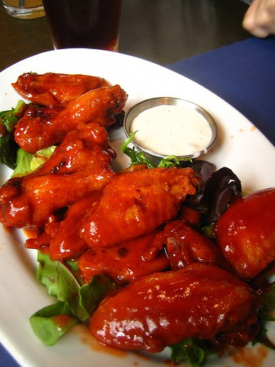
True wing lovers debate endlessly -- drums or flats, naked or not, sauced and tossed. Buffalo-spicy style (mild to inferno) are yesterday's flavors. Tampa Bay wings go wild, favored with teriyaki, garlic parmesan, Hawaiian savory, hickory smoked barbecue, lemon pepper, Cajun, original 100 ways and other sauces. Deep-fried chicken wings served with a hot sauce and blue cheese dressing originated at the Anchor Bar in Buffalo, N.Y., circa 1964, and are so quintessential that chains such as TGI Friday's, Hooter's, Mugs 'N Jugs, and the Wing House made their reps on having a leg up on wings. In St. Petersburg, MidTown Sundries and Clearwater's Quaker Steak and Lube are top roosters. Here are some of our other favorite cluckers.
Green Iguana: Let her drink the frozen pupu drinks, while you down a pound of wings for only $6.99 in these scrumptious flavors: Island Chili, Lava Sauce, Sweet Caribbean barbecue, Jamaican Jerk (not named after your ex-boyfriend), spicy Honey Dijon, Southwest Chipotle BBQ and the original.
See website for multiple locations in St. Petersburg and Tampa.
Hattricks: Hattricks is a simple sports bar, its wings a variety of hot or barbecue. But if you dine in, it offers 50-cent wing specials during its daily happy hour. Buckets of beers, cheap brews during happy hour, and cheerleader-pretty servers make it all so easy to hang out all night.
107 S. Franklin St.; 813-225-4288
The Original Honey's Sports Bar: With a sister restaurant in Niagara Falls, this authentic taste of Buffalo Wings are amazing and Bills' fans love them. Try the BBQ raspberry, honey garlic and charbroiled ones as well the beef on a weck, an upstate favorite perfect for Super Bowl.
11115 N. Dale Mabry Hwy.; 813-264-1616
Walter's Press Box: With its old-fashioned newsroom bar decor, Walter's Press Box serves elegantly meaty, deep-fried jumbo wings that come slathered in mild to atomic Buffalo sauce, or Selmon Brothers BBQ, honey BBQ or Cajun, served with celery and blue cheese for dipping. Feeling healthy? Order them up in a salad or wrap.
222 S. Dale Mabry Hwy.; 813-876-3528
Varsity Club: People come for the hot garlic or Italiano wings, and stay for the Asian sesame, teriyaki, lemon pepper, Cajun and the rest of the menu, especially the sensationally smoking nachos.
36355 E. Lake Road, Palm Harbor; 727-781-4455

