Baby Buzz
Dec 2012
Sarah Gilbreath

[head] Ho Ho Home Décor
[deck] That’s a Christmas decoration? This year’s holiday décor breaks from tradition in bright colors and fun designs. Here’s what to snap up in the post-holiday sales to decorate a fabulous nursery that will stay beautiful all year long!

[subhead] Perfect ornamentation
This year, dozens of fun new styles are sneaking their way into the holiday shelves, even if they have nothing to do with the holiday season. Pick up some themed ornaments to match your nursery a few days after Christmas to maximize the bang for your buck. Classic kid favorites like Disney, Pixar, and Dr. Seuss all have ornament lines perfect for your little one’s room. Mount a curtain rod over a window and hang the ornaments from it using varying lengths or ribbon or fishing wire, or hang individual ornaments from a picture rail along the tops of the walls. Our favorite picks? The rocket ships and robots from Hobby Lobby, and these adorable, colorful animals from Target. (photo credit: http://www.target.com/p/4-piece-zoo-animal-ornaments/-/A-14127381#prodSlot=medium_3_25)

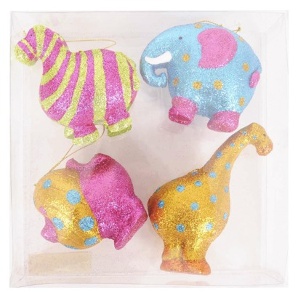
(Caption: How cute are these?)

[subhead] Wrap it up!
You’ve no doubt seen some of the many amazing wallpapered dresser upcycles floating around the internet (link: http://www.apartmenttherapy.com/dressing-up-dressers-with-wall-149894). Get the same look for less by using wrapping paper! Start by taking out the drawers and removing their handles. Sand down any finishes on the fronts. Measure the wrapping paper to fit the front of the drawers, making sure to cut holes for the handles. Using decoupage glue like Mod Podge, decoupage the paper onto the front of the drawers (make sure you use a thick, good-quality paper so the ink won’t run!) After they dry, reattach the handles. You can do each drawer in a different paper, or go for a more uniform look. If you don’t want to tackle an entire dresser, try covering a lampshade for a more subdued look. If your lampshade is round, apply the paper in strips to prevent it from buckling.
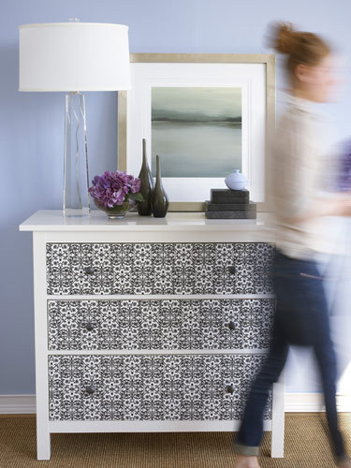
(Caption: Copy this look!)

[subhead] Oh deer!
If you’re going for a woodland theme, capitalize on the colored deer trend (link to either http://michelleward.typepad.com/michelleward/2008/12/a-wink-for-my-stable.html or http://fab.com/inspiration/pink-glitter-deer-set-of-3 ) by painting deer figurines from the toy aisle. If you’re up for a challenge, kick it up a notch! Papier-mâché outdoor deer armatures (like these from Walmart http://www.walmart.com/ip/48-in.-Animated-Grapevine-Standing-Deer/22003151 and Kmart http://www.kmart.com/48inch-105ct-multi-posing-brown-deer/p-009V004888822000P?prdNo=20&blockNo=20&blockType=G20 ) , let the glue dry, and paint the sculpture. (choose pic from any of the above links). You can even mix in a little glitter for an extra sparkle!

