Mar. 31 2010 — 9:43 am | 422 views | 0 recommendations | 2 comments

http://trueslant.com/mpnunan/2010/03/31/how-the-aid-biz-undermines-local-biz-in-haiti-and-beyond/

How the aid biz undermines local biz in Haiti and beyond
By MP NUNAN
Haiti-based businessman Maulik Radia has weathered two coup d’etats, two major hurricanes and now an earthquake in the country he’s worked in for the past 25 years.
But now he faces his latest challenge: the aid industry – and how it’s killing the demand for locally-produced buckets.
As the General Manager of a plastics company, Plastech Solutions, Radia has had to lay off more than 20 of his 150 staff because his company cannot compete with the free materials coming in from the US and other countries.
“Manufacturing has shifted to the US and benefits the US producer,” Radia says, adding that the US military has been shipping donated goods to Haiti free of charge.
“On top of that, the US gives tax advantages [to donors,] so it’s a write-off. So how do you expect me match that?”
Most heavily hit was the demand for 5 gallon buckets – used in a post-disaster situation for myriad tasks, including water purification, construction and as containers for carrying emergency household goods distributed by aid groups.
Prior to the January 12, 2010 earthquake, Radia could sell a single bucket for $4. Now, with donated buckets glutting the market, he has to push to keep the price above $2.50.
That earthquake is estimated to have killed more than 220 thousand people and left more than a million homeless.
I went to Haiti earlier this month on a trip sponsored by The Peace Dividend Trust, an organization that encourages international organizations to spend their money locally, rather than sourcing aid material from overseas. (Full disclosure: the head of The Peace Dividend Trust, Scott Gilmore, is a friend of mine. I shot a promotional video for PDT in Haiti.)
“Buying local” is a simple concept – but one that has been too often ignored by the aid-industry. In theory, after the earthquake, Plastech Solutions should have had more demand for 5 gallon buckets, and Radia should be hiring more Haitian staff, rather than laying them off.
But according to PDT, as little as 5 percent of aid money spent during a humanitarian crisis is spent in the local economy. Much of the funding goes toward foreign goods and ex-patriate salaries for aid-workers. (PDT’s “Haiti First” project is intended to link aid-groups with Haitian suppliers that meet international standards for goods and services.)
Now consider that the United Nations is sponsoring a donor conference on Haiti today. The Haitian government has asked for $11.5 billion to rebuild the country over the next several years. Five percent of that is a trifle over half a billion dollars to stay in Haiti. A relative pittance.
And that’s if donors agree to Haitian officials’ full request for funding. (It seems clear that a $3.9 billion short-term plan will likely win approval.)
I’m not suggesting that the international community ignore on-going humanitarian problems associated with disasters or war. Haiti still needs help.
But the Haiti situation represents the classic conundrum of balancing humanitarian largesse and the dangers of associated with the creation of a welfare state – versus the need to stimulate local economic growth.
(Some members of Radia’s Haitian staff have walked out of their homes, he says – even though they were left standing by the earthquake. They’ve moved into “tent city” refugee camps, where they get free food everyday. Because hey – why not?)

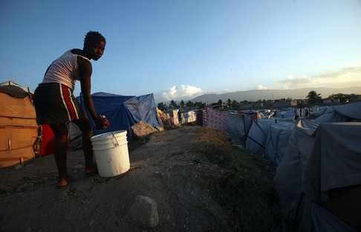

Radia says he hopes his business has stabilized and he won’t be forced into any more lay-offs. But he remains concerned.
The US Agency for International Development (USAID) is donating 500 tons of cooking oil to Haiti in April. Radia fears that will decimate demand for locally packaged cooking oil – and the demand on Plastech Solutions for plastic cooking oil bottles.
In an email, USAID spokeswoman Moira Whelan told me, “Ensuring that our work furthers the Haitian economy is a top priority to USAID. We work hand-in-hand with local business owners and have deployed market experts to make sure that the investments we make are sound and can become self-sustaining.”
It will probably take more than that to convince Radia – who says he has yet to be contacted by USAID or any other international agencies. (A letter he wrote to the Clinton Foundation, expressing concern about the effect international aid has on Haitian business, he says, has gone unacknowledged.)
Still, even Radia admits it’s difficult to know, after a disaster, just where to draw the line.
“How do you stop feeding everybody?” Radia asks. “How much is economic and not disaster-related? Somewhere along the line, people need to be told [the aid] needs to end.”

