The Childhood Obesity Dilemma: Are The Parents or The Children The Solution?

By Barbara Sadick – Opinion Piece

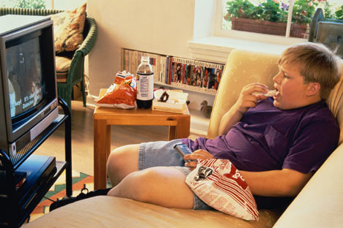

Obesity is a growing epidemic in developed and developing countries, with the United States

in the lead of global prevalence. This is troubling information as obesity is linked to chronic

diseases such as Type II diabetes, metabolic syndrome, heart disease, certain cancers, arthritis,

asthma, behavioral disorders in children, and overall reduced quality of life. Nine million

American children are classified as obese bit.ly/9QFDJQ, and African-American children have

a 51% higher rate of obesity than do whites bit.ly/a7Zcgq. While two million adolescents in

the U.S. currently have pre-diabetes bit.ly/4yn5Rs, Type II diabetes is highly preventable with

increased physical exercise and healthy dietary practices bit.ly/dDvAL9.

In addition to health consequences, obesity has taken an economic toll on an already taxed

system. By 2002, the Centers for Disease Control and Prevention estimated that the economic

consequences of overweight and obesity had reached $92.6 billion, half of which was paid

through Medicaid and Medicare. Stemming and reversing the obesity epidemic in children has

been deemed a “national priority” by the Institute of Medicine.

The growing obesity epidemic is linked to the increasing availability of dense, highly

processed food and the decrease in physical activity. Research shows that American children

spend more time watching television and videotapes, using the internet and playing video games

than doing anything else other than sleeping bit.ly/az0dzu. Physical activity requirements in

school have severely declined, with only 8% of middle school and 2% of high schools requiring

daily physical exercise http://bit.ly/cwfU3e+.

Too many parents put children in front of a television set to keep them out of the way, and

while children are watching television, chances are they’re snacking on Dorritos and drinking

sodas and sweetened fruit juices high in calories and non-existent in nutritional value. Schools

serve burgers, fries, and chicken tenders, and have choices of cakes and puddings for dessert –

and for snacks between meals, school vending machines have chips and candy to encourage

excess consumption. Where are the parents?

Can we educate parents? I think not. While some parents are aware of the value of fresh,

healthy food and water, and physical exercise, others have set hazardous, unhealthy examples.

Just as they warned students about the dangers of smoking cigarettes in the early nineties, the

schools must lead the way in educating students to stop and become conscious of what they are

eating and drinking. Just as kids were once taught to go home and annoy their parents and any

other smoker about the hazards of smoking, so they must be taught to go home and insist upon

healthy food choices. In the same way they once unrelentingly yelled, “Smoking is bad!” and

eagerly crushed any cigarette in sight, kids must now confront parents who serve coca cola and

fried chicken for dinner.

The Institute of Medicine of the National Academies speculates that the childhood obesity

epidemic may reduce the trend of increased life expectancy bit.ly/9tbZ7f. Few adult-oriented

programs have had much success, so it is now time to arm our kids for battle. Schools must

educate our children, who must then take action by going home, clearing off the shelves, and

throwing away the pop tarts. Children of the world unite! You have nothing to lose but your

bulging belly rolls. Let the revolution begin!

Photo Credit: babble.com

