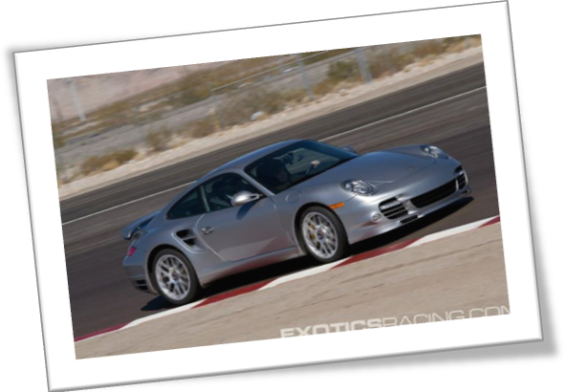
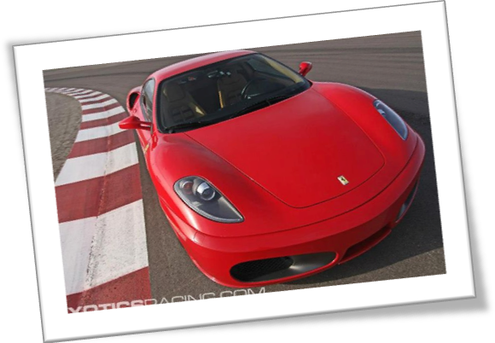

The 2 car combo allows for experiencing the similarities and differences between two of the world’s most elite supercars from the incomparable fleet at Exotics Racing. Depending on the combination chosen, things such as power and handling may noticeably vary. The possibility of achieving two completely unique driving experiences is what makes this combo exciting.
For instance, there’s fast and then there is faster. The Ferrari F430 F1 goes from 0-60 mph in just 3.9 seconds, while the Porsche 997 Turbo S can achieve this speed in a lightning fast 2.6! The results may literally astound you. This is merely one of the many exhilarating 2 car combos available. Compare and contrast to your heart’s content.

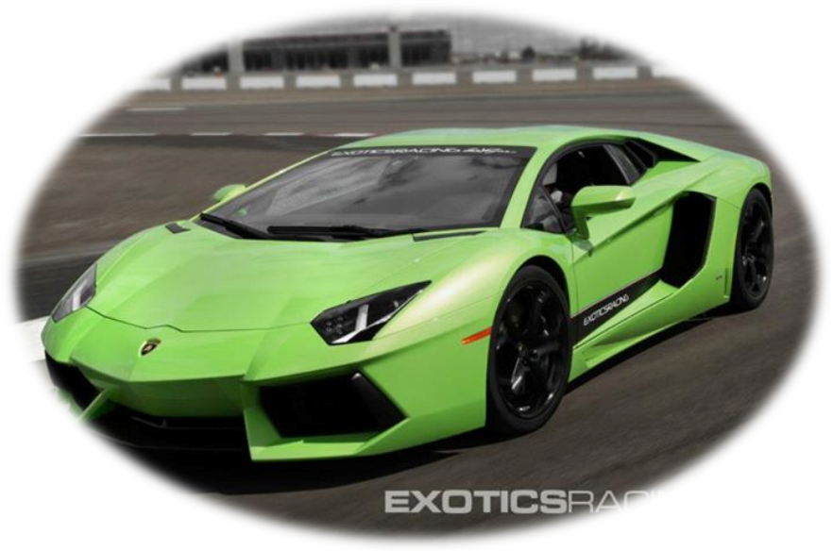

Featured in film, television, music videos, and even songs, the Lamborghini is a celebrity of sorts when it comes to sports cars. As one of the latest line-up additions, the Aventador has certainly followed suit. Perhaps this is why it is my favorite of the Exotics Racing fleet. It seems so elusive and iconic—like something you only see in the movies.
However, the Aventador is not my favorite supercar solely because of its fame. I love the bold design, the scissor doors, and the vibrant colors. Everything about it is magnificently distinctive. Built in Italy, this car represents the epitome of innovation.
I believe the Lamborghini website says it best in referencing the Aventador as having “Just arrived from the future.” Unlike any other car in its class, the Aventador is ahead of its time indeed.

