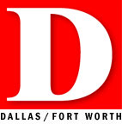

Pulse
A cowboy chef, Paris Hilton’s puppy breeder, and the richest man in Dallas (he’s not who you think).
edited by Adam McGill
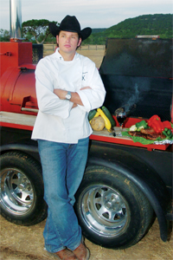
Cooks ’N Boots
Chef Andrew Alexander’s love for Southwestern cooking began at an early age in his grandmother’s kitchen. But it wasn’t until his freshman year in college that he discovered his true calling. Several wild hog cook-offs inspired Alexander to pick up a spatula full-time and to design the barbecue smoker that would change his life.
Fast forward a few years to last summer, when the Culinary Institute of America graduate made his debut on NBC’s Today show by chance. “It was the last week of my externship at the Mansion on Turtle Creek, and Chef Dean Fearing asked if he could borrow my smoker for the live filming of his annual barbecue with celebrity weatherman Al Roker.” Roker plucked Alexander from the crowd. He flashed his “Cowboys Make Better Lovers” t-shirt, and a star was born.
Alexander now runs his own catering company, works as a restaurant consultant around Texas, and makes frequent trips to New York as a celebrity guest chef on NBC’s morning program.
But even with his newfound fame, his heart belongs here, where he can ride horses, hunt, fish, and visit his favorite hometown restaurant, El Fenix. “It’s crazy, but I just love their cheese enchiladas.”
—CHERYL NG COLLETT

