https://www.chicagobusiness.com/cgi-bin/mag/article.pl?article_id=27949

Issue  June 11, 2007 |  | Subscribe to  Crain's Chicago Business | Top of Form  Bottom of Form
  Past
  Issues
Subscribe to an RSS feed on this topic

Wisconsin and Michigan aren't exotic enough for some second- or third-home buyers. A real vacation home for this crowd requires a passport, an airline ticket and possibly a second language.

Distant locales for exotic tastes

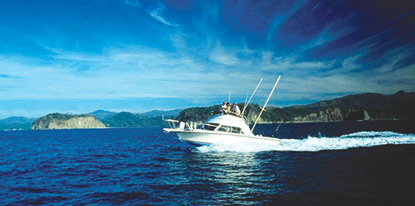
Pacific Coast properties in Costa Rica allow easy access to deep-sea fishing.
Deep-sea fishing off Pacific coastline
Rian Wren, who owns a six-bedroom, 5,000-square-foot home in Winnetka, purchased a second home for his family in Costa Rica.
He had vacationed there in January 2006 with three friends, and after traveling from the inland capital of San Jose to the coastal towns of Jaco and Dominical, he was hooked.
"We drove down an unfinished road to the southwestern part of Costa Rica," says Mr. Wren, president and CEO of Chicago-based Neutral Tandem, a telecommunications service provider. "The road is almost non-existent, just dirt and rock. You go over 13 different single-lane bridges, one of which was out, so we had to take the car through the river on four-wheel drive. But when you get to the coast, it's absolutely beautiful."
Two weeks after the trip, Mr. Wren, 50, and his friends jointly bought two 1,800-square-foot, two-bedroom homes in Dominical for a total of about $1 million. One is 100 feet from the Pacific Ocean, and the other is on a mountainside.
The getaway allows Mr. Wren to pursue an interest he can't closer to home: deep-sea fishing.
"To get good fishing in the Gulf Stream, you usually have to go 25 miles out," Mr. Wren says. "Down there, it's one or two miles out, and you see dolphins, whales and sea turtles.
"I've caught a lot of mahi-mahi there," he says. "You bring it back to the beach, and there is a guy on a wooden bench who will fillet it for you. You just give him a piece of meat in return for cleaning the fish."
Dawn Reiss
©2007 by Crain Communications Inc.

