Reuters

SPORTS NEWS | Fri May 11, 2012 | 5:18pm EDT

Huge crowd expected at Seau's memorial in San Diego

left
right
13/13
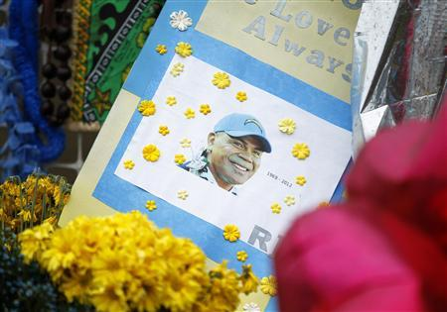
left
right
A memorial continues to grow outside the beach front home of former NFL linebacker Junior Seau on the eve of his funeral in Oceanside, California May 10, 2012. REUTERs/Mike Blake
1/13

left
right
2/13

left
right
3/13

left
right
4/13

left
right
5/13

left
right
6/13

left
right
7/13

left
right
8/13

left
right
9/13

left
right
10/13

left
right
11/13

left
right
12/13

left
right
13/13
left
right
1/13

By Troy Anderson | OCEANSIDE, CALIFORNIA
Tens of thousands of fans are expected to attend Junior Seau's public memorial in a San Diego stadium on Friday, more than a week after the former National Football League star killed himself in his beachfront home.
Seau died on May 2 in a bedroom of his home in Oceanside, just north of San Diego, from a self-inflicted gunshot to the chest, according to police. The 43-year-old former linebacker left no suicide note.
Regarded as one of the best defensive players of his generation, Seau spent most of his 20-year career with the San Diego Chargers and was selected 12 times for the Pro Bowl, the NFL's all-star game. He retired after the 2009 season.
Seau, who was born in the San Diego area to parents of Samoan descent, was revered as a gregarious athlete who gave generously to youth-oriented charities.
The Chargers are paying for the "Celebration of Life" memorial for Seau on Friday evening and said between 30,000 to 60,000 people were expected to pack Qualcomm Stadium for the event.
Former Chargers quarterback Dan Fouts and ex-coach Bobby Ross, who took the team to its only Super Bowl appearance during the 1994 season, are among the dignitaries expected at the tribute.
PRIVATE VIEWING
On Thursday evening, Seau's casket was taken to an Oceanside chapel for a private viewing attended by hundreds of family and friends, many of them in traditional Samoan dress. Cyrus Satoafaiga, 35, remembered his cousin Seau as an upbeat person.
"Just hanging out at our family cookouts and joking around and making everyone laugh, always making it a joyous time with the family," Satoafaiga said.
Pastor Shawn Mitchell, a spokesman for the Seau family, had said last week that the family planned to have Seau's brain examined for evidence of injury, but he has since said they were giving the decision further thought.
Seau's death has led to speculation that years of absorbing hits to the head may have prompted his suicide. The NFL in recent years has faced heightened scrutiny over the potential for head injuries to contribute to depression and long-term health problems in players.

ALSO IN SPORTS NEWS
- Murray wins first title of year in Dubai
- Djokovic has lost his edge, says former mentor Pilic
Sarah Gordon, a spokeswoman for the San Diego County Medical Examiner's Office, said on Thursday her agency was still awaiting word from the Seau family to have the brain examined. That exam would be done by an outside group.
In a Los Angeles Times opinion piece on Thursday, former NFL linebacker Riki Ellison wrote that he believes Seau's death "is the result of sustained concussions to the brain together with the inability to control depression" that follows after leaving an adrenaline-fueled career in professional sports.
In February 2011, former Chicago Bears defensive back Dave Duerson shot himself to death and left notes asking that his brain be examined for evidence of injury from his playing days. Last month, retired Atlanta Falcons safety Ray Easterling, who was among hundreds of former NFL players suing the league over head injuries, killed himself.
Despite the high-profile suicides, a study published in January from a division of the U.S. Centers for Disease Control and Prevention showed retired NFL players had a lower rate of suicide than the general public.
(Reporting by Troy Anderson: Writing by Alex Dobuzinskis; Editing by Paul Simao)
http://www.reuters.com/article/2012/05/11/us-usa-nfl-seau-idUSBRE84A0X220120511

