Reuters

[U.S.](http://www.reuters.com/news/archive/domesticNews) | Wed Aug 29, 2012 | 12:00am EDT

California leaders strike public pension reform deal

left

right

5/5

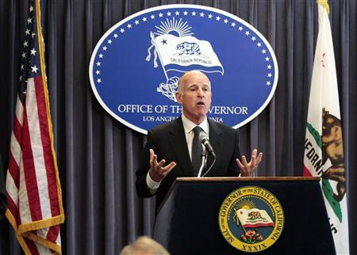

left

right

California Governor Jerry Brown speaks at a news conference to announce the Public Employee Pension Reform Act of 2012 at Ronald Reagan State Building in Los Angeles, California August 28, 2012. REUTERS/Mario Anzuoni

1/5

left

right

left

right

5/5



left

right

1/5

California Governor Jerry Brown and lawmakers have reached a deal to raise public employees' retirement ages, have them pay more into their pension accounts, and cap retirement payments in a vast overhaul of the state's pension system that he says will save $30 billion.

Union leaders panned the deal between Brown and fellow Democrats who control the legislature and hope to drum up support for his tax measure on the November ballot by showing voters they can tackle big challenges.

California faces a huge liability for funding the nation's largest public pension system, but other states and cities also have enormous pension funding gaps and will be watching the state closely.

ADVERTISING

Brown did not get everything he wanted from lawmakers, such as a hybrid plan that would funnel some contributions into 401(k)-style accounts, and some of the deal's measures will not affect current employees.

But Brown told a news event in Los Angeles that the changes would ensure the state's pension system would be sustainable.

"We have lived beyond our means," he said. "The chickens are coming home to roost and this is just one in a series of countermeasures that will be required over the next decade."

The legislature's Democratic leaders plan for the full state Senate and Assembly to vote on the changes on Friday, the last day of the legislature's session for this year.

Democrats have enough votes on their own to approve the plan, which is based on proposals made by Brown last year. The legislature's Republican minority endorsed his proposals.

The package of reforms includes provisions that will require new state and local government workers to split payments to pension accounts at least evenly with their employers.

Local governments using the state's pension fund to manage retirement accounts could impose higher payments from employees if they are unable to negotiate the 50-50 split in five years.

New employees must work two additional years to get maximum benefits after retirement. Formulas used to calculate pensions for new employees will be changed, making them less generous.

Government employers will be given more flexibility in crafting pension plans and new rules will be put in place to prevent inflated pension payments.

Additionally, savings to the state from employees paying more toward their pensions will be used to reduce its unfunded pension liability.

"Anything that reduces the state's unfunded pension obligation would be a good thing," said Steven Zimmermann, Western Region managing director at Standard & Poor's Ratings Services.

LABOR UNIONS OUTRAGED

Democrats in a conference committee of both legislative chambers approved the deal 4-0 late on Tuesday. The two Republicans on the committee abstained, protesting lack of time to study the measures, and labor groups were stunned.

"We are outraged that a Democratic governor and Democratic legislature are taking a wrecking ball to retirement security for teachers, firefighters, school employees, and police officers," said Dave Low, chairman of Californians for Retirement Security, which represents 1.5 million public employees and retirees.

Outside the state building where Brown unveiled the agreement, union activists said the deal unfairly bypassed collective bargaining rights.

ALSO IN U.S.

* [In day of pro-Trump rallies, California march turns violent](http://www.reuters.com/article/us-usa-trump-supporters-idUSKBN16B0O8)
* [Mexico opens migrant defense centers at U.S. consulates](http://www.reuters.com/article/us-usa-mexico-immigration-idUSKBN16B0PL)

"Labor did not have input on this and we are very, very concerned on what this will mean for rank-and-file workers," said Barbara Maynard, also with Californians for Retirement Security.

Brown has lobbied lawmakers for a pension package since last year and has said that putting changes into law is critical for helping convince voters to support his November tax measure.

If voters reject the measure, California will need to cut more spending, including more than $5 billion from popular education programs, to keep its books balanced. The measure would increase the state sales tax to 7.5 percent from 7.25 percent for four years and raise income taxes on Californians making more than $250,000 a year for seven years.

"Pension reform is just a big issue for folks these days," said Larry Gerston, a political scientist at San Jose State University. "This helps build his credibility."

(Reporting by Alex Dobuzinskis and Troy Anderson in Los Angeles, Peter Henderson in San Francisco and Suzanne Hurt in Sacramento; Writing by Jim Christie.; Editing by Richard Chang and Lisa Shumaker)

<http://www.reuters.com/article/2012/08/29/us-california-pensions-idUSBRE87R13B20120829>