Newsmax.com

Rick Warren, Pastors Baptize 50,000th Person at Saddleback Church
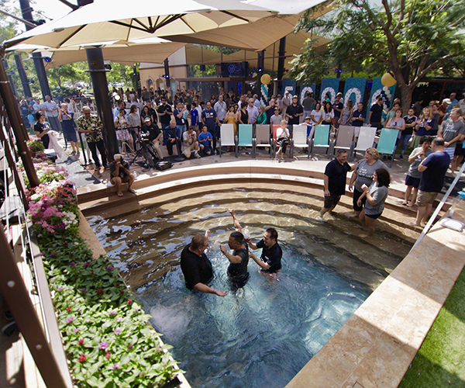
Saddleback Church baptism (Saddleback Church)
By Troy Anderson | Sunday, 12 August 2018 08:09 PM
Shortly after his first Easter Sunday service in 1980, Pastor Rick Warren baptized the first nine people at what would become one of America's largest megachurches.
This weekend, Warren and other pastors at Saddleback Church's 19 campuses baptized their 50,000th person — setting a record in church history.
"Today, we pass a historic milestone at Saddleback Church in that the second of the commands of the Great Commission is to baptize," the author of "The Purpose Driven Life" told thousands of people in attendance at the church's main campus in Lake Forest, California. "And this weekend at all of our campuses we are going to do something that no church in history has ever done — baptize the 50,000th changed life."
Adrienne Zieglar, a 35-year-old Irvine, California, resident who Warren baptized on Sunday, described her baptism as spiritually "liberating."
"I'm proud to be a part of history," Zieglar told Newsmax.
Beccah Akers, a 27-year-old Phoenix, Arizona, resident, says she felt "very loved."
"(Warren) is the shepherd of his flock," Akers says. "It's very obvious that God hand-selected him to be a pastor, and to be baptizing this many people."
Irene Anderson, a 51-year-old Irvine resident, says she "totally felt God's love."
"I don't know how to describe it," Anderson says. "It's very special, very different, very gentile. (Warren) is just looking at you with love. I feel like Jesus is in him and he's in Jesus. It was a great experience. I felt I really had a connection with God, like a strong bond."
Tom Holladay, the teaching pastor at Saddleback Church, says the baptism experience often touches people's hearts.
"With 50,000 baptisms, I think of every individual life," Holladay says. "It's very hard for any of us to watch baptisms without tearing up because you just think of the families that are changed, and the kids that are changed, and the lives that are changed, and so 50,000 is a historic number, but it's also a very personal number to all of us."
Hundreds of people were baptized at the church's various campuses over the weekend. As a result, Holladay says it would "take a lot of good science to figure out" exactly who the 50,000th person was. However, he says the church will likely do what it has done in the past to honor those who got baptized.
"In one sense, we're saying that everybody who is baptized this weekend — you're a part of the 50,000," Holladay says. "It's not like one person wins the 50,000th award. So, what we did last time is we picked out somebody from each of our campuses that was about the time that it would have been, and they went out to lunch with Rick and celebrated. We'll probably do something like that again this time."
The "historical milestone" that Saddleback set this weekend is among dozens of "historical "first" milestones in the Christian world that the church has set over the past 38 years, including:
- Saddleback was the first church in American history to grow to 10,000 people without owning a building.
- Saddleback was the first American church to have nearly 40,000 people meeting weekly for Bible studies and fellowship in over 8,200 small groups. "You became the first church in America to have more people in small groups studies than in weekend worship," Warren wrote in "A Love Letter from Me to You" to his congregation.
- Saddleback was the first local congregation in 2,000 years of Christian history to obey Jesus Christ's Great Commission to "go make disciples of every nation." Over 26,000 Saddleback members have taken the gospel to all 197 official nations of the world through the Global P.E.A.C.E. plan.

https://www.newsmax.com/newsfront/rick-warren-saddleback-church-50-000th-baptism/2018/08/12/id/876694

