Townhall.com

The ‘Great Reset’ and End of Free Speech
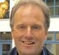
Troy Anderson
|
Posted: Sep 08, 2022 12:01 AM

The opinions expressed by columnists are their own and do not necessarily represent the views of Townhall.com.
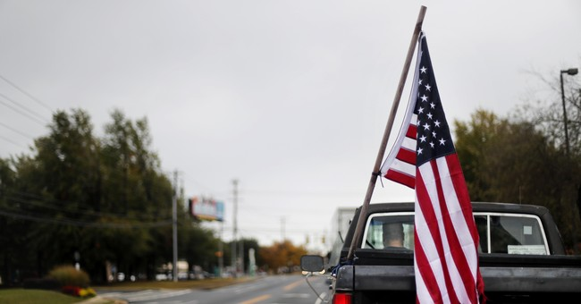
Source: AP Photo/David Goldman
Editor's note: This piece was co-authored by Col. David Giammona.
During a recent meeting of the World Economic Forum in the ski resort town of Davos, Switzerland, Australian government’s eSafety Commissioner Julie Inman Grant called for a “recalibration” of the right to freedom of speech worldwide.
“We are finding ourselves in a place where we have increasing polarization everywhere, and everything feels binary when it doesn’t need to be,” Inman Grant said. “So, I think we’re going to have to think about a recalibration of a whole range of human rights that are playing out online, from the freedom of speech to be[ing] free from online violence.”
A recalibration of a whole range of human rights? Wow, are we really listening and hearing what she is saying? This is the very message of the Nazi Party in the years leading up to World War II.
“When the Nazis came to power in 1933, the German constitution guaranteed freedom of speech and freedom of the press,” according to the United States Holocaust Memorial Museum in Washington, D.C. “Through decrees and laws, the Nazis abolished these civil rights and destroyed German democracy. Starting in 1934, it was illegal to criticize the Nazi government. Even telling a joke about Hitler was considered treachery. People in Nazi Germany could not say or write whatever they wanted.
Today, many liberal American universities espouse the virtues of socialism, communism, and the new world order. With that, many of these institutions covertly and sometimes overtly suppress conservative thought and speech.
It is no secret that American universities, once bastions of freedom of speech, now stealthily censor many conservative speakers from coming on campus. In fact, if you are a conservative professor, you are in a very small group on today’s college campuses. Liberal professors outnumber conservatives by a 12-1 margin.
Suffice to say, the reason for much of the progressive, liberal, socialist, and communist thought stems from years of the universities pumping out graduates indoctrinated in Marxist and new world order doctrines.
Most conservative students and professors feel enormous pressure to keep silent so that they can lead productive lives. Many conservatives have confided that if they speak out their views, often they are at best laughed at and at worst bullied.
As the United States fills up with thought police and leftist propaganda machines such as the mainstream media, more and more of the conservative right are being stymied and silenced into submission.
It just may be that the left really supports the World Economic Forum propaganda about recalibrating human rights because their agenda supports this agenda. After all, if they can silence the right, they win.
What they don’t understand in history is that those who first introduce this kind of tactic are usually the first ones eliminated in a regime change.
When Joseph Stalin gained power in Russia, he executed hundreds of thousands of those who helped him. All told, Stain was responsible for killing tens of millions of his own people.
During The Great Purge, Stalin sought to rid the Communist Party of some of his biggest detractors and rivals. Hundreds of thousands of people were initially arrested by his secret police. Many were executed or sent to gulags. Over a third of the Communist Party died during the purge, including many party bosses, military leaders, and high government officials.
We need to be vitally aware of all that is being planned for us in the new world order or what the World Economic Forum now calls the “Great Reset.”
Those who are planning do not have our best interests in mind. Let us not fall into deception and complacency.
Our bestselling new book, The Military Guide to Disarming Deception: Battlefield Tactics to
Expose the Enemy’s Lies and Triumph in Truth, is a guide to help you and your family successfully navigate this new Orwellian world of censorship, disinformation, and the push to eliminate free speech.
It’s time for the silent majority to be silent no longer.
U.S. Army Chaplain (Col.) David Giammona is an end-times expert, scholar, author, writer, speaker, and president of Battle Ready Ministries. He is co-author with Troy Anderson of the bestsellers The Military Guide to Armageddon and The Military Guide to Disarming Deception. Find out more at www.davidjgiammona.com and www.battle-ready.org.
Troy Anderson is a Pulitzer Prize-nominated investigative journalist, bestselling co-author of The Babylon Code, Trumpocalypse, The Military Guide to Armageddon and The Military Guide to Disarming Deception, vice president of Battle Ready Ministries, president of the Inspire Literary Group, and former executive editor of Charisma magazine and Charisma Media and reporter at the Los Angeles Daily News. Find out more at www.troyanderson.us, www.battle-ready.org and www.inspireliterary.com.
https://townhall.com/columnists/troyanderson/2022/09/08/the-great-reset-and-end-of-free-speech-n2612780

