The Return Israel: A Dress Rehearsal for Jesus' Second Coming
9:00AM EDT 10/8/2022 REV. KEVIN JESSIP AND TROY ANDERSON
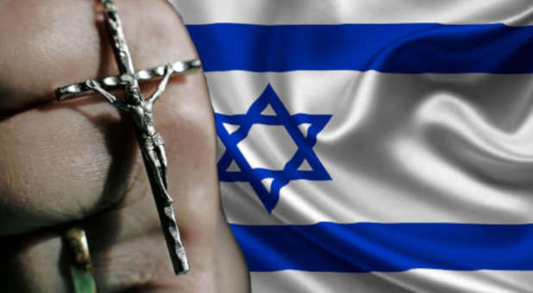(Charisma News archives)<p
Read Time: 3 Minutes 37 Seconds
Editor's Note: This is the third of a three-part series. Click here for part one, and click here for part two.
As we saw with The Return: National and Global Day of Prayer and Repentance on Sept. 26, 2020 on the National Mall in Washington, D.C., if America can be rocked through a sacred day of prayer—just imagine what God has in store when the nations gather in Jerusalem.
It has been called a dress rehearsal for the second coming of Messiah: a global convergence of His elect from the nations to The Return Israel in Jerusalem. Like The Return, many will attend the event in person and millions will join us via live streaming.
Over several days, at a date to be determined in 2024, we will bless Israel from north to south with acts of service, prayer and reconciliation, with worship and celebration. We will raise up a new generation to reconcile with our Jewish brothers and restore the deep treasures of our biblical heritage.
Cultivation: Next Generation
In the Galilee and Mt. Carmel regions, young adults will walk in Yeshua's steps, serving the people of Israel through the Beautiful Land project or working alongside archaeologists to restore the ancient heritage of the land.
Their time in the north climaxes with a final night of worship on Mount Carmel before they join with the nations in Jerusalem.
Reconciliation: A Holy Gathering
In the heart of Israel, believers from around the world will assemble in the city of Jerusalem—joined by millions of prayer warriors worldwide—as we stand in repentance and reconciliation with our Jewish brothers and sisters. There we will pray for the peace of Jerusalem and intercede for the people of Israel.
Celebration: A Night of Worship
On the final day, we gather in southern Israel for baptisms at the Jordan River and tours of this incredible region, including the fabled Masada at the Dead Sea. That evening, we will join together for a tremendous night of praise, worship and victory at the foot of the ancient fortress.
Miniseries: Transformed Lives
To prepare hearts for The Return Israel is a film series event that brings the Land of Israel to life, showing its miraculous transformation from a wasteland back to the promised land. In each episode, this anointed travelogue will transport viewers to the Bible's key places, unfolding God's plan for His chosen people—and patterns marking the end of the age. The landmark series will be streamed worldwide, presented by the creators of The Return International and various Christian, Messianic, Arab and Jewish music artists and teachers.
Connection: Return Israel App
Bringing all this together behind the scenes is The Return Israel App—our daily connection to like-minded believers. Once the custom-designed app goes live, it will be an international video portal directly to the live events, the miniseries and dozens of teaching and testimony videos and materials to prepare hearts for this holy convocation — plus full information about the travel, tours and activities surrounding the Israel event. It will also be the hub for our network of intercessors and prayer warriors.
Watch this exclusive first look video of The Return Israel. And catch the vision of The Return Israel with this free digital download and please share it with your friends, loved ones and like-minded believers who come to mind.
The Return Israel will be a prophetic culminating experience where the nations will gather, reaching all ages and backgrounds, every tribe and tongue, beginning now through 2023 with teaching, worship, testimonies, cinematic filming, events and will be livestreamed globally in every language, ending in a series of events in Israel in 2024.
How do you prepare for such a time? Our coming interactive Return Israel App will keep you updated with times, places, travel and service opportunities, along with global worship videos and teaching series to prepare your heart for this season.
The app will also be your streaming portal to our exclusive cinematic miniseries, highlighting the restoration of the land and the people as well as the live events surrounding The Return Israel.
Find out more at thereturn.org.
Rev. Kevin Jessip is the co-founder and president of The Return International, president of the Global Strategic Alliance and chairman of Save the Persecuted Christians. He is an adviser to national and global leaders within the business, political and faith communities. After years as an executive for one of the world's largest publicly traded companies, Kevin was called into a deeper ministry, where he began as a youth evangelist over four decades ago, to become a dedicated leader for national and global repentance.
Troy Anderson is a Pulitzer Prize-nominated investigative journalist, bestselling co-author of The Military Guide to Armageddon, Trumpocalypse and The Babylon Code and former executive editor of Charisma magazine and Charisma Media and reporter at the Los Angeles Daily News. His latest book, The Military Guide to Disarming Deception, was released Aug. 9. He is the executive editor of The Return International and vice president of Battle Ready Ministries.
https://www.charismanews.com/culture/90357-the-return-israel-a-dress-rehearsal-for-jesus-second-coming?fbclid=IwAR02Uy_9M77G0tOuXrVG5zhwhHftR1txEB0luUwCF5lhmbzEKDI__3lEvOY

