Mystery of local lion king keeping scientists guessing
By Troy Anderson, Staff Writer
Los Angeles Daily News
Updated: 04/04/2010 06:45:04 PM PDT

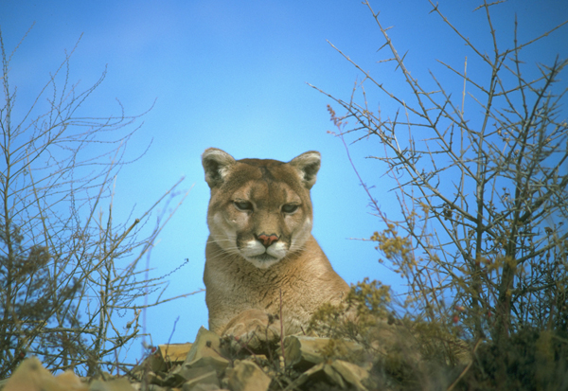
Fish and Game officials killed hundreds of mountain lions throughout California to prevent them from threatening humans. But new research is finding that, even as civilization continues to push further into their habitat, the big cats are behaving themselves a little better, with fewer attacks. Photo: California Department of Fish and Game
ON THE WEB
National Park Servicewww.nps.gov/samo/naturescience/ pumapage.htm
Mountain Lion Foundationwww.mountainlion.org
California Wildlife Centerwww.californiawildlifecenter.org
California Dept. of Fish & Gamewww.dfg.ca.gov/news/issues/lion/
In a tale worthy of Greek tragedy, the lion king of the Santa Monica Mountains a few years ago murdered his lioness and two of his offspring.
Yet the fierce P-1, as scientists call him, has never attacked people or pets.
Such is the mystery and contradiction of one of the West's last great predators, the mountain lion, which can grow to nearly 200 pounds and kills prey by chomping on their necks.
For the last eight years, federal wildlife experts have been studying the mountain lion population in the Santa Monicas, using radio collars to track the movements of 15 of the cats also known as cougars or pumas.
While the study remains ongoing, some of their research was detailed in a book released last month titled "Urban Carnivores: Ecology, Conflict and Conservation."
"There are cases where people have been attacked, but everything we've learned shows it is such a rare, even bizarre kind of event," said co-author Seth Riley, a wildlife ecologist for the Santa Monica Mountains National Recreation Area.
"They are out doing what they are supposed to be doing, which is staying out of people's way and eating deer."
The study is changing how wildlife officials and others view mountain lions. Even though the solitary cougars can evoke fear when spotted by hikers, the study has found that they can coexist with humans, even in urban areas, if able to roam in a sufficiently large habitat.
P-1, for example, the first to be tagged for the study, is considered the alpha cat of the group. He is one of the more aggressive animals, has fathered at least four cubs and got in several bloody fights. He also killed lioness P-2 and two of the cubs she bore for him.
But there is no evidence that he has attacked humans.
Since 1890, mountain lions in California have attacked 16 people, killing six. The last and only known attack in Los Angeles County occurred in 1995 in the San Gabriel Mountains. In statistical terms, people are 1,000 times more likely to be struck by lightning than attacked by a mountain lion.
Each year, the state Department of Fish and Game issues more than 100 "deprivation" permits, giving homeowners and livestock owners permission to hire specialists to euthanize lions that kill livestock and pets or threaten public safety.
But the number of cougars killed in California has dropped from a high of 148 in 2000 to 46 in 2008.
Officials at Fish and Game and the national Mountain Lion Foundation attribute the drop to campaigns educating the public on how to protect themselves, pets and livestock. Tips include bringing pets inside at night, securing animal enclosures and using guard dogs.
"Years ago, ranchers and people who had pets and livestock kind of assumed that killing the mountain lion was their only option when there was a problem," said Amy Rodrigues, the foundation's outreach coordinator. "But if you kill a lion, you just opened up that territory and a new mountain lion is likely to move in and that will just continue the cycle of losing livestock and having to kill more mountain lions."
At one point during the study, P-1 killed some of a hobby rancher's animals in the Santa Monica Mountains, said Jeff Sikich, a National Parks Service wildlife biologist. But instead of having P-1 killed, the rancher built an enclosure for his sheep and goats and bought Anatolian shepherd dogs.
Using a GPS tracking device, Sikich determined the cougar returned the next night but was deterred by the dogs.
Remarkably, the killing of the rancher's livestock was a rarity. Since 2002, officials have examined more than 400 sites where the lions have lingered for three or four days - a sign of a kill - and 95 percent of the dead animals were deer.
Tracking lions in an urban landscape helps biologists learn how they survive in the 153,000-acre park. Biologists are especially interested in whether they can cross freeways, making their way to the Simi Hills, Santa Susana Mountains and the Los Padres National Forest - the nearest source of genetically-different mountain lions.
"We've only had one lion cross the 101 Freeway from the north to the south," Sikich said. "In the long term, unless these populations are mixing, inbreeding will set in and that will eventually lead to them dying off."
Leading solitary lives, and having little contact with others unless mating or mothering, adult lions typically roam an area of 100 square miles. As part of efforts to ensure their survival, various agencies have acquired 85,000 acres in the Santa Monica Mountains, increasing interconnected habitat and helping ensure their genetic diversity and survival.
Meanwhile, the "whole big soap opera" with P-1 continues, Rodrigues said.
While it's common for male mountain lions to fight and kill each other to protect their territory and food supply, Riley said lion experts are unaware of any other male killing the female he mated with.
Riley speculates P-1 may have killed her while she was protecting her four one-year-old cubs. P-1 may have wanted to kill his two sons to protect his territory in an area surrounded by an ocean, freeways and massive development, Riley said. P-1 eventually did kill two of his children - a male and a female.
In 2007, the battery on his collar died and officials lost track of him. Since then, several other adult males have moved into his territory.
Last year, he got in a scrap with a younger cat in the Hidden Valley area.
"We went up there, found blood on the rocks and also P-1's collar, which is kind of amazing because these collars are rugged," Riley said. "So we knew he had been alive at least at that point, but we didn't know if anyone had died."
About a month later, they found new scat in the area. Genetic testing determined it came from P-1, who is believed to be 12 or 13 years old now - about the maximum life expectancy for a lion.
Biologists wonder if the king of the mountain lions is still out there.
"Maybe he's not out there anymore and if he is maybe he's not as dominant," Riley said. "We may never know of course."
Return to Top

