Storied red diamond enough to make collector's blood boil
By Troy Anderson, Staff Writer

diamond
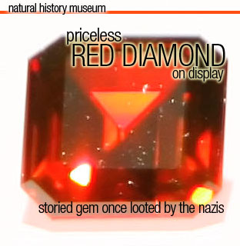

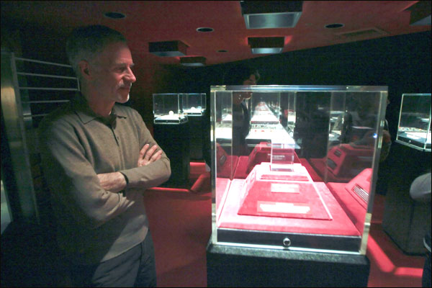
Curator of Mineral Sciences for the Natural History Museum of Los Angeles County Anthony Kampf Ph.D. stands next to the 'Kazanjian Red' at the Los Angeles museum. (Hans Gutnecht/Staff Photographer)

When he first saw the storied 5.05-carat red diamond - a gem colored "as if a drop of blood fell upon the hand of the cutter" - Douglas Kazanjian thought it was heaven-sent.
Kazanjian, head of a Beverly Hills jewelry firm, told his father they had a once-in-a-lifetime opportunity to buy one of the world's most famous diamonds - one with a long history that includes being stolen by the Nazis during World War II and kept at Adolph Hitler's summer retreat.
"Red is the rarest color in diamonds," said Kazanjian, chief executive officer of Kazanjian Bros. Inc., a jeweler and collector of rare gems.
"This is one of the rarest diamonds in the world, and even if my company went on for another 1,000 years we would never find a diamond more rare than this."
The stone, one of only three true blood-red diamonds of 5-plus carats known to exist - is on display through Feb. 1 at the Natural History Museum of Los Angeles County, the first stop on a worldwide tour.
Thousands have already visited the museum to see the emerald-cut diamond with a deep reddish hue.
"Everybody who has seen it has marveled at it, partly because of its beauty and partly because it's a very rare stone," said Anthony R. Kampf, curator of minerals and gems at the museum. "I think what really makes it stand out even more than its appearance is the fact that it has a very interesting history."
The stone's journey from the diamond fields of South Africa to Hitler's collection to the Kazanjian Bros. began in the mid-1920s during a diamond rush in Lichtenburg, South Africa, when thousands of people dug for diamonds, according to Ian Balfour's book "Famous Diamonds."
The most unusual discovery involved a nondescript, dark and rough 35-carat stone a broker purchased for the equivalent of $40 a carat, Kampf said.
"I'm sure they didn't realize what they had at the time until they cut into it because it was so dark," Kampf said. "The couldn't even see it was red. At that time, there were no significant red diamonds known."
Still uncut and of unknown value, it eventually was sent to Amsterdam-based jewelers the Goudvis brothers for cleaving and polishing, Balfour wrote.
In Holland, a master cutter made windows on each side of the stone. Under a lamp, he saw a reddish glow. After seven months of studying, cutting and polishing, the diamond was finished and viewed under candlelight.
"They were so surprised because it showed this amazing red color," Kazanjian said. "They said it was as if a drop of blood fell upon the hand of the cutter."
When no dealer in Amsterdam could estimate the diamond's worth, the Goudvis brothers sent it to New York City, but couldn't find any buyers willing to pay their price. It was returned to Europe and placed in a safe in Arnhem, the Netherlands, Balfour wrote.
In 1944, the Nazis stole the red diamond and other precious stones and took them to Germany. When the war ended, the American military discovered the stolen gems and artwork in a salt mine near Adolph Hitler's Bavarian summer retreat at Berchtesgaden. A general called the head of the war-loot commission and notified him that they had found many diamonds and what they thought was a large ruby.
"This was part of Hitler's personal collection during the war," Kazanjian said. "I'm sure he saw it. ... He took all the best art and valuables of Europe."
After the war, the red diamond was returned to the Goudvis family, but the brothers had died and the heirs were in debt to their bank.
So they sold the gem to a well-known broker. After two more owners, it was sold to an unidentified private collector in 1970 and its whereabouts remained a mystery for nearly three decades.
In 2007, a woman from the Far East whom Kazanjian Bros. had once helped sell an emerald ring paid a visit to the U.S. and showed the jewelers what they realized was the famous red diamond.
"My father and I looked at it and were stunned because we had never seen a red diamond that size before," Kazanjian said. "She had a history on it, including papers from (the previous owner)."
Kazanjian told his father he felt as if his ancestors had sent the red diamond to them from heaven. Kazanjian's grandfather James Kazanjian had traveled the world in search of rare gems and discovered the world's largest ruby in what is believed to be the legendary King Solomon's mines.
The family founded Kazanjian Bros. in 1918 in New York, then opened a Los Angeles location a decade later and relocated to Beverly Hills in 1969.
Knowing the diamond's history, Kazanjian bought the gem and named it the Kazanjian Red Diamond. He declined to disclose the purchase price or identify the woman who sold it to him.
He plans to sell it someday and use the proceeds for his family's scholarship foundation, but decided to send it on a world tour first, starting in Los Angeles.
The exhibit at the museum's Gem and Mineral Hall includes a display called "Hollywood Jewels," also on loan from the Kazanjian Foundation and featuring gems owned by Hollywood luminaries from Carole Lombard to Madonna.
All the jewels are displayed inside the museum's Gem Vault, which is watched by security guards during the day and "locked up tighter than a drum" at night, Kampf said.
Kampf said the heightened security is necessary given that value of the red diamond. In 1987, a 0.95 carat blood-red diamond set a world-record price of $926,000. Kazanjian declined to estimate the value of the Kazanjian Red Diamond.
"This stone is worth a lot more than five times that because it's not just five times bigger; it's a thousand times more rare," Kazanjian said. "It's so rare, it's priceless."
troy.anderson@dailynews.com 213-974-8985

Emerald's journey from Brazil to L.A. a real gem of a tale
By Troy Anderson, Staff Writer
Updated: 01/10/2009 12:20:08 AM PST

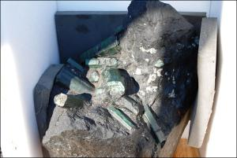
Related stories
Shrouded in mystery, the journey of the Bahia Emerald from a Brazilian mine to Los Angeles is a caper reminiscent of an "Indiana Jones" action flick.
But gemstone experts and sheriff's investigators are skeptical about portions of the story surrounding the 850-pound stone purportedly worth at least $370million.
"The problem with this type of thing is there is an enormous amount of hype surrounding this," said Edward Boehm, vice president of the International Colored Gemstone Association, a New York City-based trade group. "They love it when there is a lot of hype around something like this because ... the value is established through the publicity."
The emerald - believed to be the second-largest stone of its kind in the world - was reportedly discovered July 9, 2001, in the Brazilian state of Bahia in a dense and rugged jungle. The only stories of its origins have been detailed on an obscure Australian blog, called Fortress Australia, and repeated on other sites, including Wikipedia. A miner, who discovered a large crystal protruding from a black rock, began to excavate and within several hours had dug out a huge concentration of emerald crystals embedded in the rock.
He and his fellow miners moved it to a nearby trail, where they assembled a mule team. Over the next 11 months, the miners traveled more than 700 miles through the jungle, according to the Web site. They were attacked by black panthers, and eventually had to fashion a makeshift harness from wood and vines to carry it the rest of the way.
"It's a very interesting story, depending upon whom you believe," said Los Angeles County Sheriff's Department Lt. Thomas Grubb. "Who knows if that is true. I certainly can't verify it."
Finally arriving in Sao Paulo on April 20, 2002, the miners took the rock to the Bank of Brazil. A gemologist appraised the rock and announced it "was indeed one of a kind," according to the Web site.
Accompanied by heavy security, the rock was shipped to the United States for further examination and stored in a vault in South El Monte.
In September, an undisclosed individual, apparently using false documents, took the stone from South El Monte to Las Vegas, Grubb said.
A theft report was made to the sheriff's station in Temple City and the department's Organized Crime Team traveled to Idaho and then to a Las Vegas warehouse to track down the missing stone. The suspects agreed to release it to the sheriff's investigators "pending the outcome of a judicial process which will identify the lawful owner," according to a Sheriff's Department statement.
On Dec. 19, the detectives went to Las Vegas to a prearranged location and recovered the stone. Nobody was arrested, but detectives are continuing their investigation.
"The parties in possession of the stone decided to cooperate with us," Grubb said. "We had no problems with them. I don't know if there are going to be any suspects we are going to pursue for prosecution at this point, but it is possible."
Meanwhile, the stone is being securely stored in the custody of the Sheriff's Department pending its release to the lawful owners.
Attorneys for the different parties have declined to comment.
Boehm believes the gem's value is massively inflated, in part by the legend behind its discovery.
"It's a large piece of rock with emerald crystals," he said. "And the crystals themselves are not really of gem quality. The value was placed excessively high and I'm sure there's probably an ownership issue with whoever mined it and brought it to the U.S."

