
Lifetime Achievement Award

In Crises, Rhodes Was the Man in the Middle
Rob Garver
DEC 1, 2011 6:04pm ET
As head of Citibank's operations in Venezuela in the 1970s, William R. Rhodes was summoned to a meeting with the country's minister of development, where his bank was subjected to a very colorful threat.
The Venezuelan government was on a nationalization binge, and foreign-owned businesses were being forced to sell out to local interests. Chase Bank, the Rockefeller family interests, and Sears Roebuck were all about to be pushed out of the country, and the minister made it clear that the government had its eye on Citibank.
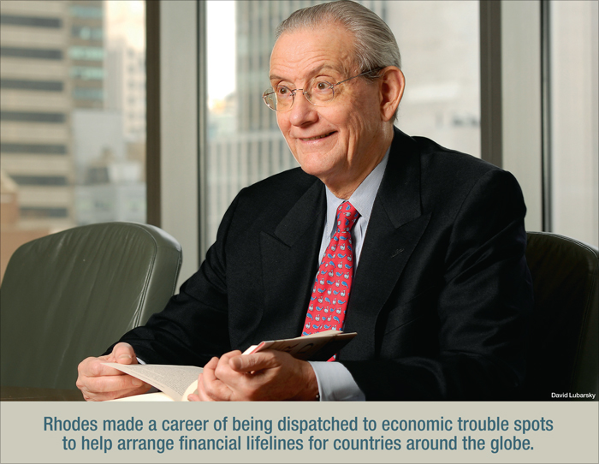
"Hemos decidido por lo momento do no caparte, pero podemos considerarlo en el futuro," the minister told Rhodes.
Fluent in Spanish, Rhodes had no doubt about what the minister meant: "For the moment, we have decided not to castrate you, but we maintain the right to consider it in the future."
The threat was a major concern to Citibank. The company had seen its highly profitable Cuban operations nationalized under Cuba's president, Fidel Castro, and management had no desire to suffer the same fate in Venezuela.
Neither did Rhodes, and what happened next is a key story in the history of the man being honored with American Banker's Lifetime Achievement Award for 2011. At the time, he was not yet a veteran of multiple global financial crises, nor had he become the go-to negotiator for leading major sovereign debt workouts in countries around the world. But the determination and grit that Rhodes showed in Venezuela, along with his ability to parlay a deep understanding of the culture into a successful business strategy would set the stage for his handling of many crises to come.
Rhodes and his team set out to prove to the Venezuelan government that Citi was too valuable to the country's economy to consider nationalizing it. They did it by launching an exhaustive tour of the country's 23 states, meeting with government officials, business leaders and others.
They poured resources into serving the needs of the country's agricultural center, and pulled in Citi executives from around the globe to offer Venezuela the opportunity to transform itself into a financial center for the region.
Rhodes was willing to talk to anyone, and when he talked, he did it in Spanish, a language he had learned as a young man and had perfected during his time in South America. He and his team traveled the country, learning about the needs of its businesses and people, and making sure that Citi found a way to serve them.
Within a few years, competitors like Chase had sold out and left Venezuela. To this day, Citi's branch in Caracas remains wholly owned by the bank.
Reflecting on those days years later, he would write, "Seek to immerse yourself in a country's language, culture and history. A small amount of research can go far."
The instinct to immerse himself in other country's cultures has always been Rhodes' default setting. It was 1954, the president of Brazil had recently shot himself, and workers throughout the country were striking when Rhodes, then a young American sailor, stepped off the deck of a cargo ship and began making his way toward Sao Paolo.
The strike had affected work at the docks and Rhodes, making his second trip along the South American coast, took the advantage of the delay to see more of the country than his vantage point on the Danish-flagged freighter would allow.
At the time also a student at Brown University, Rhodes was spending a second summer earning money for college cleaning decks, alongside Danes, Norwegians and other sailors from backgrounds vastly different from those of a young man raised in Douglaston, N.Y., and sent to prep school at Northfield Mount Hermon.
"It opened my eyes," the 76-year-old retired senior vice chairman and senior international officer of Citigroup and Citibank said of his time as a sailor, not only by giving him the opportunity to learn and practice Spanish, but by exposing him to the world beyond the Northeast.
That Rhodes should show up in Brazil as the country entered a time of severe crisis was, at the time, no more than a coincidence. But in many ways, it would become the defining pattern of his life.
Rhodes made a career of being dispatched to economic trouble spots to arrange financial lifelines for countries around the globe. From Mexico to Argentina to Korea, he always made an effort to get out among the people, to learn something of the language, and to seek an understanding of the culture that went beyond spreadsheets and bond ratings.
It was 1957 when Rhodes first joined the bank, and he spent many years living and traveling abroad, including time in Jamaica, and all across Central and South America, where his Spanish skills, and willingness to pick up bits of Portuguese and to learn the diverse customs of the people he was working with, made him an invaluable asset to the bank's international team and earned him the respect of both bankers and public officials throughout the region.
Brought back to New York in 1977 as Citi's head of Latin American corporate business, it was only a few short years later that Rhodes found himself squarely in the middle of the Latin American debt crisis that began to spread in 1982.
Mexico was unable to pay its dollar-denominated debt to banks around the globe, and as the crisis deepened, it became clear that several other countries in Central and South America were facing the same problem.
Officials at central banks around the world as well as the International Monetary Fund determined that the banks holding the troubled sovereign debt would have to agree on a unified approach to the problem rather than forcing each country to battle with multiple banks over the terms of separate deals.
The challenge was no small one, as then-Federal Reserve Board Chairman Paul A. Volcker recalled in the introduction to Rhodes' new book, "Banker to the World."
"It was apparent from the start that the commercial banks themselves, with their own stability at risk, would need to stand together if they were to deal with the crisis," he wrote. "By some bit of serendipity, the right man appeared at the right time."
Volcker went on to note that as the crisis jumped from country to country, he and his counterparts at other central banks repeatedly found themselves turning to Rhodes to negotiate — or salvage — essential deals.
"What sticks in my mind to this day are the relatively ineffective efforts by other bankers who were called upon from time to time to lead the financing effort for particular countries," he wrote. "It was not that they lacked financial expertise. What was absent was an instinctive understanding of the varied interests at stake, the ability to marshal a consensus, and, when needed, the will to exert authority. Those were qualities Bill Rhodes brought to the table, and on more than one occasion I felt the need to implore Walter Wriston, then Citibank's chairman, to send Bill back into the fray."
Interestingly, when asked to identify some of the most powerful influences on him during his career, Rhodes named Wriston and Volcker, a pair of men who, while frequently adversaries, both worked closely with him on many important ventures.
"As far as I am concerned, [Wriston] was a great mentor," Rhodes said. "He always believed that you had to serve the public and that when crises came up it was your duty to try to work them out."
Rhodes called Volcker "the greatest public servant in the U.S. that I have known or had a chance to work with."
The early stages of the Latin American debt crisis of the mid-1980s was the first of several times Rhodes would be called upon to help a heavily indebted country retrench.
Later that decade, Rhodes found himself working alongside then-Treasury Secretary Nicholas Brady to develop what became known as the "Brady Bond." Under the program, commercial banks holding loans to Latin American nations agreed to accept bonds collateralized by U.S. Treasury obligations in exchange for the loans, allowing them to move risky debt off their balance sheets by selling it on the open market.
It was the intervention of the Treasury Department in cooperation with the International Monetary Fund, the World Bank and private lenders that finally brought the situation in Latin America under control.
"The Brady Bonds basically securitized the debt and put it in the hands of thousands rather than hundreds," Rhodes said. "What I learned there was that neither the public sector nor the private sector could do it alone."
In the late 1990s, Rhodes was agin called on to help lead a developing economy out of crisis. When what was supposed to be a controlled devaluation of the Thai baht created a series of runs on Asian currencies, Rhodes was called in to broker a deal after it became apparent that South Korea was in danger of defaulting on its debt.
"If Korea had gone under, that would have sent shockwaves through the rest of Asia and beyond," Rhodes said.
One person who frequently crossed paths with Rhodes in those days was Citi colleague Jorge A. Bermudez, formerly he firm's chief risk officer.
"He sets a goal and he goes after it," Bermudez said. "He's like a bulldog. He will work 24 hours, seven days a week to get a problem resolved."
The flip side to that intensity is "a humanity that allows him to understand the needs of different parties," Bermudez added.
Bermudez said he was always struck by Rhodes' ability to understand how to press for a deal while simultaneously finding ways to make sure all parties would come away from the table feeling satisfied.
That Rhodes was frequently sought out by government officials is slightly ironic because, like most bankers, he has a complicated relationship with regulators. He frequently warns about the negative consequences of disparate regulatory regimes across borders, and said he is particularly concerned that uneven implementation of the new Basel capital accords, meant to harmonize rules globally, could actually create potential for regulatory arbitrage.
"The idea was that we were going to have a comprehensive set of rules that would level the playing field worldwide," he said, which gave bankers the impression that there would be similarity in application across borders.
"Basel has since said that their standards are minimal standards," he said. "You were supposed to have cooperation and coordination across borders and it is not clear that is happening in the way it was envisioned."
The danger, he said, lies in creating incentives for banks to move operations to areas that offer the most lenient supervisory terms. "Institutions will tend to go where there is less regulation," he said. "These norms and regulations that have been agreed upon have to be implemented on a coordinated basis."
"Regulators want the same thing the banks do," he added. "They want a system that functions and functions well — a safe and sound banking system. Sure there are occasional flare-ups, but basically the regulators are there to do a job and I always felt the best policy was to work with them, and at the end of the day if they find things that they think aren't being done properly, you have to try to put it right."
In his career, Rhodes has seen plenty of public protests against economic injustice and general frustration with banks and the financial system. But those have typically been taking place at a significant remove from Citi's hometown.
But as the Occupy Wall Street protesters continued to camp out in lower Manhattan, he said it is important that bankers make an honest effort to be sure that they are serving not just their own interests, but the country's as well. "You always have to justify what you are doing, not only in difficult times but in good times," he said. "You have to really think of the public service side of it as well as just running your business. The two go together."
Are banks doing that now?
"It depends on the institution. But I don't think you can ever do enough to show people that you are part of the community," he said.
Rhodes first learned those lessons in the cities and villages of Venezuela, and colleagues say that he was never shy about sharing his experience and hard-earned wisdom. Younger staffers jokingly referred to Rhodes as "Uncle Bill," and thought of him as the person to go to when you needed some sound advice.
"When you had a major issue, he was the person to go to who would help you resolve it," Bermudez said.
From fellow bankers to presidents and prime ministers, there are plenty of people around the globe who would agree.
Rob Garver is a freelance writer based in Springfield, Va.

© 2011 American Banker and SourceMedia, Inc. All Rights Reserved. SourceMedia is an Investcorp company. Use, duplication, or sale of this service, or data contained herein, except as described in the Subscription Agreement, is strictly prohibited.
_

