ART & POLITICS
Bush-masked crawler's kicks in the can
A British performance artist dons a President Bush mask, crawls on the streets of New York and asks for kicks from strangers. NANCY A. RUHLING sees if there are any takers.
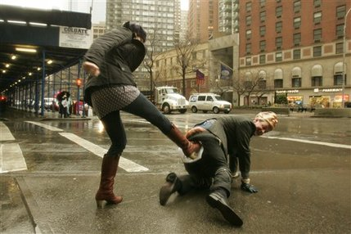
British performance artist Mark McGowan takes a boot to the bum. (AP Photo/Hiroko Masuike)
Friday, 23 February, 2007, 18:03 EST, US
NEW YORK
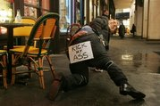
What does McGowan want you to do? Read the sign. (AP Photo/Hiroko Masuike)
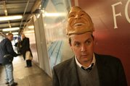
McGowan takes a break from his "kick-me" crawl. (AP Photo/Hiroko Masuike)
Mark McGowan moved forward on his hands and knees, crawling in the middle of a Midtown Manhattan street during a rainy winter rush hour. His face was behind a mask -- a President Bush mask, with thick, gray eyebrows and a broad grin.
New Yorkers can see some strange things during their commute, often without batting an eye. But something about this man's strange behavior seemed to demand action.
Perhaps was the sign on McGowan's backside with big, black letters that said: "KICK MY ASS."
Until 3 p.m. on Sunday, the 37-year-old British performance artist will be crawling all through the city daring you to take him up on his offer.
"George Bush is mental," said McGowan, who's doing the crawl as part of the art show SCOPENewYork at Damrosch Park. "His global policies are terrible. I want people to get some satisfaction when they kick Bush."
(The White House offered no immediate reaction to the artist's hands-and-knees, boot-in-the-bum journey -- a call from asap seeking comment was not returned.)
___
SUFFERING FOR ART
This isn't the first time McGowan has staged an attention-grabbing stunt. In the last eight years, the London art teacher has done everything from pulling a television with his ear for six miles in Italy -- to get the ears of the public about politicians' control of the media -- to dressing up as Queen Elizabeth II on her birthday and inviting the public to bash him in her place.
Getting kicked by strangers may be a royal pain for McGowan, but it's nothing compared to how some other artists have suffered in the name of art. Chris Burden had a friend shoot him in the arm with a rifle and crucified himself atop a Volkswagen. Then there's Gina Pane, who climbed a ladder whose steps were studded with blades, slept on an iron bed that had burning candles underneath and cut up her face with a razor blade.
McGowan has come close to this sort of suffering -- he once nailed his feet to a gallery wall to protest autumn leaves (for some reason). ("It didn't hurt that much," he says. "I just nipped at the webbing; I didn't hit the bone.")
McGowan has a lot riding on "Kick My Ass" because it's his American debut. He's been in training since December 2005, when he did an 11-day, 60-mile trial crawl from London Bridge to Canterbury Cathedral with a rose clenched between his teeth and 18 boxes of chocolates tied to his wrists and ankles. That time, the sign on his backside read, "Could You Love Me."
Now the question is: Will New Yorkers love him enough to give him the boot?
___
AND HE'S OFF
With posterior padding in place -- he wadded up his winter coat and added a pair of soft sneakers -- McGowan sets out to find out, crawling carefully out of the SCOPENewYork tent surrounded by a circus of clicking cameras.
Like a snail, he crawls, putting one black gloved hand in front of the other, trying to miss the river-like puddles on the ice-cold pavement. A woman and child, umbrellas in hand, don't even notice him as they speed by. A white-haired man, his ears decorated with gold studs, wants to kick but holds back.
"You have to have a certain respect for the presidency," he says as he walks away.
Now McGowan is crossing Columbus Avenue, and when the cabbies stop, they don't even blink.
"I want to get kicked, but I don't want to get hurt," he says. "I do have a $500,000 medical insurance policy that covers me."
The first kick is delivered by a sprinting guy in a leather jacket who does the deed swiftly and softly.
By the time McGowan reaches the next corner, he's red-faced. The mask is so hot, he takes it off. He gets on his knees and practically pleads with passers-by to connect with him.
"Wouldn't you like to kick my ass?" he asks politely.
A chic blonde grins as she primly plants her Prada pump prominently on McGowan's posterior. Another woman, a demure-looking documentary filmmaker from Queens named Amy Brown, really gives it to him.
Once Brown's started, she can't seem to stop kicking.
"It felt good," she says. "I wish I had done far more damage."
It's just what McGowan longs to hear. He has felt her pain, and it has cheered him up immensely. In the next block, he's kicked by a retiree carrying a cane, a Bush-bashing Texas native and an Ecuadorean transplant.
And so it goes, block after block: a kick here, a kick there.
When last seen, our suffering artist, suit soaked but backside proudly held as high as the Empire State Building, is crawling toward Times Square in the hopes of getting in some more kicks. His joints are very, very stiff, but so is his British upper lip.
___
asap contributor Nancy A. Ruhling is a freelance writer based in New York.
___
Want to comment? Sound off at soundoffasap@ap.org .
©2007 The Associated Press. All rights reserved. This material may not be published, broadcast, rewritten or redistributed. Learn more about our Privacy Policy.

