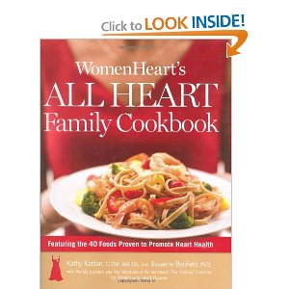

Please go here to amazon.com link and read the reviews:
http://www.amazon.com/WomenHearts-All-Heart-Family-Cookbook/dp/1594867968/ref=sr_1_1?s=books&ie=UTF8&qid=1298586174&sr=1-1

